UNITED STATES
SECURITIES AND EXCHANGE COMMISSION
Washington, D.C. 20549

FORM 6-K

REPORT OF FOREIGN PRIVATE ISSUER
PURSUANT TO RULE 13a-16 OR 15d-16
OF THE SECURITIES EXCHANGE ACT OF 1934
For the month of May 2026
(Commission File No. 001-38215)

NUCANA PLC
(Translation of registrant’s name into English)

3 Lochside Way
Edinburgh EH12 9DT
United Kingdom
(Address of registrant’s principal executive office)

Indicate by check mark whether the registrant files or will file annual reports under cover Form 20-F or Form 40-F.
Form 20-F ☒ Form 40-F ☐
Indicate by check mark if the registrant is submitting the Form 6-K in paper as permitted by Regulation S-T Rule 101 (b) (1): ☐
Indicate by check mark if the registrant is submitting the Form 6-K in paper as permitted by Regulation S-T Rule 101 (b) (7): ☐

Other Events
On May 6, 2026, NuCana plc (the “Company”) published its 2025 UK Annual Report (the “UK Annual Report”) for the year ended December 31, 2025 and distributed a notice of its annual general meeting to be held on June 8, 2026 (the “AGM”), a form of proxy and its UK Annual Report to its ordinary shareholders. The notice of the AGM is attached as Exhibit 99.1 hereto and the UK Annual Report is attached as Exhibit 99.2 hereto.
On or about May 6, 2026, Citibank, N.A., in its capacity as the depositary bank (the “Depositary”) for the Company’s American Depositary Shares (“ADSs”), commenced mailing notice materials and voting cards to ADS holders to enable ADS holders of record as of May 1, 2026 to instruct the Depositary to vote the ordinary shares represented by their ADSs. If the Depositary receives timely voting instructions from an ADS holder, it will endeavor to vote the ordinary shares (in person or by proxy) represented by the holder’s ADSs in accordance with the ADS holder’s voting instructions. The ability of the Depositary to carry out voting instructions may be limited by practical and legal limitations and ADS holders may not receive voting materials in time to enable them to return voting instructions to the Depositary in a timely manner. The notice materials to be mailed by the Depositary to ADS holders will contain a link to the Company’s website where ADS holders can view and download the AGM notice distributed by the Company to its ordinary shareholders (which contains explanatory notes for the resolutions being voted on at the AGM) and the UK Annual Report.
The information contained in Exhibits 99.1 and 99.2 shall not be deemed “filed” for purposes of Section 18 of the Securities Exchange Act of 1934, as amended (the “Exchange Act”), or incorporated by reference in any filing under the Securities Act of 1933, as amended, or the Exchange Act, unless expressly set forth by specific reference in such a filing.
Exhibits

Exhibit |  | Description
99.1 |  | Notice of Annual General Meeting
99.2 |  | 2025 UK Annual Report

SIGNATURES
Pursuant to the requirements of the Securities Exchange Act of 1934, the registrant has duly caused this report to be signed on its behalf by the undersigned, thereunto duly authorized.

NuCana plc
By: |  | /s/ Ian Webster
Name: |  | Ian Webster
Title: |  | Interim Chief Financial Officer  (Principal Financial and Accounting Officer)
Date: May 6, 2026
Exhibit 99.1


A New Era in Oncology Notice of 2026 Annual General Meeting Monday, 8th June 2026 at 11.00am Venue: Lochside House 3 Lochside Way Edinburgh EH12 9DT U.K.


NuCana plc
77-78 Cannon Street, London, England, EC4N 6AF
Company number: 03308778

2

NOTICE OF 2026 ANNUAL GENERAL MEETING

NOTICE OF 2026 ANNUAL GENERAL MEETING
NOTICE is hereby given that the 2026 annual general meeting of NuCana plc (the “Company”) will be held on 8 June 2026 at 11.00am at Lochside House, 3 Lochside Way, Edinburgh EH12 9DT, UK for transaction of the following business:
Ordinary Resolutions
To consider and, if thought fit, pass the following resolutions (1 to 10 inclusive), which will be proposed as ordinary resolutions:

1. | To re-elect (as a Class I director) Hugh Stephen Griffith, who is retiring by rotation in accordance with the Articles of Association of the Company, as a director of the Company.

2. | To re-elect (as a Class I director), Andrew Martin Kay, who is retiring by rotation in accordance with the Articles of Association of the Company, as a director of the Company.

3. | To re-appoint Ernst & Young LLP as auditors of the Company to hold office from the conclusion of this meeting until the conclusion of the next annual general meeting of the Company.

4. | To authorise the directors to determine the remuneration of the auditors of the Company.

5. | To receive the Company’s audited accounts for the financial year ended 31 December 2025, together with the Strategic Report, Directors’ Report and Auditors’ Report on those accounts.

6. | To receive and approve the Directors’ Remuneration Report (other than the part containing the Directors’ Remuneration Policy) for the financial year ended 31 December 2025.

7. | To receive and approve the Directors’ Remuneration Policy set out on pages 27 to 31 of the Directors’ Remuneration Report for the financial year ended 31 December 2025, such remuneration policy to take effect from the date on which this resolution is passed.

8. | THAT, in accordance with section 618 of the Companies Act 2006 (the “Act”), each of the 15,040,465,803 deferred shares of £0.0004 each in the issued share capital of the Company be and is sub-divided into 100 deferred shares of £0.000004, having the same rights and being subject to the same restrictions (except as to nominal value) as the existing deferred shares in the capital of the Company, as set out in the Company’s articles of association from time to time, such that, following the passing of this resolution, the Company’s issued share capital shall be comprised of 20,809,854,947 ordinary shares of £0.0004 each and 1,504,046,580,300 deferred shares of £0.000004 each.

9. | THAT, subject to the passing of Resolution 8 and in accordance with section 618 of the Act, each of the 20,809,854,947 ordinary shares of £0.0004 each in the issued share capital of the Company be and is sub-divided into and redesignated as (i) 1 ordinary share of £0.000004, having the same rights and being subject to the same restrictions (except as to nominal value) as the existing ordinary shares in the capital of the Company, as set out in the Company’s articles of association from time to time, and (ii) 99 deferred shares of £0.000004 each, having the same rights and being subject to the same restrictions as the existing deferred shares in the capital of the Company, as set out in the Company’s articles of association from time to time, such that, following the passing of this resolution, the Company’s issued share capital shall be comprised of 20,809,854,947 ordinary shares and 3,564,222,220,053 deferred shares, in each case, of £0.000004 each (the “Sub-Division”).

10. | THAT the directors be generally and unconditionally authorised pursuant to Section 551 of the Act to exercise all the powers of the Company to allot shares in the Company or grant rights to subscribe for or to convert any security into shares in the Company up to an aggregate nominal amount of £5,000,000. This authority shall, unless previously renewed, revoked or varied by the Company in general meeting, expire on 30 June 2027 or, if earlier, the conclusion of the annual general meeting of the Company to be held in 2027, save that the Company may, at any time before such expiry, make any offer or agreement which would or might require rights to subscribe for or to convert securities into shares to be granted or equity securities to be allotted after the authority expires, and the directors may allot shares or grant such rights in pursuance of such offer or agreement as if the authority had not expired. This resolution revokes and replaces all unexercised authorities previously granted to the directors to allot shares or grant rights to subscribe for or convert securities into shares but without prejudice to any allotment of shares or grant of rights already made, offered or agreed to be made pursuant to such authorities.
Special Resolution
To consider and, if thought fit, pass the following resolution 11, which will be proposed as a special resolution:

11. | THAT, subject to the passing of resolution 10, the directors be empowered pursuant to Section 570 of the Act to allot equity securities (as defined in Section 560 (1) of the Act) for cash under the authority given by that resolution as if Section 561(1) of the Act did not apply to any such allotment, provided that such authority shall be limited to the allotment of equity securities up to a

3

NOTICE OF 2026 ANNUAL GENERAL MEETING

nominal amount of £5,000,000, such authority to expire on the conclusion of the annual general meeting of the Company to be held in 2027, but prior to its expiry the Company may make offers, and enter into agreements, which would, or might, require equity securities to be allotted after the authority expires and the Board may allot equity securities under any such offer or agreement as if the authority had not expired.
Recommendation
The directors of the Company consider that all the proposals to be considered at the annual general meeting are in the best interests of the Company and its shareholders as a whole and are most likely to promote the success of the Company. It is essential that the proposed resolutions are passed. Failure to do so would severly compromise the Company’s ability to finance its plans on a continuing basis. The directors unanimously recommend that you vote in favour of all the proposed resolutions as they intend to do in respect of their own beneficial holdings.

BY ORDER OF THE BOARD |  | Registered office
 |  | 77-78 Cannon Street
 |  | London
 |  | England
 |  | EC4N 6AF
Martin Quinn
Company Secretary
6 May 2026
YOUR VOTE IS IMPORTANT. Members will be able to attend the AGM in person however you are strongly encouraged to vote on all resolutions in advance of the AGM by appointing the Chair of the meeting as your proxy. Further details on how shareholders can appoint the Chair of the meeting as their proxy are set out in this document.
NOTES
The following notes explain your general rights as a member and your right to attend and vote at the annual general meeting or to appoint someone else to vote on your behalf.

1. | Any member entitled to attend, speak and vote at the annual general meeting may appoint one or more proxies to attend, speak and vote on their behalf. A proxy need not be a member of the Company but must attend the meeting. A member may appoint more than one proxy in relation to the annual general meeting provided that each proxy is appointed to exercise the rights attached to a different share or shares held by that member. To appoint more than one proxy you should contact the Company’s registrar, Computershare Investor Services PLC (“Computershare”), at the address below.

2. | Only those members registered in the register of members of the Company as at 11.00am on 4 June 2026 or, in the event that the meeting is adjourned, in such register not later than 48 hours before the time of the adjourned meeting, shall be entitled to attend, or vote (whether in person or by proxy) at the meeting in respect of the number of shares registered in their names at the relevant time.

3. | A form of proxy has been provided for use by members. To be valid it should be completed, signed and delivered (together with the power of attorney or other authority (if any) under which it is signed, or a notarially certified copy of such power or authority) to the Company’s registrar, Computershare, at Computershare Investor Services PLC, The Pavilions, Bridgwater Road, Bristol BS99 6ZY, not later than 48 hours (not including non-business days) before the time appointed for holding the annual general meeting or any adjourned meeting or, in the case of a poll taken more than 48 hours after it is demanded, not less than 24 hours before the time appointed for the taking of the poll.

4. | In the case of a corporation, the form of proxy must be executed under its common seal (or such form of execution as has the same effect) or signed on its behalf by an attorney or a duly authorised officer of the corporation. A corporation which is a member can appoint one or more corporate representatives who may exercise on its behalf all its powers as a member provided that they do not do so in relation to the same shares.

5. | In the case of joint holders, the vote of the senior who tenders a vote whether in person or by proxy will be accepted to the exclusion of the votes of any other joint holders. For these purposes, seniority shall be determined by the order in which the names stand in the Company’s relevant register of members for the certificated or uncertificated shares of the Company (as the case may be) in respect of the joint holding.

4

NOTICE OF 2026 ANNUAL GENERAL MEETING

6. | CREST members who wish to appoint a proxy or proxies by using the CREST electronic appointment service may do so for the meeting and any adjournments of it by utilising the procedures described in the CREST Manual. The message, (a CREST proxy instruction) must be properly authenticated in accordance with the specifications of Euroclear UK & Ireland Limited (“EUI”) and must contain the information required for such instructions, as described in the CREST Manual. The message, regardless of whether it relates to the appointment of a proxy or to an amendment to the instruction given to a previously appointed proxy must, in order to be valid, be transmitted so as to be received by the Company’s registrar, Computershare not later than the time stated in Note (3) above. For this purpose, the time of receipt will be taken to be the time (as determined by the time stamp applied to the message by the CREST Applications Host) from which the Company’s registrar is able to retrieve the message by enquiry to CREST in the manner prescribed by EUI.
CREST members and, where applicable, their CREST sponsors or voting service providers should note that EUI does not make available special procedures for any particular messages. Normal system timings and limitations will therefore apply in relation to the input of CREST proxy instructions. It is the responsibility of the CREST member concerned to take (or, if the CREST member is a CREST personal member or sponsored member or has appointed a voting service provider, to procure that their CREST sponsor or voting service provider takes) such action as shall be necessary to ensure that a message is transmitted by any particular time. Reference should be made to those sections of the CREST Manual concerning practical limitations of the CREST system and timings.
The Company may treat as invalid a CREST proxy instruction in the circumstances set out in Regulation 35(5)(a) of the Uncertificated Securities Regulations 2001.

7. | Proxymity Voting. If you are an institutional investor you may also be able to appoint a proxy electronically via the Proxymity platform, a process which has been agreed by the Company and approved by the Company’s registrar. For further information regarding Proxymity, please go to www.proxymity.io. Your proxy must be lodged by 11.00am BST on 4 June 2026 in order to be considered valid. Before you can appoint a proxy via this process you will need to have agreed to Proxymity’s associated terms and conditions. It is important that you read these carefully as you will be bound by them and they will govern the electronic appointment of your proxy.

8. | The completion and return of a form of proxy will not preclude a member from attending in person at the meeting and voting should they wish to do so, but if a member appoints a proxy and attends the meeting in person, the proxy appointment will automatically be terminated. Further, the appointment under the form of proxy may be terminated by the member prior to the commencement of the meeting (or any adjournment of the meeting). To be valid, the notice of termination of the authority of the person appointed to act as proxy must be deposited at the offices of the Company’s registrar, Computershare at, not less than 48 hours (not including non-business days) before the time fixed for the holding of the annual general meeting or any adjournment thereof (as the case may be).

9. | Under Section 527 of the Companies Act 2006 (the “Act”), members meeting the threshold requirement set out in that section have the right to require the Company to publish on a website a statement setting out any matter relating to: (a) the audit of the Company’s accounts (including the auditor’s report and the conduct of the audit) that are to be laid before the annual general meeting; or (b) any circumstance connected with an auditor of the Company ceasing to hold office since the previous meeting at which annual accounts and reports were laid in accordance with Section 437 of the Act. The Company may not require the members requesting any such website publication to pay its expenses in complying with Sections 527 or 528 of the Act. Where the Company is required to place a statement on a website under Section 527 of the Act, it must forward the statement to the Company’s auditors not later than the time when it makes the statement available on the website. The business which may be dealt with at the annual general meeting includes any statement that the Company has been required, under Section 527 of the Act, to publish on a website.

10. | Copies of the directors’ service contracts and letters of appointment for non-executive directors will be available for inspection at the Global Headquarters of the Company at 3 Lochside Way, Edinburgh EH12 9DT during normal business hours on any week day (public holidays excepted) from the date of this Notice of annual general meeting until the date of the annual general meeting, and at the place of the annual general meeting for one hour before the meeting and at the meeting itself.

11. | Except as set out in the notes to this Notice, any communication with the Company in relation to the annual general meeting, including in relation to proxies, should be sent to the Company’s registrar, Computershare at Computershare Investor Services PLC, The Pavilions, Bridgwater Road, Bristol BS99 6ZY. No other means of communication will be accepted. In particular, you may not use any electronic address provided either in this Notice or in any related documents to communicate with the Company for any purpose other than those expressly stated.

5

NOTICE OF 2026 ANNUAL GENERAL MEETING

EXPLANATORY NOTES TO THE RESOLUTIONS PROPOSED AT THE ANNUAL GENERAL MEETING
The resolutions to be proposed at the AGM of the Company to be held on 8 June 2026 at 11.00am are set out in this Notice of AGM. The following notes provide an explanation to the resolutions being put to shareholders.
Ordinary Resolutions
Resolutions 1 to 10 are proposed as ordinary resolutions. Assuming that a quorum is present, an ordinary resolution is passed on a show of hands if it is approved by a simple majority (more than 50%) of the votes cast by shareholders present (in person or by proxy) at the meeting and entitled to vote. On a poll, an ordinary resolution is passed if it is approved by holders representing a simple majority of the total voting rights of shareholders present (in person or by proxy) who (being entitled to vote) vote on the resolution.
Resolutions 1- 2 Re-election of directors
Under the Company’s Articles of Association there are three classes of board members (Class I, Class II and Class III) with each class having a specified term of office. The Company’s Articles of Association require the Class I directors to retire from office this year. Hugh Stephen Griffith currently serves as a Class I director. Hugh Stephen Griffith is retiring and (being eligible) is standing for re-election as a Class I director at the AGM. Andrew Martin Kay currently serves as a Class I director. Andrew Martin Kay is retiring and (being eligible) is standing for re-election as a Class I director at the AGM. Biographical information for each director standing for re-election is included on page 10 of this Notice. THE BOARD RECOMMENDS A VOTE FOR THE RE-ELECTION OF EACH OF HUGH STEPHEN GRIFFITH AND ANDREW MARTIN KAY TO THE BOARD OF DIRECTORS.
Resolution 3 – Re-appointment of auditors
The Act requires that auditors be appointed at each general meeting, at which accounts are laid, to hold office until the next AGM. The appointment of Ernst & Young LLP as auditors of the Company terminates at the conclusion of the AGM. They have indicated their willingness to stand for reappointment as auditors of the Company until the conclusion of the AGM in 2027.
The Audit Committee has assessed the effectiveness, independence and objectivity of the auditors, Ernst & Young LLP, and concluded that the auditors were in all respects effective.
THE BOARD RECOMMENDS A VOTE FOR THE RE-APPOINTMENT OF ERNST & YOUNG LLP AS AUDITORS.
Resolution 4 – Authorising and fixing the remuneration of the auditors
This resolution gives authority to the directors to determine the auditors’ remuneration.
It is normal practice for shareholders to resolve at the AGM that the directors shall decide on the level of remuneration of the auditors for the audit work to be carried out by them in the next financial year. The amount of the remuneration paid to the auditors for the next financial year will be disclosed in the next audited accounts of the Company.
THE BOARD RECOMMENDS A VOTE FOR THE AUTHORISATION OF THE DIRECTORS TO DETERMINE THE AUDITORS’ REMUNERATION.
Resolution 5 – Laying of accounts
The directors are required to present to shareholders at the AGM, the annual accounts of the Company for the year ended 31 December 2025, the Strategic Report, the Directors’ Report and the Auditors’ Report on the accounts.
THE BOARD RECOMMENDS A VOTE FOR THE RESOLUTION TO RECEIVE THE ANNUAL ACCOUNTS OF THE COMPANY FOR THE YEAR ENDED
31 DECEMBER 2025, THE STRATEGIC REPORT, THE DIRECTORS’ REPORT AND THE AUDITORS’ REPORT ON THE ACCOUNTS.
Resolution 6 – Directors’ Remuneration Report
Shareholders are invited to cast their vote on the Directors’ Remuneration Report, in accordance with Section 439 of the Act. The Directors’ Remuneration Report is set out on pages 19 to 32 of the Company’s annual accounts and reports for the year ended 31 December 2025. The vote is advisory in nature and therefore no entitlement to remuneration is conditional on the passing of this resolution.
THE BOARD RECOMMENDS A VOTE FOR THE RESOLUTION TO RECEIVE AND APPROVE THE DIRECTORS’ REMUNERATION REPORT FOR THE FINANCIAL YEAR ENDED 31 DECEMBER 2025.
Resolution 7 – Directors’ Remuneration Policy
In accordance with the requirements of the Act, as a company registered in England and Wales and listed on Nasdaq, the Company is required to establish a Directors’ Remuneration Policy containing a framework of limits within which the remuneration committee are authorised by shareholders to operate. This Remuneration Policy has to be annually disclosed within the Remuneration Report contained within the Company’s annual report, and this policy is required to be approved by shareholders at least every three years, by the passing of an ordinary resolution at the AGM.

6

NOTICE OF 2026 ANNUAL GENERAL MEETING

Shareholders are asked to approve the Directors’ Remuneration Policy which is set out in full on pages 27 to 31 of the Directors’ Remuneration Report. The vote on the Directors’ Remuneration Policy is binding in that, once the policy is approved, the Company will not be able to make a remuneration payment to a current or prospective director or a payment for loss of office to a current or past director, unless that payment is consistent with the policy or has been specifically approved by a resolution of the Company’s shareholders. If resolution 7 is passed, the Directors’ Remuneration Policy will take effect immediately.
THE BOARD RECOMMENDS A VOTE FOR THE RESOLUTION TO RECEIVE AND APPROVE THE DIRECTORS’ REMUNERATION POLICY.
Background to Resolutions 8 – 9
The Company issues ordinary shares which currently have a nominal value of £0.0004 each. Under U.K. company law the Company is prohibited from issuing ordinary shares at a price which is less than this nominal value.
Each of the Company’s ADSs in issue represents 5,000 ordinary shares of £0.0004 each so this sets a minimum price of £2 at which each new ADS must be issued (given that the nominal value for 5,000 newly issued ordinary shares represented by each ADS must be paid under U.K. company law). The Company’s ADSs are currently trading at a price beneath this minimum price which means that the Company is currently unable to issue new ordinary shares/ADSs at market value.
Resolution 9, the Sub-Division, is the Company’s proposal to address this issue. Resolution 8 is necessary to facilitate the Sub-Division.
Capital Reorganisation by way of Sub-Division
Sub-Division of shares is a process by which a limited company having a share capital changes the structure of that share capital by increasing the number of shares it has in issue and decreasing the nominal value of each of those shares. On a Sub-Division, the total nominal value of the Company’s issued share capital remains unchanged.
The Company currently has:-

 |  |  | 20,809,854,947 ordinary shares of £0.0004 each in issue (“the Existing Ordinary Shares”); and

 |  |  | 15,040,465,803 deferred shares of £0.0004 each in issue (“the Existing Deferred Shares”).
The Existing Deferred Shares have no dividend or voting rights and, upon a return of capital, the right only to receive the amount paid up thereon after the holders of the Existing Ordinary Shares in the capital of the Company have received the amounts entitled to be paid to holders of Existing Ordinary Shares in the share capital of the Company and the further payment of £10,000,000.00 in respect of each Existing Ordinary Share.
It is proposed by Resolution 8 that all the Existing Deferred Shares in issue be each subdivided into 100 deferred shares of £0.000004 each (“the Deferred Shares”) so the class of Deferred Share has that new nominal value prior to the Sub-Division proposed by Resolution 9.
Subject to the passing to Resolution 8, the Board proposes by Resolution 9 to carry out a subdivision and redesignation of the Existing Ordinary Shares by 1:100 so that each Existing Ordinary Share will be subdivided into and redesignated as 1 new ordinary share of £0.000004 each (“the New Ordinary Shares”) and 99 Deferred Shares of £0.000004 each (“the Capital Reorganisation”).
No share certificates will be issued in respect of the Deferred Shares created by Resolution 9 and the CREST accounts of holders of New Ordinary Shares will not be credited with any Deferred Shares.
This will increase the number of shares in issue to 20,809,854,947 New Ordinary Shares and 3,564,222,220,053 Deferred Shares with the nominal value of each share being £0.000004.
The rights of the New Ordinary Shares and the Deferred Shares are set out in the Company’s Articles of Association and in the case of the Deferred Shares summarised as follows. The Deferred Shares have no dividend or voting rights and, upon a return of capital, the right only to receive the amount paid up thereon after the holders of the New Ordinary Shares in the capital of the Company have received the amounts entitled to be paid to holders of New Ordinary Shares in the share capital of the Company and the further payment of £10,000,000.00 in respect of each New Ordinary Share.
Following the proposed Capital Reorganisation the aggregate number of shares held (directly or by virtue of holding an ADS) by a shareholder in the Company will be higher, but the nominal value of each of those shares will be lower and the total nominal value of the shares held by a shareholder will be unchanged by Resolution 9. The total nominal value of the Company’s issued share capital following the passing of Resolution 9 will remain unchanged at £14,340,128.30.
Materially each shareholders proportionate holding, by number of shares, in the issued share capital of the Company will be unchanged following the passing of Resolution 9.

7

NOTICE OF 2026 ANNUAL GENERAL MEETING

The passing of Resolutions 8 and 9 will allow the Company to issue new ADSs.
Resolution 8 – the Sub-Division of the Existing Deferred Shares
The Existing Deferred Shares have a nominal value of £0.0004 each and it is necessary to sub-divide these into shares of £0.000004 each to facilitate the Sub-Division proposed by Resolution 9.
THE BOARD RECOMMENDS YOU VOTE FOR THE RESOLUTION SUB-DIVIDING THE EXISTING DEFERRED SHARES.
Resolution 9 – the Sub-Division of the Existing Ordinary Shares
The Existing Ordinary Shares have a nominal value of £0.0004. The Board proposes, by Resolution 9, to carry out a subdivision and redesignation of the Existing Ordinary Shares by 1:100 so that each Existing Ordinary Share will be subdivided into and redesignated as 1 new ordinary share of £0.000004 each and 99 Deferred Shares of £0.000004 each. Each shareholders proportionate holding, by number of shares, in the issued share capital of the Company will be unchanged following the passing of Resolution 9.
THE BOARD RECOMMENDS YOU VOTE FOR THE RESOLUTION SUB-DIVIDING AND REDESIGNATING THE EXISTING ORDINARY SHARES.
Background to Resolution 10 and Special Resolution 11
As a matter of U.K. company law, directors of a company incorporated in England must have authority from shareholders to allot or grant rights to subscribe for, or to convert any security into, the company’s shares. In addition, when an allotment of shares is for cash, the company must first offer those shares on the same terms to existing shareholders of the company on a pro-rata basis (commonly referred to as statutory pre-emption rights) unless these statutory pre-emption rights are dis-applied, by approval of the shareholders.
Resolutions 10 and 11, which we refer to as our “Share Issuance Proposals,” ask our shareholders for authority for the directors to allot shares or grant rights over shares up to an aggregate nominal amount of £5,000,000 and the power for the directors to allot shares or grant rights over shares for cash up to an aggregate nominal amount of £5,000,000 on a non-preemptive basis. This authority and power would expire at the conclusion of our 2027 AGM.
Many of our peer companies are listed and incorporated in the United States, and are thus not subject to similar share issuance restrictions. We are asking you to approve our Share Issuance Proposals to allow us to continue to execute on our business and growth strategy in a timely and competitive manner.
Should our shareholders not approve resolutions 10 and 11, whilst we appreciate that we would still have the ability to seek shareholder approval in connection with a specific issuance of shares on a case-by-case basis by convening general meetings from time to time, we do not believe that such an approach is a workable alternative to obtaining approval of resolutions 10 and 11 at the AGM as we propose. The uncertainty as to whether we could obtain shareholder approval for a specific issuance, as well as the delays we would experience in seeking and obtaining such approval, could be harmful to the terms of such a share issuance. In addition, the case-by-case approval approach ignores market windows and other deal timing and competitive realities.
Specifically, the requirement to first offer shares, that we propose to issue for cash, to all of our existing shareholders in time-consuming pro-rata rights offerings would considerably reduce the speed at which we could complete capital-raising activities undertaken in furtherance of our growth strategy, would increase our costs, might otherwise make it difficult or impossible for us to complete such transactions, and could put us at a distinct competitive disadvantage relative to our peer companies.
Access to capital and the ability to raise equity capital at short notice have been important factors that have contributed to our ability to execute our long-term growth strategy. In practice, offering shares to existing shareholders in accordance with U.K. statutory pre-emption rights can be time-consuming, so U.K. market practice for listed companies is to annually seek a shareholder resolution waiving or dis-applying pre-emption rights over new share issuances for cash, up to an agreed limit. We fully appreciate that our proposals are in excess of the investment advisory guidance in this regard and for this reason, our proposals may attract a negative voting recommendation from certain proxy advisory firms. However, we have an established track record since our IPO in October 2017 of securing annual shareholder support for a resolution dis-applying pre-emption rights over amounts of share capital in excess of the investment advisory guidance. Using these authorities, we have always acted in the best interests of the Company.
We believe the request for authorisation and disapplication of pre-emption rights sought will provide us with the continued flexibility to raise equity capital that we believe we may require at this stage of development of the Company. This recognises the fact that as a development-stage business, we have needed access to equity capital to ensure that we can maintain the business appropriately capitalised to expedite our development programs. We have publicly stated that we believe our existing cash resources will be sufficient to fund the Company into 2029. We believe it is in the interests of all shareholders to ensure that we retain the ability to raise equity capital on reasonably short notice if advisable. We propose to seek an authority (to expire at the 2027 AGM) to allot shares or grant rights over shares and under this authority to seek the power to allot shares or grant rights over shares for cash on a non-preemptive basis up to an aggregate nominal amount of £5,000,000.

8

NOTICE OF 2026 ANNUAL GENERAL MEETING

Where passed, in addition to these resolutions giving the Company the necessary flexibility to raise equity capital they will also give authority to allot shares or grant rights to subscribe for shares under or in connection with any existing, amended or new share option schemes or long term incentive plans as the directors may approve without offering them first to existing shareholders in proportion to their current holdings. Crucially this will allow the Company to maintain share option schemes with sufficient share reserves to appropriately compensate, motivate and retain our employees, directors and consultants, thereby aligning their interests with those of our shareholders.
Many of the companies with which we compete for talent are listed and incorporated in the United States and are not subject to similar restrictions on the authorisation of shares and disapplication of pre-emption rights related to shares. In this respect we believe the approval of Resolutions 10 and 11 is critical to enable us to continue to execute on our business strategy by attracting and retaining qualified employees, directors and consultants in a highly competitive market for talent.
The Share Issuance Proposals are consistent with U.S. capital markets practice and U.S. governance standards, and, if approved, will keep us on an equal footing with our peer companies which are incorporated and listed in the United States. We believe that the Share Issuance Proposals are appropriate to the needs of the Company and in the best interests of shareholders. We are therefore asking you to approve the Share Issuance Proposals to allow us to continue to execute our business and growth strategy in a timely and competitive manner.
Summary
The Share Issuance Proposals, if approved, will allow our Board of Directors continued flexibility to issue shares subject to other requirements of Nasdaq Stock Market and the Securities and Exchange Commission. The Share Issuance Proposals, as proposed:

 |  |  | will not exempt us from any Nasdaq corporate governance or other requirements, including those limiting the issuance of shares;

 |  |  | will keep us on an equal footing with our peer companies who are incorporated and listed in the United States; and

 |  |  | are fully consistent with U.S. capital markets practice and governance standards.
Resolution 10 - Authority to allot, or grant rights to subscribe for, shares
The directors may only allot shares or grant rights over shares if authorised to do so by shareholders.
Under this resolution the Board is seeking the authority to allot shares in the Company or grant rights to subscribe for or to convert any security into shares in the Company up to an aggregate nominal amount of £5,000,000 such authority, unless previously revoked or varied by the Company, to expire at the conclusion of the AGM of the Company to be held in 2027.
THE BOARD RECOMMENDS YOU VOTE FOR THE RESOLUTION SO AUTHORISING THE DIRECTORS.
Special Resolution
Resolution 11 is proposed as a special resolution. A special resolution requires the affirmative vote of not less than 75% of the votes cast by shareholders present (in person or by proxy) at the meeting and entitled to vote. On a poll, a special resolution is passed if it is approved by holders representing at least 75% of the votes cast (in person or by proxy) at the meeting who (being entitled to vote) vote on the resolution.
Resolution 11 – Disapplication of pre-emption rights
Please consider our section above entitled Background to Resolution 10 and Special Resolution 11.
As a U.K. company, the Company’s shareholders are entitled, under Section 561 of the Act to pre-emption rights, whereby, in the event that the Company wishes to allot and issue new shares for cash or issue shares pursuant to any rights to subscribe for shares (whether pursuant to share option rights granted to employees or otherwise) those securities must first be offered to existing shareholders in proportion to the number of ordinary shares they each hold before they can be offered to new shareholders.
As set out above, in certain circumstances, it may be in the best interests of the Company to allot shares (or to grant rights over shares) for cash without first offering them proportionately to existing shareholders. This cannot be done under the Act unless the shareholders have first waived their pre-emption rights.
Therefore this resolution, which will be proposed as a special resolution subject to the passing of resolution 10, seeks the empowerment of the directors to allot equity securities under the authority given to them by resolution 10 above without offering them first to existing shareholders in proportion to their current holdings up to an aggregate nominal amount of £5,000,000.
THE BOARD RECOMMENDS YOU VOTE FOR THE RESOLUTION SO EMPOWERING THE DIRECTORS.

9

NOTICE OF 2026 ANNUAL GENERAL MEETING

Appendix A: Directors’ Biographies
Hugh Stephen Griffith (Director, appointed 2008)
Hugh Griffith is our founder and has served as our Chief Executive Officer and as a member of our board of directors since our operations began in March 2008.
Prior to founding NuCana, Mr. Griffith was Chief Operating Officer of Bioenvision, Inc., a biopharmaceutical company, from July 2004 until December 2007, when it was acquired by Genzyme Corporation (now Sanofi). During this time he grew Bioenvision’s market capitalisation from $22 million to $345 million in five years, culminating in the successful approval of clofarabine for paediatric acute leukaemia. He previously served as Commercial Director of Bioenvision, Inc. from September 2002 to June 2004. Before that, Mr. Griffith held several senior commercial positions at Quantanova Limited, a biopharmaceutical company, from January 2002 to July 2002, Abbott Laboratories (now AbbVie Inc.) from October 1995 to December 2001, and Warner-Lambert Company (now Pfizer Inc.) from April 1992 to October 1995.
Mr. Griffith co-founded Edixomed Limited and served as a director from 2009 until its acquisition by Convatec Group for $220 million in 2023. He also co-founded MedAnnex Limited and served as a director from 2010 to 2024.
Mr. Griffith is a named inventor on over 389 patents and over 300 pending patent applications. He received an M.B.A. from Cardiff Business School and a B.Sc. Honours in Biology from the University of Stirling. He chairs the Finance Special Interest Group of the Scottish Lifesciences Association and serves on its advisory board. He received a lifetime achievement award for ‘Outstanding Contribution to Life Sciences’ by the Scottish Government.
We believe that Mr. Griffith possesses specific attributes that qualify him to serve as a member of our board of directors, including the perspective and experience he brings as our Chief Executive Officer, which provides historic knowledge of our company, operational expertise and continuity to our board of directors, and his significant experience in the biopharmaceutical industry in positions including chairman, chief executive officer, chief operating officer, executive and non-executive director, with a strong track record in drug development and regulatory approval, commercial launch experience, capital markets and investor relations, business development and licensing, intellectual property, and mergers and acquisitions.
Based on his significant experience in the biopharmaceutical industry in positions including chairman, chief executive officer, chief operating officer and executive director, the Corporate Nominating and Governance Committee concluded that Mr. Griffith is qualified to serve on our Board of Directors.
THE BOARD RECOMMENDS A VOTE FOR THE RE-ELECTION OF HUGH STEPHEN GRIFFITH TO THE BOARD OF DIRECTORS.
Andrew Martin Kay (Director, appointed 2020)
Andrew Kay has served as a member and Chair of our Board of Directors since December 2020. He brings more than 30 years of experience in building and leading biotechnology and pharmaceutical companies.
He currently serves as Chairman of AdvanCell and WalkSafe Chaperhome Limited. He previously served as Chairman of NeRRe Therapeutics from 2017 to 2026, and as Chairman of Blueberry Therapeutics, KaNDy Therapeutics and Wilson Therapeutics. KaNDy Therapeutics was acquired by Bayer in 2020 for a deal value of up to $875 million, and Wilson Therapeutics was acquired by Alexion Pharmaceuticals for $855 million in 2018.
Prior to that, Andrew served as President and Chief Executive Officer of Algeta. During Andrew’s leadership, Algeta’s lead product, Xofigo, was approved by the FDA and EMA for the treatment of bone metastases in castration-resistant prostate cancer patients, followed by a strong commercial launch. In February 2014, Algeta was acquired by Bayer AG for $2.9 billion.
Prior to Algeta, Andrew served as Global Head of Marketing and Sales and as a member of the Healthcare Committee and Pharmaceutical Executive Committee at Novartis. He also held several senior commercial positions in Europe and the United States at AstraZeneca, Eli Lilly, Sandoz and Boots. Andrew has a degree in Pharmacy, having trained at Nottingham University in the United Kingdom.
We believe that Mr. Kay possesses specific attributes that qualify him to serve as a member of our board of directors, including his significant experience in building and leading biotechnology and pharmaceutical companies, with a strong track record in drug development and regulatory approval, commercial launch experience, mergers and acquisitions, capital markets and investor relations, and international pharmaceutical operations.
Based on his significant experience in the biopharmaceutical industry in positions including chairman, president and chief executive officer, the Corporate Nominating and Governance Committee concluded that Mr. Kay is qualified to serve on our Board of Directors.
THE BOARD RECOMMENDS A VOTE FOR THE RE-ELECTION OF ANDREW MARTIN KAY TO THE BOARD OF DIRECTORS.

10

Lochside House,
3 Lochside Way,
Edinburgh,
EH12 9DT,
U.K.
T: +44 (0)131 357 1111
E: info@nucana.com
www.nucana.com
Exhibit 99.2


Nucana A New Era in Oncology For the year ended 31 December 2025 ANNUAL REPORT


Nucana A New Era in OncologyDirectorsRegistered OfficeHugh Griffith77-78 Cannon StreetAndrew KayLondonMartin MellishEC4N 6AFCyrille LeperlierU.K.Elliott LevyAdam George (retired 21 March 2025)Global HeadquartersBali Muralidhar (retired 21 October 2025)Lochside House3 Lochside WaySecretaryEdinburghMartin QuinnEH12 9DTU.K.AuditorsE: info@nucana.comErnst & Young LLPwww.nucana.com144 Morrison StreetEdinburghEH3 8EXRegistered No. 03308778U.K.


Contents 01 Strategic report 2 02 Directors’ report 16 03 Directors’ remuneration report 19 04 Statement of directors’ responsibilities 33 05 Independent auditor’s report to the members of NuCana plc 35 06 Financial statements 43 07 Notes to the financial statements 50 08 Advisers 75


01 strategicreportintroductionNuCana was incorporated under the laws of England and Wales on 28 January 1997 under the name Biomed (UK) Limited and commenced operations in 2008. On 28 April 2008, we changed our name to NuCana BioMed Limited. On 29 August 2017, we re-registered as a public limited company and changed our name to NuCana plc. On 2 October 2017, we completed our initial public offering of American Depositary Shares, or ADSs, on the Nasdaq Global Select Market. On 9 November 2023 we transferred our listing to The Nasdaq Capital Market. Our ADSs are traded under the symbol “NCNA”. NuCana plc on behalf of itself and its subsidiaries, NuCana, Inc., NuCana Limited (incorporated in Ireland) and NuCana Biomed Trustee Company Limited (which may be referred to as “the Group”, “the Company”, “we”, “us” or “our”), is required to produce a strategic report complying with the requirements of the Companies Act 2006.

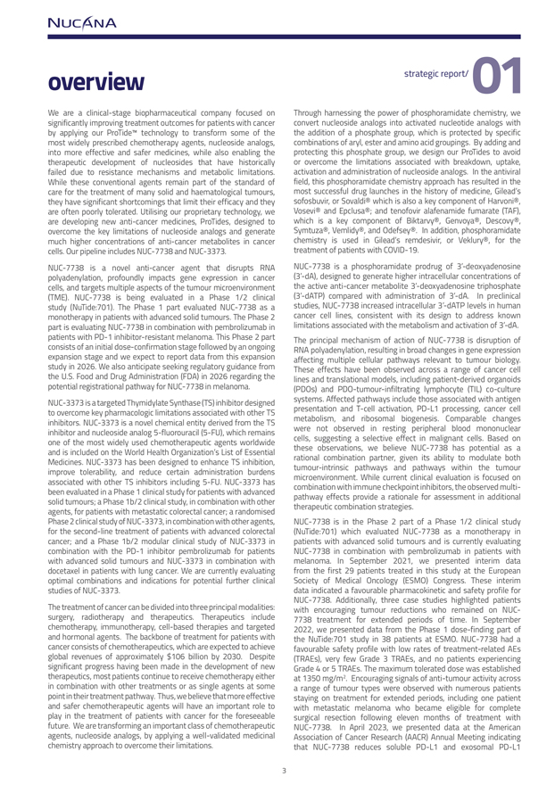
overview strategic report/ 01We are a clinical-stage biopharmaceutical company focused on Through harnessing the power of phosphoramidate chemistry, we significantly improving treatment outcomes for patients with cancer convert nucleoside analogs into activated nucleotide analogs with by applying our ProTide technology to transform some of the the addition of a phosphate group, which is protected by specific most widely prescribed chemotherapy agents, nucleoside analogs, combinations of aryl, ester and amino acid groupings. By adding and into more effective and safer medicines, while also enabling the protecting this phosphate group, we design our ProTides to avoid therapeutic development of nucleosides that have historically or overcome the limitations associated with breakdown, uptake, failed due to resistance mechanisms and metabolic limitations. activation and administration of nucleoside analogs. In the antiviral While these conventional agents remain part of the standard of field, this phosphoramidate chemistry approach has resulted in the care for the treatment of many solid and haematological tumours, most successful drug launches in the history of medicine, Gilead’s they have significant shortcomings that limit their efficacy and they sofosbuvir, or Sovaldi® which is also a key component of Harvoni®, are often poorly tolerated. Utilising our proprietary technology, we Vosevi® and Epclusa®; and tenofovir alafenamide fumarate (TAF), are developing new anti-cancer medicines, ProTides, designed to which is a key component of Biktarvy®, Genvoya®, Descovy®, overcome the key limitations of nucleoside analogs and generate Symtuza®, Vemlidy®, and Odefsey®. In addition, phosphoramidate much higher concentrations of anti-cancer metabolites in cancer chemistry is used in Gilead’s remdesivir, or Veklury®, for the cells. Our pipeline includes NUC-7738 and NUC-3373. treatment of patients with COVID-19.NUC-7738 is a novel anti-cancer agent that disrupts RNA NUC-7738 is a phosphoramidate prodrug of 3’-deoxyadenosine polyadenylation, profoundly impacts gene expression in cancer (3’-dA), designed to generate higher intracellular concentrations of cells, and targets multiple aspects of the tumour microenvironment the active anti-cancer metabolite 3’-deoxyadenosine triphosphate (TME). NUC-7738 is being evaluated in a Phase 1/2 clinical (3’-dATP) compared with administration of 3’-dA. In preclinical study (NuTide:701). The Phase 1 part evaluated NUC-7738 as a studies, NUC-7738 increased intracellular 3’-dATP levels in human monotherapy in patients with advanced solid tumours. The Phase 2 cancer cell lines, consistent with its design to address known part is evaluating NUC-7738 in combination with pembrolizumab in limitations associated with the metabolism and activation of 3’-dA. patients with PD-1 inhibitor-resistant melanoma. This Phase 2 part The principal mechanism of action of NUC-7738 is disruption of consists of an initial dose-confirmation stage followed by an ongoing RNA polyadenylation, resulting in broad changes in gene expression expansion stage and we expect to report data from this expansion affecting multiple cellular pathways relevant to tumour biology. study in 2026. We also anticipate seeking regulatory guidance from These effects have been observed across a range of cancer cell the U.S. Food and Drug Administration (FDA) in 2026 regarding the lines and translational models, including patient-derived organoids potential registrational pathway for NUC-7738 in melanoma. (PDOs) and PDO-tumour-infiltrating lymphocyte (TIL) co-culture NUC-3373 is a targeted Thymidylate Synthase (TS) inhibitor designed systems. Affected pathways include those associated with antigen to overcome key pharmacologic limitations associated with other TS presentation and T-cell activation, PD-L1 processing, cancer cell inhibitors. NUC-3373 is a novel chemical entity derived from the TS metabolism, and ribosomal biogenesis. Comparable changes inhibitor and nucleoside analog 5-fluorouracil (5-FU), which remains were not observed in resting peripheral blood mononuclear one of the most widely used chemotherapeutic agents worldwide cells, suggesting a selective effect in malignant cells. Based on and is included on the World Health Organization’s List of Essential these observations, we believe NUC-7738 has potential as a Medicines. NUC-3373 has been designed to enhance TS inhibition, rational combination partner, given its ability to modulate both tumour-intrinsic pathways and pathways within the tumour improve tolerability, and reduce certain administration burdens microenvironment. While current clinical evaluation is focused on associated with other TS inhibitors including 5-FU. NUC-3373 has combination with immune checkpoint inhibitors, the observed multi-been evaluated in a Phase 1 clinical study for patients with advanced pathway effects provide a rationale for assessment in additional solid tumours; a Phase 1b/2 clinical study, in combination with other therapeutic combination strategies. agents, for patients with metastatic colorectal cancer; a randomised Phase 2 clinical study of NUC-3373, in combination with other agents, NUC-7738 is in the Phase 2 part of a Phase 1/2 clinical study for the second-line treatment of patients with advanced colorectal (NuTide:701) which evaluated NUC-7738 as a monotherapy in cancer; and a Phase 1b/2 modular clinical study of NUC-3373 in patients with advanced solid tumours and is currently evaluating combination with the PD-1 inhibitor pembrolizumab for patients NUC-7738 in combination with pembrolizumab in patients with with advanced solid tumours and NUC-3373 in combination with melanoma. In September 2021, we presented interim data docetaxel in patients with lung cancer. We are currently evaluating from the first 29 patients treated in this study at the European optimal combinations and indications for potential further clinical Society of Medical Oncology (ESMO) Congress. These interim studies of NUC-3373. data indicated a favourable pharmacokinetic and safety profile for NUC-7738. Additionally, three case studies highlighted patients The treatment of cancer can be divided into three principal modalities: with encouraging tumour reductions who remained on NUC-surgery, radiotherapy and therapeutics. Therapeutics include 7738 treatment for extended periods of time. In September chemotherapy, immunotherapy, cell-based therapies and targeted 2022, we presented data from the Phase 1 dose-finding part of and hormonal agents. The backbone of treatment for patients with the NuTide:701 study in 38 patients at ESMO. NUC-7738 had a cancer consists of chemotherapeutics, which are expected to achieve favourable safety profile with low rates of treatment-related AEs global revenues of approximately $106 billion by 2030. Despite (TRAEs), very few Grade 3 TRAEs, and no patients experiencing significant progress having been made in the development of new Grade 4 or 5 TRAEs. The maximum tolerated dose was established therapeutics, most patients continue to receive chemotherapy either at 1350 mg/m2. Encouraging signals of anti-tumour activity across in combination with other treatments or as single agents at some a range of tumour types were observed with numerous patients point in their treatment pathway. Thus, we believe that more effective staying on treatment for extended periods, including one patient and safer chemotherapeutic agents will have an important role to with metastatic melanoma who became eligible for complete play in the treatment of patients with cancer for the foreseeable surgical resection following eleven months of treatment with future. We are transforming an important class of chemotherapeutic NUC-7738. In April 2023, we presented data at the American agents, nucleoside analogs, by applying a well-validated medicinal Association of Cancer Research (AACR) Annual Meeting indicating chemistry approach to overcome their limitations. that NUC-7738 reduces soluble PD-L1 and exosomal PD-L1

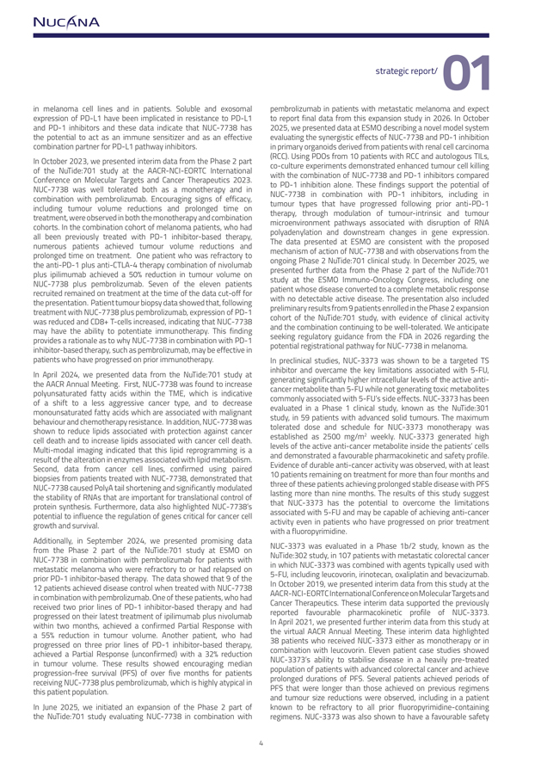
strategic report/ 01 in melanoma cell lines and in patients. Soluble and exosomal pembrolizumab in patients with metastatic melanoma and expect expression of PD-L1 have been implicated in resistance to PD-L1 to report final data from this expansion study in 2026. In October and PD-1 inhibitors and these data indicate that NUC-7738 has 2025, we presented data at ESMO describing a novel model system the potential to act as an immune sensitizer and as an effective evaluating the synergistic effects of NUC-7738 and PD-1 inhibition combination partner for PD-L1 pathway inhibitors. in primary organoids derived from patients with renal cell carcinoma (RCC). Using PDOs from 10 patients with RCC and autologous TILs, In October 2023, we presented interim data from the Phase 2 part co-culture experiments demonstrated enhanced tumour cell killing of the NuTide:701 study at the AACR-NCI-EORTC International with the combination of NUC-7738 and PD-1 inhibitors compared Conference on Molecular Targets and Cancer Therapeutics 2023. to PD-1 inhibition alone. These findings support the potential of NUC-7738 was well tolerated both as a monotherapy and in NUC-7738 in combination with PD-1 inhibitors, including in combination with pembrolizumab. Encouraging signs of efficacy, tumour types that have progressed following prior anti-PD-1 including tumour volume reductions and prolonged time on therapy, through modulation of tumour-intrinsic and tumour treatment, were observed in both the monotherapy and combination microenvironment pathways associated with disruption of RNA cohorts. In the combination cohort of melanoma patients, who had polyadenylation and downstream changes in gene expression. all been previously treated with PD-1 inhibitor-based therapy, The data presented at ESMO are consistent with the proposed numerous patients achieved tumour volume reductions and mechanism of action of NUC-7738 and with observations from the prolonged time on treatment. One patient who was refractory to ongoing Phase 2 NuTide:701 clinical study. In December 2025, we the anti-PD-1 plus anti-CTLA-4 therapy combination of nivolumab plus ipilimumab achieved a 50% reduction in tumour volume on presented further data from the Phase 2 part of the NuTide:701 NUC-7738 plus pembrolizumab. Seven of the eleven patients study at the ESMO Immuno-Oncology Congress, including one recruited remained on treatment at the time of the data cut-off for patient whose disease converted to a complete metabolic response the presentation. Patient tumour biopsy data showed that, following with no detectable active disease. The presentation also included treatment with NUC-7738 plus pembrolizumab, expression of PD-1 preliminary results from 9 patients enrolled in the Phase 2 expansion was reduced and CD8+ T-cells increased, indicating that NUC-7738 cohort of the NuTide:701 study, with evidence of clinical activity may have the ability to potentiate immunotherapy. This finding and the combination continuing to be well-tolerated. We anticipate provides a rationale as to why NUC-7738 in combination with PD-1 seeking regulatory guidance from the FDA in 2026 regarding the inhibitor-based therapy, such as pembrolizumab, may be effective in potential registrational pathway for NUC-7738 in melanoma. patients who have progressed on prior immunotherapy. In preclinical studies, NUC-3373 was shown to be a targeted TS inhibitor and overcame the key limitations associated with 5-FU, In April 2024, we presented data from the NuTide:701 study at generating significantly higher intracellular levels of the active antithe AACR Annual Meeting. First, NUC-7738 was found to increase cancer metabolite than 5-FU while not generating toxic metabolites polyunsaturated fatty acids within the TME, which is indicative commonly associated with 5-FU’s side effects. NUC-3373 has been of a shift to a less aggressive cancer type, and to decrease monounsaturated fatty acids which are associated with malignant evaluated in a Phase 1 clinical study, known as the NuTide:301 behaviour and chemotherapy resistance. In addition, NUC-7738 was study, in 59 patients with advanced solid tumours. The maximum shown to reduce lipids associated with protection against cancer tolerated dose and schedule for NUC-3373 monotherapy was established as 2500 mg/m2 weekly. NUC-3373 generated high cell death and to increase lipids associated with cancer cell death. Multi-modal imaging indicated that this lipid reprogramming is a levels of the active anti-cancer metabolite inside the patients’ cells result of the alteration in enzymes associated with lipid metabolism. and demonstrated a favourable pharmacokinetic and safety profile. Second, data from cancer cell lines, confirmed using paired Evidence of durable anti-cancer activity was observed, with at least biopsies from patients treated with NUC-7738, demonstrated that 10 patients remaining on treatment for more than four months and NUC-7738 caused PolyA tail shortening and significantly modulated three of these patients achieving prolonged stable disease with PFS the stability of RNAs that are important for translational control of lasting more than nine months. The results of this study suggest protein synthesis. Furthermore, data also highlighted NUC-7738’s that NUC-3373 has the potential to overcome the limitations potential to influence the regulation of genes critical for cancer cell associated with 5-FU and may be capable of achieving anti-cancer growth and survival. activity even in patients who have progressed on prior treatment with a fluoropyrimidine.Additionally, in September 2024, we presented promising data from the Phase 2 part of the NuTide:701 study at ESMO on NUC-3373 was evaluated in a Phase 1b/2 study, known as the NUC-7738 in combination with pembrolizumab for patients with NuTide:302 study, in 107 patients with metastatic colorectal cancer metastatic melanoma who were refractory to or had relapsed on in which NUC-3373 was combined with agents typically used with prior PD-1 inhibitor-based therapy. The data showed that 9 of the 5-FU, including leucovorin, irinotecan, oxaliplatin and bevacizumab. 12 patients achieved disease control when treated with NUC-7738 In October 2019, we presented interim data from this study at the in combination with pembrolizumab. One of these patients, who had AACR-NCI-EORTC International Conference on Molecular Targets and received two prior lines of PD-1 inhibitor-based therapy and had Cancer Therapeutics. These interim data supported the previously progressed on their latest treatment of ipilimumab plus nivolumab reported favourable pharmacokinetic profile of NUC-3373. within two months, achieved a confirmed Partial Response with In April 2021, we presented further interim data from this study at a 55% reduction in tumour volume. Another patient, who had the virtual AACR Annual Meeting. These interim data highlighted progressed on three prior lines of PD-1 inhibitor-based therapy, 38 patients who received NUC-3373 either as monotherapy or in achieved a Partial Response (unconfirmed) with a 32% reduction combination with leucovorin. Eleven patient case studies showed in tumour volume. These results showed encouraging median NUC-3373’s ability to stabilise disease in a heavily pre-treated progression-free survival (PFS) of over five months for patients population of patients with advanced colorectal cancer and achieve receiving NUC-7738 plus pembrolizumab, which is highly atypical in prolonged durations of PFS. Several patients achieved periods of this patient population. PFS that were longer than those achieved on previous regimens and tumour size reductions were observed, including in a patient In June 2025, we initiated an expansion of the Phase 2 part of known to be refractory to all prior fluoropyrimidine-containing the NuTide:701 study evaluating NUC-7738 in combination with regimens. NUC-3373 was also shown to have a favourable safety

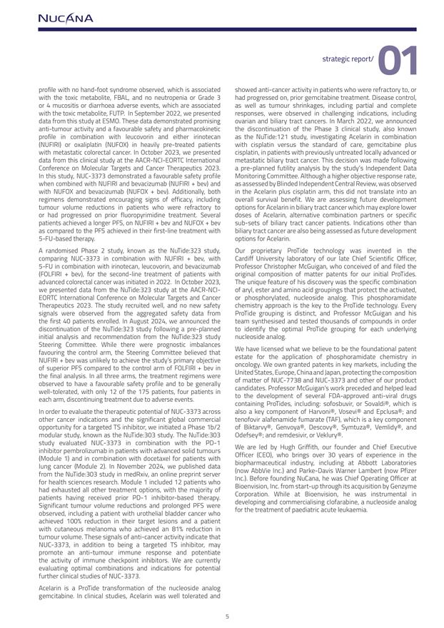
strategic report/ 01 profile with no hand-foot syndrome observed, which is associated showed anti-cancer activity in patients who were refractory to, or with the toxic metabolite, FBAL, and no neutropenia or Grade 3 had progressed on, prior gemcitabine treatment. Disease control, or 4 mucositis or diarrhoea adverse events, which are associated as well as tumour shrinkages, including partial and complete with the toxic metabolite, FUTP. In September 2022, we presented responses, were observed in challenging indications, including data from this study at ESMO. These data demonstrated promising ovarian and biliary tract cancers. In March 2022, we announced anti-tumour activity and a favourable safety and pharmacokinetic the discontinuation of the Phase 3 clinical study, also known profile in combination with leucovorin and either irinotecan as the NuTide:121 study, investigating Acelarin in combination (NUFIRI) or oxaliplatin (NUFOX) in heavily pre-treated patients with cisplatin versus the standard of care, gemcitabine plus with metastatic colorectal cancer. In October 2023, we presented cisplatin, in patients with previously untreated locally advanced or data from this clinical study at the AACR-NCI-EORTC International metastatic biliary tract cancer. This decision was made following Conference on Molecular Targets and Cancer Therapeutics 2023. a pre-planned futility analysis by the study’s Independent Data In this study, NUC-3373 demonstrated a favourable safety profile Monitoring Committee. Although a higher objective response rate, when combined with NUFIRI and bevacizumab (NUFIRI + bev) and as assessed by Blinded Independent Central Review, was observed with NUFOX and bevacizumab (NUFOX + bev). Additionally, both in the Acelarin plus cisplatin arm, this did not translate into an regimens demonstrated encouraging signs of efficacy, including overall survival benefit. We are assessing future development tumour volume reductions in patients who were refractory to options for Acelarin in biliary tract cancer which may explore lower or had progressed on prior fluoropyrimidine treatment. Several doses of Acelarin, alternative combination partners or specific patients achieved a longer PFS, on NUFIRI + bev and NUFOX + bev sub-sets of biliary tract cancer patients. Indications other than as compared to the PFS achieved in their first-line treatment with biliary tract cancer are also being assessed as future development 5-FU-based therapy. options for Acelarin.A randomised Phase 2 study, known as the NuTide:323 study, Our proprietary ProTide technology was invented in the comparing NUC-3373 in combination with NUFIRI + bev, with Cardiff University laboratory of our late Chief Scientific Officer, 5-FU in combination with irinotecan, leucovorin, and bevacizumab Professor Christopher McGuigan, who conceived of and filed the (FOLFIRI + bev), for the second-line treatment of patients with original composition of matter patents for our initial ProTides. advanced colorectal cancer was initiated in 2022. In October 2023, The unique feature of his discovery was the specific combination we presented data from the NuTide:323 study at the AACR-NCI- of aryl, ester and amino acid groupings that protect the activated, EORTC International Conference on Molecular Targets and Cancer or phosphorylated, nucleoside analog. This phosphoramidate Therapeutics 2023. The study recruited well, and no new safety chemistry approach is the key to the ProTide technology. Every signals were observed from the aggregated safety data from ProTide grouping is distinct, and Professor McGuigan and his the first 40 patients enrolled. In August 2024, we announced the team synthesised and tested thousands of compounds in order discontinuation of the NuTide:323 study following a pre-planned to identify the optimal ProTide grouping for each underlying initial analysis and recommendation from the NuTide:323 study nucleoside analog.Steering Committee. While there were prognostic imbalances favouring the control arm, the Steering Committee believed that We have licensed what we believe to be the foundational patent NUFIRI + bev was unlikely to achieve the study’s primary objective estate for the application of phosphoramidate chemistry in of superior PFS compared to the control arm of FOLFIRI + bev in oncology. We own granted patents in key markets, including the the final analysis. In all three arms, the treatment regimens were United States, Europe, China and Japan, protecting the composition observed to have a favourable safety profile and to be generally of matter of NUC-7738 and NUC-3373 and other of our product well-tolerated, with only 12 of the 175 patients, four patients in candidates. Professor McGuigan’s work preceded and helped lead each arm, discontinuing treatment due to adverse events. to the development of several FDA-approved anti-viral drugs containing ProTides, including: sofosbuvir, or Sovaldi®, which is In order to evaluate the therapeutic potential of NUC-3373 across also a key component of Harvoni®, Vosevi® and Epclusa®; and other cancer indications and the significant global commercial tenofovir alafenamide fumarate (TAF), which is a key component opportunity for a targeted TS inhibitor, we initiated a Phase 1b/2 of Biktarvy®, Genvoya®, Descovy®, Symtuza®, Vemlidy®, and modular study, known as the NuTide:303 study. The NuTide:303 Odefsey®; and remdesivir, or Veklury®. study evaluated NUC-3373 in combination with the PD-1 inhibitor pembrolizumab in patients with advanced solid tumours We are led by Hugh Griffith, our founder and Chief Executive (Module 1) and in combination with docetaxel for patients with Officer (CEO), who brings over 30 years of experience in the lung cancer (Module 2). In November 2024, we published data biopharmaceutical industry, including at Abbott Laboratories from the NuTide:303 study in medRxiv, an online preprint server (now AbbVie Inc.) and Parke-Davis Warner Lambert (now Pfizer for health sciences research. Module 1 included 12 patients who Inc.). Before founding NuCana, he was Chief Operating Officer at had exhausted all other treatment options, with the majority of Bioenvision, Inc. from start-up through its acquisition by Genzyme patients having received prior PD-1 inhibitor-based therapy. Corporation. While at Bioenvision, he was instrumental in Significant tumour volume reductions and prolonged PFS were developing and commercialising clofarabine, a nucleoside analog observed, including a patient with urothelial bladder cancer who for the treatment of paediatric acute leukaemia. achieved 100% reduction in their target lesions and a patient with cutaneous melanoma who achieved an 81% reduction in tumour volume. These signals of anti-cancer activity indicate that NUC-3373, in addition to being a targeted TS inhibitor, may promote an anti-tumour immune response and potentiate the activity of immune checkpoint inhibitors. We are currently evaluating optimal combinations and indications for potential further clinical studies of NUC-3373.Acelarin is a ProTide transformation of the nucleoside analog gemcitabine. In clinical studies, Acelarin was well tolerated and

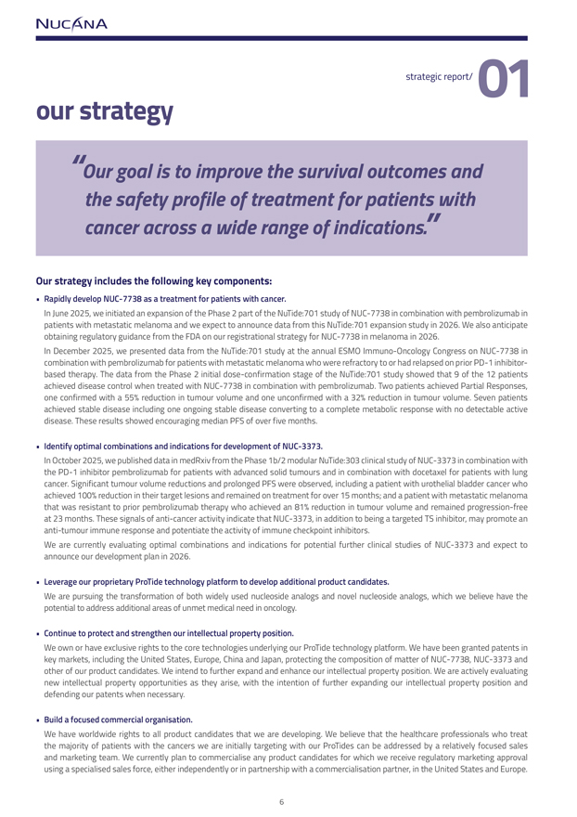
strategic report/ 01our strategy“Our goal is to improve the survival outcomes and the safety profile of treatment for patients with cancer across a wide range of indications.” Our strategy includes the following key components:  Rapidly develop NUC-7738 as a treatment for patients with cancer. In June 2025, we initiated an expansion of the Phase 2 part of the NuTide:701 study of NUC-7738 in combination with pembrolizumab in patients with metastatic melanoma and we expect to announce data from this NuTide:701 expansion study in 2026. We also anticipate obtaining regulatory guidance from the FDA on our registrational strategy for NUC-7738 in melanoma in 2026.In December 2025, we presented data from the NuTide:701 study at the annual ESMO Immuno-Oncology Congress on NUC-7738 in combination with pembrolizumab for patients with metastatic melanoma who were refractory to or had relapsed on prior PD-1 inhibitor-based therapy. The data from the Phase 2 initial dose-confirmation stage of the NuTide:701 study showed that 9 of the 12 patients achieved disease control when treated with NUC-7738 in combination with pembrolizumab. Two patients achieved Partial Responses, one confirmed with a 55% reduction in tumour volume and one unconfirmed with a 32% reduction in tumour volume. Seven patients achieved stable disease including one ongoing stable disease converting to a complete metabolic response with no detectable active disease. These results showed encouraging median PFS of over five months. Identify optimal combinations and indications for development of NUC-3373. In October 2025, we published data in medRxiv from the Phase 1b/2 modular NuTide:303 clinical study of NUC-3373 in combination with the PD-1 inhibitor pembrolizumab for patients with advanced solid tumours and in combination with docetaxel for patients with lung cancer. Significant tumour volume reductions and prolonged PFS were observed, including a patient with urothelial bladder cancer who achieved 100% reduction in their target lesions and remained on treatment for over 15 months; and a patient with metastatic melanoma that was resistant to prior pembrolizumab therapy who achieved an 81% reduction in tumour volume and remained progression-free at 23 months. These signals of anti-cancer activity indicate that NUC-3373, in addition to being a targeted TS inhibitor, may promote an anti-tumour immune response and potentiate the activity of immune checkpoint inhibitors.We are currently evaluating optimal combinations and indications for potential further clinical studies of NUC-3373 and expect to announce our development plan in 2026. Leverage our proprietary ProTide technology platform to develop additional product candidates. We are pursuing the transformation of both widely used nucleoside analogs and novel nucleoside analogs, which we believe have the potential to address additional areas of unmet medical need in oncology. Continue to protect and strengthen our intellectual property position. We own or have exclusive rights to the core technologies underlying our ProTide technology platform. We have been granted patents in key markets, including the United States, Europe, China and Japan, protecting the composition of matter of NUC-7738, NUC-3373 and other of our product candidates. We intend to further expand and enhance our intellectual property position. We are actively evaluating new intellectual property opportunities as they arise, with the intention of further expanding our intellectual property position and defending our patents when necessary. Build a focused commercial organisation. We have worldwide rights to all product candidates that we are developing. We believe that the healthcare professionals who treat the majority of patients with the cancers we are initially targeting with our ProTides can be addressed by a relatively focused sales and marketing team. We currently plan to commercialise any product candidates for which we receive regulatory marketing approval using a specialised sales force, either independently or in partnership with a commercialisation partner, in the United States and Europe.

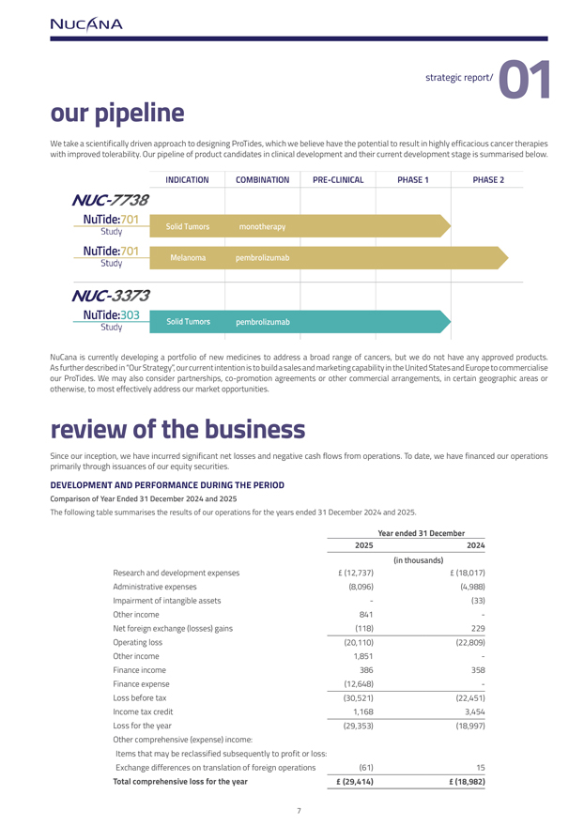
strategic report/ 01our pipelineWe take a scientifically driven approach to designing ProTides, which we believe have the potential to result in highly efficacious cancer therapies with improved tolerability. Our pipeline of product candidates in clinical development and their current development stage is summarised below.NuCana is currently developing a portfolio of new medicines to address a broad range of cancers, but we do not have any approved products. As further described in “Our Strategy”, our current intention is to build a sales and marketing capability in the United States and Europe to commercialise our ProTides. We may also consider partnerships, co-promotion agreements or other commercial arrangements, in certain geographic areas or otherwise, to most effectively address our market opportunities.review of the businessSince our inception, we have incurred significant net losses and negative cash flows from operations. To date, we have financed our operations primarily through issuances of our equity securities.DEVELOPMENT AND PERFORMANCE DURING THE PERIODComparison of Year Ended 31 December 2024 and 2025The following table summarises the results of our operations for the years ended 31 December 2024 and 2025.20252024(in thousands)Research and development expenses£ (12,737)£ (18,017)Administrative expenses(8,096)(4,988)Impairment of intangible assets-(33)Other income841-Net foreign exchange (losses) gains(118)229Operating loss(20,110)(22,809)Other income1,851-Finance income386358Finance expense(12,648)-Loss before tax(30,521)(22,451)Income tax credit1,1683,454Loss for the year(29,353)(18,997)Other comprehensive (expense) income:Items that may be reclassified subsequently to profit or loss:Exchange differences on translation of foreign operations(61)15Total comprehensive loss for the year£ (29,414)£ (18,982)

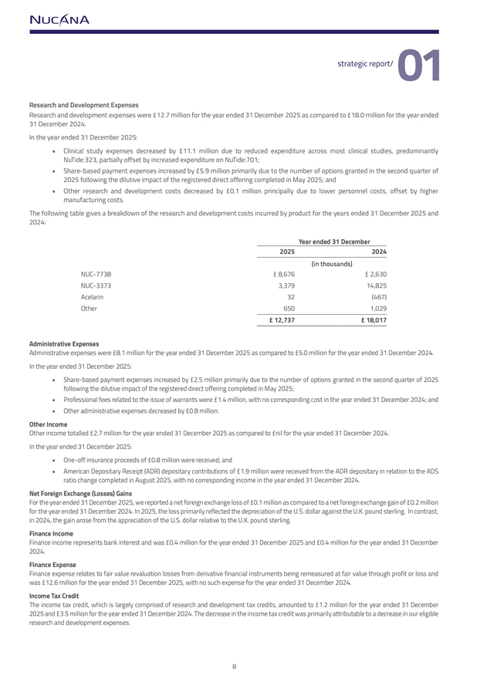
strategic report/ 01Research and Development Expenses Research and development expenses were £12.7 million for the year ended 31 December 2025 as compared to £18.0 million for the year ended 31 December 2024.In the year ended 31 December 2025:  Clinical study expenses decreased by £11.1 million due to reduced expenditure across most clinical studies, predominantly NuTide:323, partially offset by increased expenditure on NuTide:701;  Share-based payment expenses increased by £5.9 million primarily due to the number of options granted in the second quarter of 2025 following the dilutive impact of the registered direct offering completed in May 2025; and  Other research and development costs decreased by £0.1 million principally due to lower personnel costs, offset by higher manufacturing costs.The following table gives a breakdown of the research and development costs incurred by product for the years ended 31 December 2025 and 2024: Year ended 31 December 2025 2024 (in thousands)NUC-7738 £ 8,676£ 2,630NUC-33733,37914,825Acelarin32(467)Other6501,029£ 12,737 £ 18,017Administrative Expenses Administrative expenses were £8.1 million for the year ended 31 December 2025 as compared to £5.0 million for the year ended 31 December 2024. In the year ended 31 December 2025:  Share-based payment expenses increased by £2.5 million primarily due to the number of options granted in the second quarter of 2025 following the dilutive impact of the registered direct offering completed in May 2025;  Professional fees related to the issue of warrants were £1.4 million, with no corresponding cost in the year ended 31 December 2024; and  Other administrative expenses decreased by £0.8 million.Other Income Other income totalled £2.7 million for the year ended 31 December 2025 as compared to £nil for the year ended 31 December 2024. In the year ended 31 December 2025:  One-off insurance proceeds of £0.8 million were received; and  American Depositary Receipt (ADR) depositary contributions of £1.9 million were received from the ADR depositary in relation to the ADS ratio change completed in August 2025, with no corresponding income in the year ended 31 December 2024.Net Foreign Exchange (Losses) Gains For the year ended 31 December 2025, we reported a net foreign exchange loss of £0.1 million as compared to a net foreign exchange gain of £0.2 million for the year ended 31 December 2024. In 2025, the loss primarily reflected the depreciation of the U.S. dollar against the U.K. pound sterling. In contrast, in 2024, the gain arose from the appreciation of the U.S. dollar relative to the U.K. pound sterling.Finance IncomeFinance income represents bank interest and was £0.4 million for the year ended 31 December 2025 and £0.4 million for the year ended 31 December 2024. Finance ExpenseFinance expense relates to fair value revaluation losses from derivative financial instruments being remeasured at fair value through profit or loss and was £12.6 million for the year ended 31 December 2025, with no such expense for the year ended 31 December 2024.Income Tax Credit The income tax credit, which is largely comprised of research and development tax credits, amounted to £1.2 million for the year ended 31 December 2025 and £3.5 million for the year ended 31 December 2024. The decrease in the income tax credit was primarily attributable to a decrease in our eligible research and development expenses.

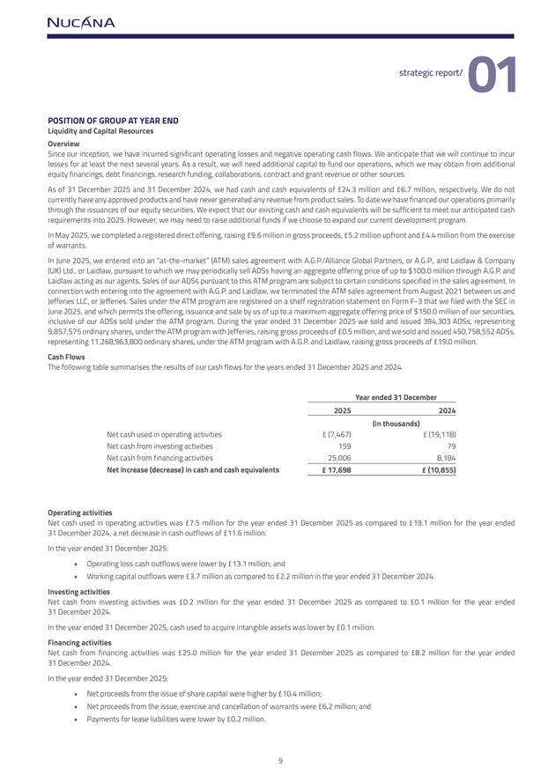
strategic report/ 01POSITION OF GROUP AT YEAR ENDLiquidity and Capital Resources Overview Since our inception, we have incurred significant operating losses and negative operating cash flows. We anticipate that we will continue to incur losses for at least the next several years. As a result, we will need additional capital to fund our operations, which we may obtain from additional equity financings, debt financings, research funding, collaborations, contract and grant revenue or other sources.As of 31 December 2025 and 31 December 2024, we had cash and cash equivalents of £24.3 million and £6.7 million, respectively. We do not currently have any approved products and have never generated any revenue from product sales. To date we have financed our operations primarily through the issuances of our equity securities. We expect that our existing cash and cash equivalents will be sufficient to meet our anticipated cash requirements into 2029. However, we may need to raise additional funds if we choose to expand our current development program.In May 2025, we completed a registered direct offering, raising £9.6 million in gross proceeds, £5.2 million upfront and £4.4 million from the exercise of warrants.In June 2025, we entered into an “at-the-market” (ATM) sales agreement with A.G.P./Alliance Global Partners, or A.G.P., and Laidlaw & Company (UK) Ltd., or Laidlaw, pursuant to which we may periodically sell ADSs having an aggregate offering price of up to $100.0 million through A.G.P. and Laidlaw acting as our agents. Sales of our ADSs pursuant to this ATM program are subject to certain conditions specified in the sales agreement. In connection with entering into the agreement with A.G.P. and Laidlaw, we terminated the ATM sales agreement from August 2021 between us and Jefferies LLC, or Jefferies. Sales under the ATM program are registered on a shelf registration statement on Form F-3 that we filed with the SEC in June 2025, and which permits the offering, issuance and sale by us of up to a maximum aggregate offering price of $150.0 million of our securities, inclusive of our ADSs sold under the ATM program. During the year ended 31 December 2025 we sold and issued 394,303 ADSs, representing 9,857,575 ordinary shares, under the ATM program with Jefferies, raising gross proceeds of £0.5 million, and we sold and issued 450,758,552 ADSs, representing 11,268,963,800 ordinary shares, under the ATM program with A.G.P. and Laidlaw, raising gross proceeds of £19.0 million. Cash Flows The following table summarises the results of our cash flows for the years ended 31 December 2025 and 2024. Year ended 31 December 2025 2024 (in thousands)Net cash used in operating activities £ (7,467)£ (19,118)Net cash from investing activities15979Net cash from financing activities25,0068,184Net increase (decrease) in cash and cash equivalents £ 17,698 £ (10,855)Operating activities Net cash used in operating activities was £7.5 million for the year ended 31 December 2025 as compared to £19.1 million for the year ended 31 December 2024, a net decrease in cash outflows of £11.6 million.In the year ended 31 December 2025:  Operating loss cash outflows were lower by £13.1 million; and  Working capital outflows were £3.7 million as compared to £2.2 million in the year ended 31 December 2024. Investing activities Net cash from investing activities was £0.2 million for the year ended 31 December 2025 as compared to £0.1 million for the year ended 31 December 2024. In the year ended 31 December 2025, cash used to acquire intangible assets was lower by £0.1 million. Financing activitiesNet cash from financing activities was £25.0 million for the year ended 31 December 2025 as compared to £8.2 million for the year ended 31 December 2024.In the year ended 31 December 2025:  Net proceeds from the issue of share capital were higher by £10.4 million;  Net proceeds from the issue, exercise and cancellation of warrants were £6.2 million; and  Payments for lease liabilities were lower by £0.2 million.

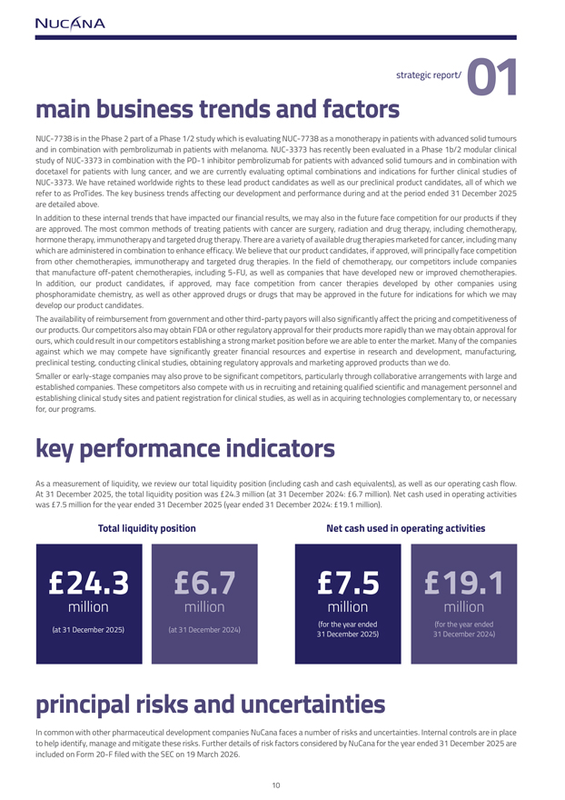
strategic report/ 01main business trends and factorsNUC-7738 is in the Phase 2 part of a Phase 1/2 study which is evaluating NUC-7738 as a monotherapy in patients with advanced solid tumours and in combination with pembrolizumab in patients with melanoma. NUC-3373 has recently been evaluated in a Phase 1b/2 modular clinical study of NUC-3373 in combination with the PD-1 inhibitor pembrolizumab for patients with advanced solid tumours and in combination with docetaxel for patients with lung cancer, and we are currently evaluating optimal combinations and indications for further clinical studies of NUC-3373. We have retained worldwide rights to these lead product candidates as well as our preclinical product candidates, all of which we refer to as ProTides. The key business trends affecting our development and performance during and at the period ended 31 December 2025 are detailed above.In addition to these internal trends that have impacted our financial results, we may also in the future face competition for our products if they are approved. The most common methods of treating patients with cancer are surgery, radiation and drug therapy, including chemotherapy, hormone therapy, immunotherapy and targeted drug therapy. There are a variety of available drug therapies marketed for cancer, including many which are administered in combination to enhance efficacy. We believe that our product candidates, if approved, will principally face competition from other chemotherapies, immunotherapy and targeted drug therapies. In the field of chemotherapy, our competitors include companies that manufacture off-patent chemotherapies, including 5-FU, as well as companies that have developed new or improved chemotherapies. In addition, our product candidates, if approved, may face competition from cancer therapies developed by other companies using phosphoramidate chemistry, as well as other approved drugs or drugs that may be approved in the future for indications for which we may develop our product candidates.The availability of reimbursement from government and other third-party payors will also significantly affect the pricing and competitiveness of our products. Our competitors also may obtain FDA or other regulatory approval for their products more rapidly than we may obtain approval for ours, which could result in our competitors establishing a strong market position before we are able to enter the market. Many of the companies against which we may compete have significantly greater financial resources and expertise in research and development, manufacturing, preclinical testing, conducting clinical studies, obtaining regulatory approvals and marketing approved products than we do.Smaller or early-stage companies may also prove to be significant competitors, particularly through collaborative arrangements with large and established companies. These competitors also compete with us in recruiting and retaining qualified scientific and management personnel and establishing clinical study sites and patient registration for clinical studies, as well as in acquiring technologies complementary to, or necessary for, our programs.key performance indicatorsAs a measurement of liquidity, we review our total liquidity position (including cash and cash equivalents), as well as our operating cash flow. At 31 December 2025, the total liquidity position was £24.3 million (at 31 December 2024: £6.7 million). Net cash used in operating activities was £7.5 million for the year ended 31 December 2025 (year ended 31 December 2024: £19.1 million).Total liquidity position Net cash used in operating activities£24.3 £6.7 £7.5 £19.1million million million million(for the year ended (for the year ended (at 31 December 2025) (at 31 December 2024)31 December 2025) 31 December 2024)principal risks and uncertaintiesIn common with other pharmaceutical development companies NuCana faces a number of risks and uncertainties. Internal controls are in place to help identify, manage and mitigate these risks. Further details of risk factors considered by NuCana for the year ended 31 December 2025 are included on Form 20-F filed with the SEC on 19 March 2026.

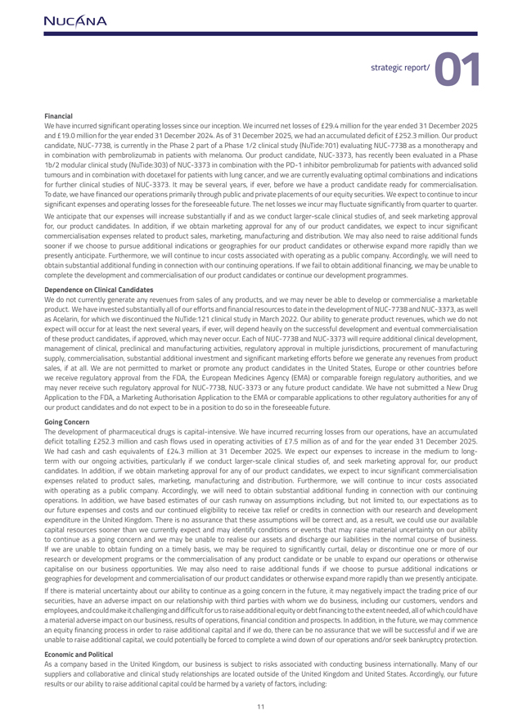
strategic report/ 01FinancialWe have incurred significant operating losses since our inception. We incurred net losses of £29.4 million for the year ended 31 December 2025 and £19.0 million for the year ended 31 December 2024. As of 31 December 2025, we had an accumulated deficit of £252.3 million. Our product candidate, NUC-7738, is currently in the Phase 2 part of a Phase 1/2 clinical study (NuTide:701) evaluating NUC-7738 as a monotherapy and in combination with pembrolizumab in patients with melanoma. Our product candidate, NUC-3373, has recently been evaluated in a Phase 1b/2 modular clinical study (NuTide:303) of NUC-3373 in combination with the PD-1 inhibitor pembrolizumab for patients with advanced solid tumours and in combination with docetaxel for patients with lung cancer, and we are currently evaluating optimal combinations and indications for further clinical studies of NUC-3373. It may be several years, if ever, before we have a product candidate ready for commercialisation. To date, we have financed our operations primarily through public and private placements of our equity securities. We expect to continue to incur significant expenses and operating losses for the foreseeable future. The net losses we incur may fluctuate significantly from quarter to quarter. We anticipate that our expenses will increase substantially if and as we conduct larger-scale clinical studies of, and seek marketing approval for, our product candidates. In addition, if we obtain marketing approval for any of our product candidates, we expect to incur significant commercialisation expenses related to product sales, marketing, manufacturing and distribution. We may also need to raise additional funds sooner if we choose to pursue additional indications or geographies for our product candidates or otherwise expand more rapidly than we presently anticipate. Furthermore, we will continue to incur costs associated with operating as a public company. Accordingly, we will need to obtain substantial additional funding in connection with our continuing operations. If we fail to obtain additional financing, we may be unable to complete the development and commercialisation of our product candidates or continue our development programmes.Dependence on Clinical CandidatesWe do not currently generate any revenues from sales of any products, and we may never be able to develop or commercialise a marketable product. We have invested substantially all of our efforts and financial resources to date in the development of NUC-7738 and NUC-3373, as well as Acelarin, for which we discontinued the NuTide:121 clinical study in March 2022. Our ability to generate product revenues, which we do not expect will occur for at least the next several years, if ever, will depend heavily on the successful development and eventual commercialisation of these product candidates, if approved, which may never occur. Each of NUC-7738 and NUC-3373 will require additional clinical development, management of clinical, preclinical and manufacturing activities, regulatory approval in multiple jurisdictions, procurement of manufacturing supply, commercialisation, substantial additional investment and significant marketing efforts before we generate any revenues from product sales, if at all. We are not permitted to market or promote any product candidates in the United States, Europe or other countries before we receive regulatory approval from the FDA, the European Medicines Agency (EMA) or comparable foreign regulatory authorities, and we may never receive such regulatory approval for NUC-7738, NUC-3373 or any future product candidate. We have not submitted a New Drug Application to the FDA, a Marketing Authorisation Application to the EMA or comparable applications to other regulatory authorities for any of our product candidates and do not expect to be in a position to do so in the foreseeable future. Going ConcernThe development of pharmaceutical drugs is capital-intensive. We have incurred recurring losses from our operations, have an accumulated deficit totalling £252.3 million and cash flows used in operating activities of £7.5 million as of and for the year ended 31 December 2025. We had cash and cash equivalents of £24.3 million at 31 December 2025. We expect our expenses to increase in the medium to long-term with our ongoing activities, particularly if we conduct larger-scale clinical studies of, and seek marketing approval for, our product candidates. In addition, if we obtain marketing approval for any of our product candidates, we expect to incur significant commercialisation expenses related to product sales, marketing, manufacturing and distribution. Furthermore, we will continue to incur costs associated with operating as a public company. Accordingly, we will need to obtain substantial additional funding in connection with our continuing operations. In addition, we have based estimates of our cash runway on assumptions including, but not limited to, our expectations as to our future expenses and costs and our continued eligibility to receive tax relief or credits in connection with our research and development expenditure in the United Kingdom. There is no assurance that these assumptions will be correct and, as a result, we could use our available capital resources sooner than we currently expect and may identify conditions or events that may raise material uncertainty on our ability to continue as a going concern and we may be unable to realise our assets and discharge our liabilities in the normal course of business. If we are unable to obtain funding on a timely basis, we may be required to significantly curtail, delay or discontinue one or more of our research or development programs or the commercialisation of any product candidate or be unable to expand our operations or otherwise capitalise on our business opportunities. We may also need to raise additional funds if we choose to pursue additional indications or geographies for development and commercialisation of our product candidates or otherwise expand more rapidly than we presently anticipate. If there is material uncertainty about our ability to continue as a going concern in the future, it may negatively impact the trading price of our securities, have an adverse impact on our relationship with third parties with whom we do business, including our customers, vendors and employees, and could make it challenging and difficult for us to raise additional equity or debt financing to the extent needed, all of which could have a material adverse impact on our business, results of operations, financial condition and prospects. In addition, in the future, we may commence an equity financing process in order to raise additional capital and if we do, there can be no assurance that we will be successful and if we are unable to raise additional capital, we could potentially be forced to complete a wind down of our operations and/or seek bankruptcy protection.Economic and PoliticalAs a company based in the United Kingdom, our business is subject to risks associated with conducting business internationally. Many of our suppliers and collaborative and clinical study relationships are located outside of the United Kingdom and United States. Accordingly, our future results or our ability to raise additional capital could be harmed by a variety of factors, including:

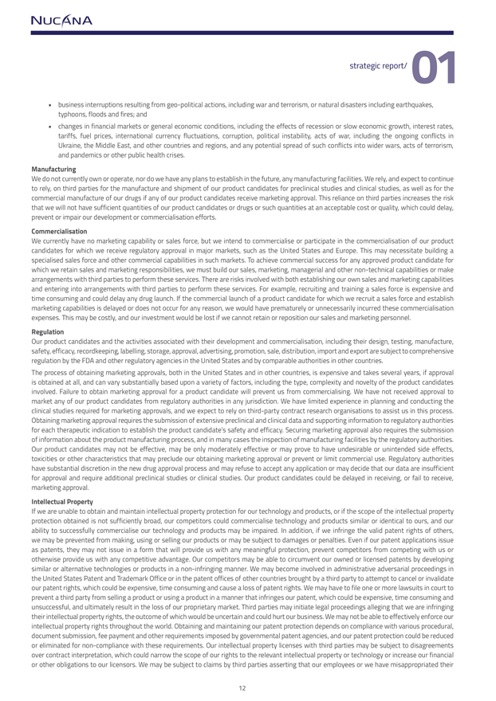
strategic report/ 01  business interruptions resulting from geo-political actions, including war and terrorism, or natural disasters including earthquakes, typhoons, floods and fires; and  changes in financial markets or general economic conditions, including the effects of recession or slow economic growth, interest rates, tariffs, fuel prices, international currency fluctuations, corruption, political instability, acts of war, including the ongoing conflicts in Ukraine, the Middle East, and other countries and regions, and any potential spread of such conflicts into wider wars, acts of terrorism, and pandemics or other public health crises.ManufacturingWe do not currently own or operate, nor do we have any plans to establish in the future, any manufacturing facilities. We rely, and expect to continue to rely, on third parties for the manufacture and shipment of our product candidates for preclinical studies and clinical studies, as well as for the commercial manufacture of our drugs if any of our product candidates receive marketing approval. This reliance on third parties increases the risk that we will not have sufficient quantities of our product candidates or drugs or such quantities at an acceptable cost or quality, which could delay, prevent or impair our development or commercialisation efforts. CommercialisationWe currently have no marketing capability or sales force, but we intend to commercialise or participate in the commercialisation of our product candidates for which we receive regulatory approval in major markets, such as the United States and Europe. This may necessitate building a specialised sales force and other commercial capabilities in such markets. To achieve commercial success for any approved product candidate for which we retain sales and marketing responsibilities, we must build our sales, marketing, managerial and other non-technical capabilities or make arrangements with third parties to perform these services. There are risks involved with both establishing our own sales and marketing capabilities and entering into arrangements with third parties to perform these services. For example, recruiting and training a sales force is expensive and time consuming and could delay any drug launch. If the commercial launch of a product candidate for which we recruit a sales force and establish marketing capabilities is delayed or does not occur for any reason, we would have prematurely or unnecessarily incurred these commercialisation expenses. This may be costly, and our investment would be lost if we cannot retain or reposition our sales and marketing personnel.RegulationOur product candidates and the activities associated with their development and commercialisation, including their design, testing, manufacture, safety, efficacy, recordkeeping, labelling, storage, approval, advertising, promotion, sale, distribution, import and export are subject to comprehensive regulation by the FDA and other regulatory agencies in the United States and by comparable authorities in other countries. The process of obtaining marketing approvals, both in the United States and in other countries, is expensive and takes several years, if approval is obtained at all, and can vary substantially based upon a variety of factors, including the type, complexity and novelty of the product candidates involved. Failure to obtain marketing approval for a product candidate will prevent us from commercialising. We have not received approval to market any of our product candidates from regulatory authorities in any jurisdiction. We have limited experience in planning and conducting the clinical studies required for marketing approvals, and we expect to rely on third-party contract research organisations to assist us in this process. Obtaining marketing approval requires the submission of extensive preclinical and clinical data and supporting information to regulatory authorities for each therapeutic indication to establish the product candidate’s safety and efficacy. Securing marketing approval also requires the submission of information about the product manufacturing process, and in many cases the inspection of manufacturing facilities by the regulatory authorities. Our product candidates may not be effective, may be only moderately effective or may prove to have undesirable or unintended side effects, toxicities or other characteristics that may preclude our obtaining marketing approval or prevent or limit commercial use. Regulatory authorities have substantial discretion in the new drug approval process and may refuse to accept any application or may decide that our data are insufficient for approval and require additional preclinical studies or clinical studies. Our product candidates could be delayed in receiving, or fail to receive, marketing approval.Intellectual PropertyIf we are unable to obtain and maintain intellectual property protection for our technology and products, or if the scope of the intellectual property protection obtained is not sufficiently broad, our competitors could commercialise technology and products similar or identical to ours, and our ability to successfully commercialise our technology and products may be impaired. In addition, if we infringe the valid patent rights of others, we may be prevented from making, using or selling our products or may be subject to damages or penalties. Even if our patent applications issue as patents, they may not issue in a form that will provide us with any meaningful protection, prevent competitors from competing with us or otherwise provide us with any competitive advantage. Our competitors may be able to circumvent our owned or licensed patents by developing similar or alternative technologies or products in a non-infringing manner. We may become involved in administrative adversarial proceedings in the United States Patent and Trademark Office or in the patent offices of other countries brought by a third party to attempt to cancel or invalidate our patent rights, which could be expensive, time consuming and cause a loss of patent rights. We may have to file one or more lawsuits in court to prevent a third party from selling a product or using a product in a manner that infringes our patent, which could be expensive, time consuming and unsuccessful, and ultimately result in the loss of our proprietary market. Third parties may initiate legal proceedings alleging that we are infringing their intellectual property rights, the outcome of which would be uncertain and could hurt our business. We may not be able to effectively enforce our intellectual property rights throughout the world. Obtaining and maintaining our patent protection depends on compliance with various procedural, document submission, fee payment and other requirements imposed by governmental patent agencies, and our patent protection could be reduced or eliminated for non-compliance with these requirements. Our intellectual property licenses with third parties may be subject to disagreements over contract interpretation, which could narrow the scope of our rights to the relevant intellectual property or technology or increase our financial or other obligations to our licensors. We may be subject to claims by third parties asserting that our employees or we have misappropriated their

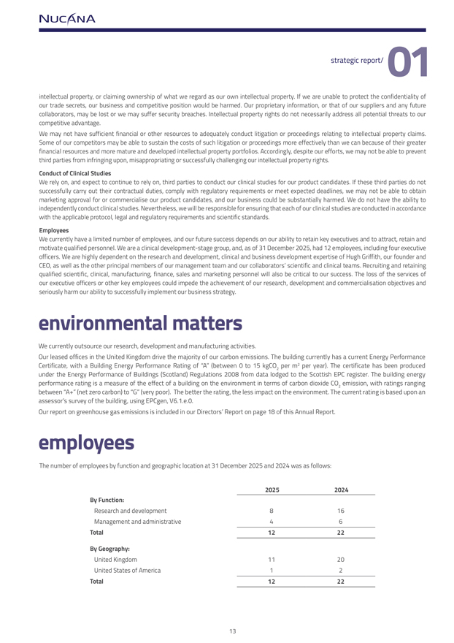

strategic report/ 01 intellectual property, or claiming ownership of what we regard as our own intellectual property. If we are unable to protect the confidentiality of our trade secrets, our business and competitive position would be harmed. Our proprietary information, or that of our suppliers and any future collaborators, may be lost or we may suffer security breaches. Intellectual property rights do not necessarily address all potential threats to our competitive advantage. We may not have sufficient financial or other resources to adequately conduct litigation or proceedings relating to intellectual property claims. Some of our competitors may be able to sustain the costs of such litigation or proceedings more effectively than we can because of their greater financial resources and more mature and developed intellectual property portfolios. Accordingly, despite our efforts, we may not be able to prevent third parties from infringing upon, misappropriating or successfully challenging our intellectual property rights.Conduct of Clinical StudiesWe rely on, and expect to continue to rely on, third parties to conduct our clinical studies for our product candidates. If these third parties do not successfully carry out their contractual duties, comply with regulatory requirements or meet expected deadlines, we may not be able to obtain marketing approval for or commercialise our product candidates, and our business could be substantially harmed. We do not have the ability to independently conduct clinical studies. Nevertheless, we will be responsible for ensuring that each of our clinical studies are conducted in accordance with the applicable protocol, legal and regulatory requirements and scientific standards.EmployeesWe currently have a limited number of employees, and our future success depends on our ability to retain key executives and to attract, retain and motivate qualified personnel. We are a clinical development-stage group, and, as of 31 December 2025, had 12 employees, including four executive officers. We are highly dependent on the research and development, clinical and business development expertise of Hugh Griffith, our founder and CEO, as well as the other principal members of our management team and our collaborators’ scientific and clinical teams. Recruiting and retaining qualified scientific, clinical, manufacturing, finance, sales and marketing personnel will also be critical to our success. The loss of the services of our executive officers or other key employees could impede the achievement of our research, development and commercialisation objectives and seriously harm our ability to successfully implement our business strategy.environmental mattersWe currently outsource our research, development and manufacturing activities.Our leased offices in the United Kingdom drive the majority of our carbon emissions. The building currently has a current Energy Performance Certificate, with a Building Energy Performance Rating of “A” (between 0 to 15 kgCO2 per m2 per year). The certificate has been produced under the Energy Performance of Buildings (Scotland) Regulations 2008 from data lodged to the Scottish EPC register. The building energy performance rating is a measure of the effect of a building on the environment in terms of carbon dioxide CO emission, with ratings ranging 2between “A+” (net zero carbon) to “G” (very poor). The better the rating, the less impact on the environment. The current rating is based upon an assessor’s survey of the building, using EPCgen, V6.1.e.0. Our report on greenhouse gas emissions is included in our Directors’ Report on page 18 of this Annual Report.employeesThe number of employees by function and geographic location at 31 December 2025 and 2024 was as follows: 2025 2024By Function: Research and development816Management and administrative46Total 12 22By Geography: United Kingdom1120United States of America12Total 12 22


strategic report/ 01As of 31 December 2025, we had 10 full-time employees and 2 part-time employees. We have never had a work stoppage and none of our employees are covered by collective bargaining agreements or represented by a labour union. We believe our employee relations are good.DiversityWe make appointments based on merit according to the balance of skills and experience offered by prospective candidates. Whilst acknowledging the benefits of diversity, individual appointments are made irrespective of personal characteristics such as sex, race, disability, gender, sexual orientation, religion or age.A breakdown of the statistics as at 31 December 2025 is as follows:Position Male Female TotalCompany Director 5 - 5Senior Manager 437Other Employees314Total Employees(1) 8 4 12(1) Total Employees includes one Executive Director, the CEO.employee consultation and human rightsWe place considerable value on the involvement of our employees. Meetings are held with employees to discuss the operations and progress of the business and employees are encouraged to become involved in the success of the Group through share option schemes (see note 15 to the financial statements). We endeavour to impact positively on the communities in which we operate. We do not, at present, have a specific policy on human rights. However, we have several policies that promote the principles of human rights, including our Anti-Slavery and Human Trafficking Policy, which governs our zero-tolerance approach to modern slavery and our commitment to acting ethically and with integrity in all our business dealings; and an Anti-Corruption and Bribery Policy in order to reflect our policy to conduct our business in an honest and ethical manner. Our Health & Safety policy sets out our commitment to provision of a safe working environment for our employees. Furthermore, our Equal Opportunities Policy promotes the right of every employee to be treated with dignity and respect and not to be harassed or bullied on any grounds. Accordingly, we have a policy framework in place to ensure that we will respect the human rights of all our employees, including: provision of a safe, clean working environment; ensuring employees are free from discrimination and coercion; not using child or forced labour and respecting the rights of privacy and protecting access and use of employee personal information. This report does not contain information relating to social or community matters as such information is not relevant in understanding our development, performance, or position.section 172(1) statementSection 172 of the Companies Act 2006 requires each of directors to act in the way they consider, in good faith, would be most likely to promote the success of the company for the benefit of its members as a whole, and in doing so, have regard (amongst other matters) to: a) the likely consequences of any decision in the long term; b) the interests of the company’s employees; c) the need to foster the company’s business relationships with suppliers, customers and others; d) the impact of the company’s operations on the community and the environment; e) the desirability of the company maintaining a reputation for high standards of business conduct; and f) the need to act fairly between members of the company. The directors continue to have regard to the interests of our key stakeholders, including our shareholders, holders of ADSs, and employees. The Board recognises its responsibility to take into consideration the needs and concerns of all our stakeholders as part of our discussion and decision-making processes.

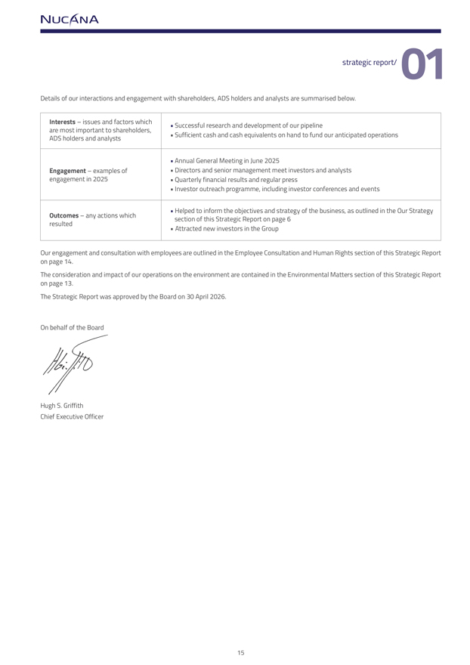
strategic report/ 01Details of our interactions and engagement with shareholders, ADS holders and analysts are summarised below.Interests – issues and factors which  Successful research and development of our pipelineare most important to shareholders, ADS holders and analysts Sufficient cash and cash equivalents on hand to fund our anticipated operations Annual General Meeting in June 2025Engagement – examples of  Directors and senior management meet investors and analystsengagement in 2025  Quarterly financial results and regular press Investor outreach programme, including investor conferences and events  Helped to inform the objectives and strategy of the business, as outlined in the Our StrategyOutcomes – any actions which section of this Strategic Report on page 6resulted Attracted new investors in the GroupOur engagement and consultation with employees are outlined in the Employee Consultation and Human Rights section of this Strategic Report on page 14.The consideration and impact of our operations on the environment are contained in the Environmental Matters section of this Strategic Report on page 13.The Strategic Report was approved by the Board on 30 April 2026.On behalf of the BoardHugh S. Griffith Chief Executive Officer



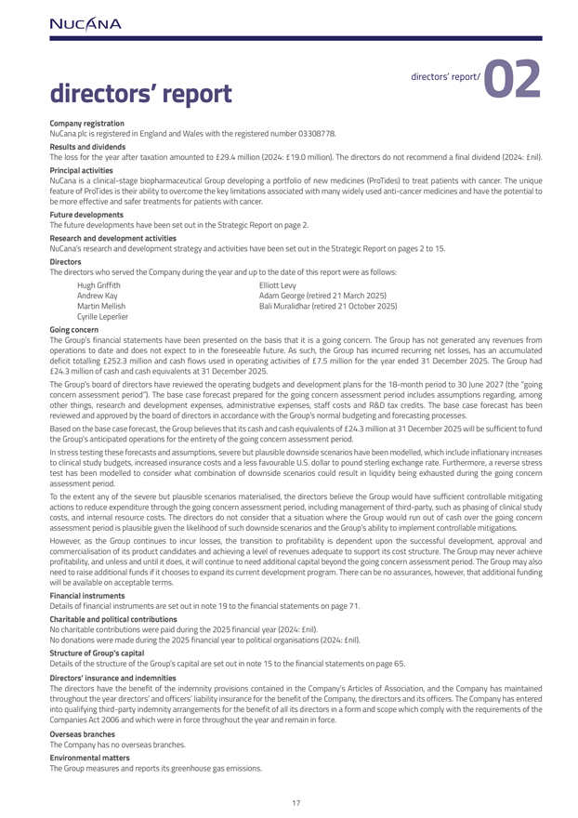
directors’ report directors’ report/ 02Company registration NuCana plc is registered in England and Wales with the registered number 03308778.Results and dividendsThe loss for the year after taxation amounted to £29.4 million (2024: £19.0 million). The directors do not recommend a final dividend (2024: £nil).Principal activities NuCana is a clinical-stage biopharmaceutical Group developing a portfolio of new medicines (ProTides) to treat patients with cancer. The unique feature of ProTides is their ability to overcome the key limitations associated with many widely used anti-cancer medicines and have the potential to be more effective and safer treatments for patients with cancer. Future developmentsThe future developments have been set out in the Strategic Report on page 2.Research and development activitiesNuCana’s research and development strategy and activities have been set out in the Strategic Report on pages 2 to 15.Directors The directors who served the Company during the year and up to the date of this report were as follows: Hugh Griffith Elliott Levy Andrew Kay Adam George (retired 21 March 2025) Martin Mellish Bali Muralidhar (retired 21 October 2025) Cyrille Leperlier Going concernThe Group’s financial statements have been presented on the basis that it is a going concern. The Group has not generated any revenues from operations to date and does not expect to in the foreseeable future. As such, the Group has incurred recurring net losses, has an accumulated deficit totalling £252.3 million and cash flows used in operating activities of £7.5 million for the year ended 31 December 2025. The Group had £24.3 million of cash and cash equivalents at 31 December 2025.The Group’s board of directors have reviewed the operating budgets and development plans for the 18-month period to 30 June 2027 (the “going concern assessment period”). The base case forecast prepared for the going concern assessment period includes assumptions regarding, among other things, research and development expenses, administrative expenses, staff costs and R&D tax credits. The base case forecast has been reviewed and approved by the board of directors in accordance with the Group’s normal budgeting and forecasting processes.Based on the base case forecast, the Group believes that its cash and cash equivalents of £24.3 million at 31 December 2025 will be sufficient to fund the Group’s anticipated operations for the entirety of the going concern assessment period. In stress testing these forecasts and assumptions, severe but plausible downside scenarios have been modelled, which include inflationary increases to clinical study budgets, increased insurance costs and a less favourable U.S. dollar to pound sterling exchange rate. Furthermore, a reverse stress test has been modelled to consider what combination of downside scenarios could result in liquidity being exhausted during the going concern assessment period.To the extent any of the severe but plausible scenarios materialised, the directors believe the Group would have sufficient controllable mitigating actions to reduce expenditure through the going concern assessment period, including management of third-party, such as phasing of clinical study costs, and internal resource costs. The directors do not consider that a situation where the Group would run out of cash over the going concern assessment period is plausible given the likelihood of such downside scenarios and the Group’s ability to implement controllable mitigations. However, as the Group continues to incur losses, the transition to profitability is dependent upon the successful development, approval and commercialisation of its product candidates and achieving a level of revenues adequate to support its cost structure. The Group may never achieve profitability, and unless and until it does, it will continue to need additional capital beyond the going concern assessment period. The Group may also need to raise additional funds if it chooses to expand its current development program. There can be no assurances, however, that additional funding will be available on acceptable terms.Financial instrumentsDetails of financial instruments are set out in note 19 to the financial statements on page 71. Charitable and political contributionsNo charitable contributions were paid during the 2025 financial year (2024: £nil).No donations were made during the 2025 financial year to political organisations (2024: £nil).Structure of Group’s capitalDetails of the structure of the Group’s capital are set out in note 15 to the financial statements on page 65.Directors’ insurance and indemnities The directors have the benefit of the indemnity provisions contained in the Company’s Articles of Association, and the Company has maintained throughout the year directors’ and officers’ liability insurance for the benefit of the Company, the directors and its officers. The Company has entered into qualifying third-party indemnity arrangements for the benefit of all its directors in a form and scope which comply with the requirements of the Companies Act 2006 and which were in force throughout the year and remain in force.Overseas branchesThe Company has no overseas branches. Environmental mattersThe Group measures and reports its greenhouse gas emissions.

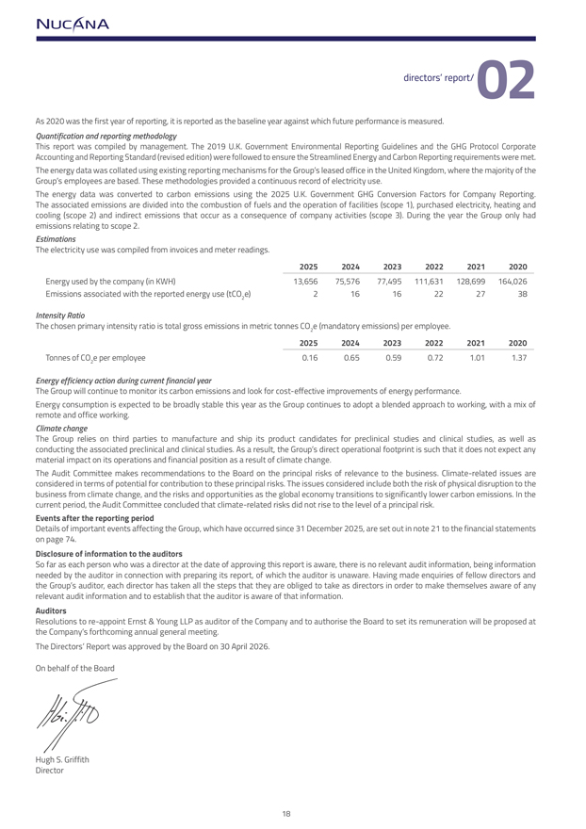
directors’ report/ 02As 2020 was the first year of reporting, it is reported as the baseline year against which future performance is measured.Quantification and reporting methodologyThis report was compiled by management. The 2019 U.K. Government Environmental Reporting Guidelines and the GHG Protocol Corporate Accounting and Reporting Standard (revised edition) were followed to ensure the Streamlined Energy and Carbon Reporting requirements were met. The energy data was collated using existing reporting mechanisms for the Group’s leased office in the United Kingdom, where the majority of the Group’s employees are based. These methodologies provided a continuous record of electricity use.The energy data was converted to carbon emissions using the 2025 U.K. Government GHG Conversion Factors for Company Reporting. The associated emissions are divided into the combustion of fuels and the operation of facilities (scope 1), purchased electricity, heating and cooling (scope 2) and indirect emissions that occur as a consequence of company activities (scope 3). During the year the Group only had emissions relating to scope 2.EstimationsThe electricity use was compiled from invoices and meter readings.2025 2024 2023 2022 2021 2020Energy used by the company (in KWH) 13,656 75,576 77,495 111,631 128,699 164,026 Emissions associated with the reported energy use (tCO e) 2 16 16 22 27 382Intensity RatioThe chosen primary intensity ratio is total gross emissions in metric tonnes CO e (mandatory emissions) per employee.22025 2024 2023 2022 2021 2020Tonnes of CO e per employee 0.16 0.65 0.59 0.72 1.01 1.372Energy efficiency action during current financial yearThe Group will continue to monitor its carbon emissions and look for cost-effective improvements of energy performance.Energy consumption is expected to be broadly stable this year as the Group continues to adopt a blended approach to working, with a mix of remote and office working.Climate changeThe Group relies on third parties to manufacture and ship its product candidates for preclinical studies and clinical studies, as well as conducting the associated preclinical and clinical studies. As a result, the Group’s direct operational footprint is such that it does not expect any material impact on its operations and financial position as a result of climate change.The Audit Committee makes recommendations to the Board on the principal risks of relevance to the business. Climate-related issues are considered in terms of potential for contribution to these principal risks. The issues considered include both the risk of physical disruption to the business from climate change, and the risks and opportunities as the global economy transitions to significantly lower carbon emissions. In the current period, the Audit Committee concluded that climate-related risks did not rise to the level of a principal risk.Events after the reporting periodDetails of important events affecting the Group, which have occurred since 31 December 2025, are set out in note 21 to the financial statements on page 74.Disclosure of information to the auditorsSo far as each person who was a director at the date of approving this report is aware, there is no relevant audit information, being information needed by the auditor in connection with preparing its report, of which the auditor is unaware. Having made enquiries of fellow directors and the Group’s auditor, each director has taken all the steps that they are obliged to take as directors in order to make themselves aware of any relevant audit information and to establish that the auditor is aware of that information.AuditorsResolutions to re-appoint Ernst & Young LLP as auditor of the Company and to authorise the Board to set its remuneration will be proposed at the Company’s forthcoming annual general meeting.The Directors’ Report was approved by the Board on 30 April 2026.On behalf of the BoardHugh S. Griffith Director



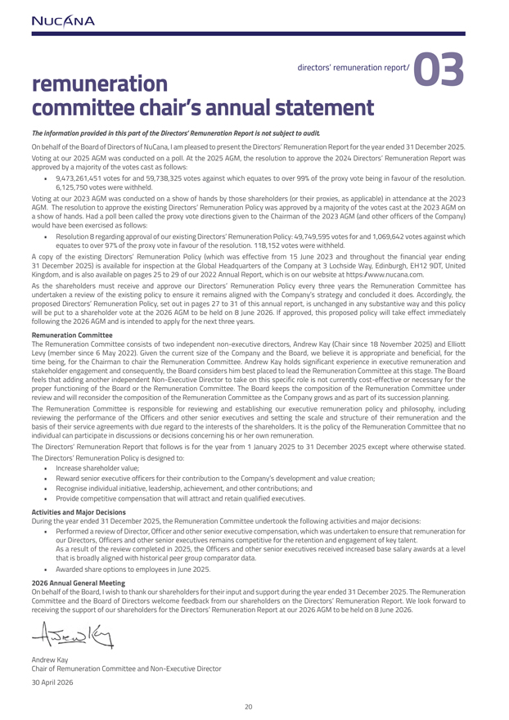
remuneration directors’ remuneration report/ 03committee chair’s annual statementThe information provided in this part of the Directors’ Remuneration Report is not subject to audit.On behalf of the Board of Directors of NuCana, I am pleased to present the Directors’ Remuneration Report for the year ended 31 December 2025. Voting at our 2025 AGM was conducted on a poll. At the 2025 AGM, the resolution to approve the 2024 Directors’ Remuneration Report was approved by a majority of the votes cast as follows:  9,473,261,451 votes for and 59,738,325 votes against which equates to over 99% of the proxy vote being in favour of the resolution. 6,125,750 votes were withheld.Voting at our 2023 AGM was conducted on a show of hands by those shareholders (or their proxies, as applicable) in attendance at the 2023 AGM. The resolution to approve the existing Directors’ Remuneration Policy was approved by a majority of the votes cast at the 2023 AGM on a show of hands. Had a poll been called the proxy vote directions given to the Chairman of the 2023 AGM (and other officers of the Company) would have been exercised as follows:  Resolution 8 regarding approval of our existing Directors’ Remuneration Policy: 49,749,595 votes for and 1,069,642 votes against which equates to over 97% of the proxy vote in favour of the resolution. 118,152 votes were withheld.A copy of the existing Directors’ Remuneration Policy (which was effective from 15 June 2023 and throughout the financial year ending 31 December 2025) is available for inspection at the Global Headquarters of the Company at 3 Lochside Way, Edinburgh, EH12 9DT, United Kingdom, and is also available on pages 25 to 29 of our 2022 Annual Report, which is on our website at https://www.nucana.com. As the shareholders must receive and approve our Directors’ Remuneration Policy every three years the Remuneration Committee has undertaken a review of the existing policy to ensure it remains aligned with the Company’s strategy and concluded it does. Accordingly, the proposed Directors’ Remuneration Policy, set out in pages 27 to 31 of this annual report, is unchanged in any substantive way and this policy will be put to a shareholder vote at the 2026 AGM to be held on 8 June 2026. If approved, this proposed policy will take effect immediately following the 2026 AGM and is intended to apply for the next three years.Remuneration CommitteeThe Remuneration Committee consists of two independent non-executive directors, Andrew Kay (Chair since 18 November 2025) and Elliott Levy (member since 6 May 2022). Given the current size of the Company and the Board, we believe it is appropriate and beneficial, for the time being, for the Chairman to chair the Remuneration Committee. Andrew Kay holds significant experience in executive remuneration and stakeholder engagement and consequently, the Board considers him best placed to lead the Remuneration Committee at this stage. The Board feels that adding another independent Non-Executive Director to take on this specific role is not currently cost-effective or necessary for the proper functioning of the Board or the Remuneration Committee. The Board keeps the composition of the Remuneration Committee under review and will reconsider the composition of the Remuneration Committee as the Company grows and as part of its succession planning. The Remuneration Committee is responsible for reviewing and establishing our executive remuneration policy and philosophy, including reviewing the performance of the Officers and other senior executives and setting the scale and structure of their remuneration and the basis of their service agreements with due regard to the interests of the shareholders. It is the policy of the Remuneration Committee that no individual can participate in discussions or decisions concerning his or her own remuneration.The Directors’ Remuneration Report that follows is for the year from 1 January 2025 to 31 December 2025 except where otherwise stated. The Directors’ Remuneration Policy is designed to:  Increase shareholder value;  Reward senior executive officers for their contribution to the Company’s development and value creation;  Recognise individual initiative, leadership, achievement, and other contributions; and  Provide competitive compensation that will attract and retain qualified executives.Activities and Major Decisions During the year ended 31 December 2025, the Remuneration Committee undertook the following activities and major decisions:  Performed a review of Director, Officer and other senior executive compensation, which was undertaken to ensure that remuneration for our Directors, Officers and other senior executives remains competitive for the retention and engagement of key talent. As a result of the review completed in 2025, the Officers and other senior executives received increased base salary awards at a level that is broadly aligned with historical peer group comparator data.  Awarded share options to employees in June 2025.2026 Annual General MeetingOn behalf of the Board, I wish to thank our shareholders for their input and support during the year ended 31 December 2025. The Remuneration Committee and the Board of Directors welcome feedback from our shareholders on the Directors’ Remuneration Report. We look forward to receiving the support of our shareholders for the Directors’ Remuneration Report at our 2026 AGM to be held on 8 June 2026.Andrew KayChair of Remuneration Committee and Non-Executive Director30 April 2026

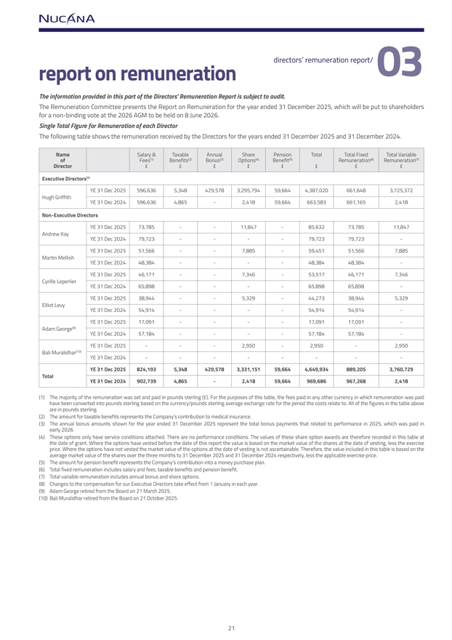
report on remuneration directors’ remuneration report/ 03The information provided in this part of the Directors’ Remuneration Report is subject to audit. The Remuneration Committee presents the Report on Remuneration for the year ended 31 December 2025, which will be put to shareholders for a non-binding vote at the 2026 AGM to be held on 8 June 2026.Single Total Figure for Remuneration of each Director The following table shows the remuneration received by the Directors for the years ended 31 December 2025 and 31 December 2024. Name Salary & TaxableAnnualSharePensionTotalTotal Fixed Total Variableof Fees(1) Benefits(2) Bonus(3) Options(4) Benefit(5) Remuneration(6) Remuneration(7)Director ££££££££Executive Directors(8) YE 31 Dec 2025596,6365,348429,5783,295,79459,6644,387,020661,6483,725,372Hugh GriffithYE 31 Dec 2024596,6364,865-2,41859,664663,583661,1652,418Non-Executive Directors YE 31 Dec 202573,785--11,847-85,63273,78511,847Andrew KayYE 31 Dec 202479,723----79,72379,723-YE 31 Dec 202551,566--7,885-59,45151,5667,885Martin MellishYE 31 Dec 202448,384----48,38448,384-YE 31 Dec 202546,171--7,346-53,51746,1717,346Cyrille Leperlier YE 31 Dec 202465,898----65,89865,898-YE 31 Dec 202538,944--5,329-44,27338,9445,329Elliot LevyYE 31 Dec 202454,914----54,91454,914-YE 31 Dec 202517,091----17,09117,091-Adam George(9) YE 31 Dec 202457,184----57,18457,184-YE 31 Dec 2025---2,950-2,950-2,950Bali Muralidhar(10) YE 31 Dec 2024--------YE 31 Dec 2025 824,193 5,348 429,578 3,331,151 59,664 4,649,934 889,205 3,760,729Total YE 31 Dec 2024 902,739 4,865 - 2,418 59,664 969,686 967,268 2,418(1) have The majority been converted of the remuneration into pounds sterling was set based and paid on the in pounds currency/pounds sterling (£) .sterling For the average purposes exchange of this table, rate for the the fees period paid the in any costs other relate currency to. All in of which the figures remuneration in the table was above paid are in pounds sterling. (2) The amount for taxable benefits represents the Company’s contribution to medical insurance. (3) early The annual 2026. bonus amounts shown for the year ended 31 December 2025 represent the total bonus payments that related to performance in 2025, which was paid in (4) These the date options of grant. only Where have service the options conditions have vested attached. before There the are date no of performance this report the conditions. value is based The values on the of market these share value of option the shares awards at are the therefore date of vesting, recorded less in this the exercise table at average price. Where market the value options of the have shares not vested over the the three market months value to of 31 the December options at 2025 the date and of 31 vesting December is not 2024 ascertainable. respectively, Therefore, less the applicable the value included exercise in price. this table is based on the (5) The amount for pension benefit represents the Company’s contribution into a money purchase plan. (6) Total fixed remuneration includes salary and fees, taxable benefits and pension benefit. (7) Total variable remuneration includes annual bonus and share options.(8) Changes to the compensation for our Executive Directors take effect from 1 January in each year. (9) Adam George retired from the Board on 21 March 2025.(10) Bali Muralidhar retired from the Board on 21 October 2025.

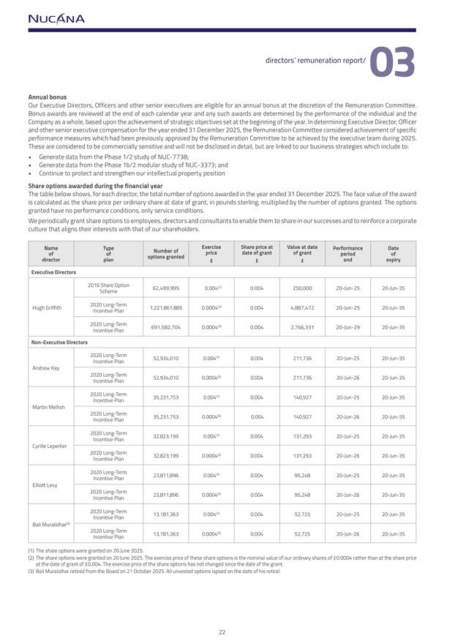
directors’ remuneration report/ 03Annual bonus Our Executive Directors, Officers and other senior executives are eligible for an annual bonus at the discretion of the Remuneration Committee. Bonus awards are reviewed at the end of each calendar year and any such awards are determined by the performance of the individual and the Company as a whole, based upon the achievement of strategic objectives set at the beginning of the year. In determining Executive Director, Officer and other senior executive compensation for the year ended 31 December 2025, the Remuneration Committee considered achievement of specific performance measures which had been previously approved by the Remuneration Committee to be achieved by the executive team during 2025. These are considered to be commercially sensitive and will not be disclosed in detail, but are linked to our business strategies which include to:  Generate data from the Phase 1/2 study of NUC-7738; Generate data from the Phase 1b/2 modular study of NUC-3373; and Continue to protect and strengthen our intellectual property positionShare options awarded during the financial yearThe table below shows, for each director, the total number of options awarded in the year ended 31 December 2025. The face value of the award is calculated as the share price per ordinary share at date of grant, in pounds sterling, multiplied by the number of options granted. The options granted have no performance conditions, only service conditions.We periodically grant share options to employees, directors and consultants to enable them to share in our successes and to reinforce a corporate culture that aligns their interests with that of our shareholders. Name Type Number of Exercise Share price at Value at date Performance Dateof of options granted price date of grant of grant period ofdirector plan £ £ £ end expiryExecutive Directors 2016 Share Option62,499,9950.004(1) 0.004250,00020-Jun-2520-Jun-35Scheme2020 Long-TermHugh Griffith1,221,867,8850.0004(2) 0.0044,887,47220-Jun-2520-Jun-35Incentive Plan2020 Long-Term691,582,7040.0004(2) 0.0042,766,33120-Jun-2920-Jun-35Incentive PlanNon-Executive Directors 2020 Long-Term52,934,0100.004(1) 0.004211,73620-Jun-2520-Jun-35Incentive PlanAndrew Kay2020 Long-Term52,934,0100.0004(2) 0.004211,73620-Jun-2620-Jun-35Incentive Plan2020 Long-Term35,231,7530.004(1) 0.004140,92720-Jun-2520-Jun-35Incentive PlanMartin Mellish2020 Long-Term35,231,7530.0004(2) 0.004140,92720-Jun-2620-Jun-35Incentive Plan2020 Long-Term32,823,1990.004(1) 0.004131,29320-Jun-2520-Jun-35Incentive PlanCyrille Leperlier 2020 Long-Term32,823,1990.0004(2) 0.004131,29320-Jun-2620-Jun-35Incentive Plan2020 Long-Term23,811,8960.004(1) 0.00495,24820-Jun-2520-Jun-35Incentive PlanElliott Levy2020 Long-Term23,811,8960.0004(2) 0.00495,24820-Jun-2620-Jun-35Incentive Plan2020 Long-Term13,181,3630.004(1) 0.00452,72520-Jun-2520-Jun-35Incentive PlanBali Muralidhar(3) 2020 Long-Term13,181,3630.0004(2) 0.00452,72520-Jun-2620-Jun-35Incentive Plan(1) The share options were granted on 20 June 2025. (2) at The the share date options of grant were of £ 0.004. granted The on exercise 20 June 2025. price of The the exercise share options price of has these not share changed options since is the the date nominal of the value grant. of our ordinary shares of £0.0004 rather than at the share price (3) Bali Muralidhar retired from the Board on 21 October 2025. All unvested options lapsed on the date of his retiral.

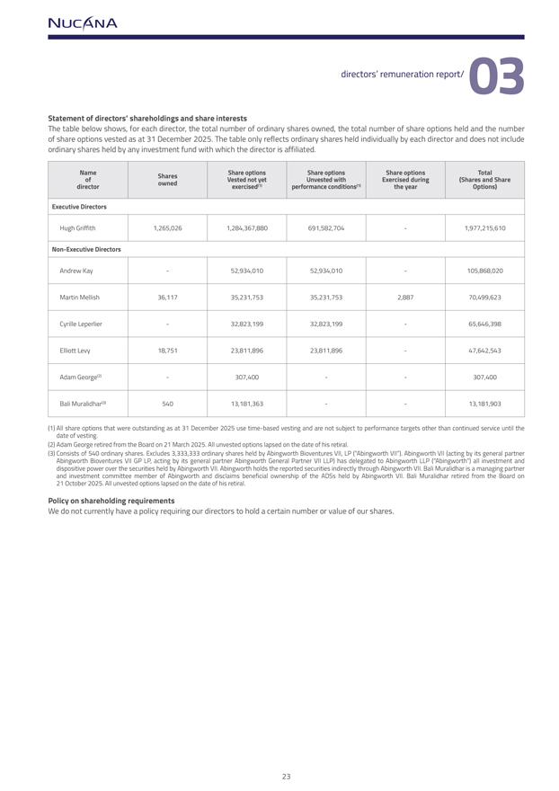
directors’ remuneration report/ 03Statement of directors’ shareholdings and share interests The table below shows, for each director, the total number of ordinary shares owned, the total number of share options held and the number of share options vested as at 31 December 2025. The table only reflects ordinary shares held individually by each director and does not include ordinary shares held by any investment fund with which the director is affiliated. Name Shares Share options Share options Share options Totalof owned Vested not yet Unvested with Exercised during (Shares and Sharedirector exercised(1) performance conditions(1) the year Options)Executive Directors Hugh Griffith1,265,0261,284,367,880691,582,704-1,977,215,610Non-Executive Directors Andrew Kay-52,934,01052,934,010-105,868,020Martin Mellish36,11735,231,75335,231,7532,88770,499,623Cyrille Leperlier -32,823,19932,823,199-65,646,398Elliott Levy18,75123,811,89623,811,896-47,642,543Adam George(2) -307,400--307,400Bali Muralidhar(3) 54013,181,363--13,181,903 date of vesting. (2) Adam George retired from the Board on 21 March 2025. All unvested options lapsed on the date of his retiral.(3) Consists Abingworth of 540 Bioventures ordinary VII shares. GP LP, Excludes acting 3,333,333 by its general ordinary partner shares Abingworth held by Abingworth General Partner Bioventures VII LLP) VII, has LP delegated (“Abingworth to Abingworth VII”). Abingworth LLP (“Abingworth”) VII (acting by all its investment general partner and dispositive and investment power committee over the securities member held of Abingworth by Abingworth and VII. disclaims Abingworth beneficial holds the ownership reported of securities the ADSs indirectly held by through Abingworth Abingworth VII. Bali VII. Muralidhar Bali Muralidhar retired is from a managing the Board partner on 21 October 2025. All unvested options lapsed on the date of his retiral. Policy on shareholding requirements We do not currently have a policy requiring our directors to hold a certain number or value of our shares.

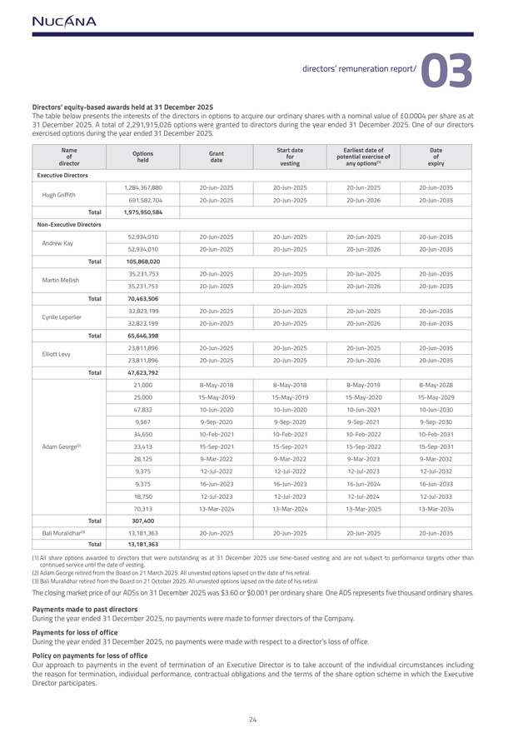
directors’ remuneration report/ 03Directors’ equity-based awards held at 31 December 2025 The table below presents the interests of the directors in options to acquire our ordinary shares with a nominal value of £0.0004 per share as at 31 December 2025. A total of 2,291,915,026 options were granted to directors during the year ended 31 December 2025. One of our directors exercised options during the year ended 31 December 2025.Name Options Grant Start date Earliest date of Dateof held date for potential exercise of ofdirector vesting any options(1) expiryExecutive Directors 1,284,367,88020-Jun-202520-Jun-2025 20-Jun-2025 20-Jun-2035Hugh Griffith691,582,70420-Jun-202520-Jun-2025 20-Jun-202620-Jun-2035Total 1,975,950,584 Non-Executive Directors 52,934,01020-Jun-202520-Jun-2025 20-Jun-2025 20-Jun-2035Andrew Kay52,934,01020-Jun-202520-Jun-2025 20-Jun-202620-Jun-2035Total 105,868,020 35,231,75320-Jun-202520-Jun-2025 20-Jun-2025 20-Jun-2035Martin Mellish35,231,75320-Jun-202520-Jun-2025 20-Jun-202620-Jun-2035Total 70,463,506 32,823,19920-Jun-202520-Jun-2025 20-Jun-2025 20-Jun-2035Cyrille Leperlier 32,823,19920-Jun-202520-Jun-2025 20-Jun-202620-Jun-2035Total 65,646,398 23,811,89620-Jun-202520-Jun-2025 20-Jun-2025 20-Jun-2035Elliott Levy23,811,89620-Jun-202520-Jun-2025 20-Jun-202620-Jun-2035Total 47,623,792 21,0008-May-20188-May-2018 8-May-20198-May-202825,00015-May-201915-May-2019 15-May-202015-May-202947,83210-Jun-202010-Jun-2020 10-Jun-202110-Jun-20309,5679-Sep-20209-Sep-2020 9-Sep-20219-Sep-203034,65010-Feb-202110-Feb-2021 10-Feb-202210-Feb-2031Adam George(2) 33,41315-Sep-202115-Sep-2021 15-Sep-202215-Sep-203128,1259-Mar-20229-Mar-2022 9-Mar-20239-Mar-20329,37512-Jul-202212-Jul-2022 12-Jul-202312-Jul-20329,37516-Jun-202316-Jun-2023 16-Jun-202416-Jun-203318,75012-Jul-202312-Jul-2023 12-Jul-202412-Jul-203370,31313-Mar-202413-Mar-2024 13-Mar-202513-Mar-2034Total 307,400 Bali Muralidhar(3) 13,181,36320-Jun-202520-Jun-2025 20-Jun-2025 20-Jun-2035Total 13,181,363 (1) All continued share options service until awarded the date to directors of vesting. that were outstanding as at 31 December 2025 use time-based vesting and are not subject to performance targets other than (2) Adam George retired from the Board on 21 March 2025. All unvested options lapsed on the date of his retiral.(3) Bali Muralidhar retired from the Board on 21 October 2025. All unvested options lapsed on the date of his retiral.The closing market price of our ADSs on 31 December 2025 was $3.60 or $0.001 per ordinary share. One ADS represents five thousand ordinary shares.Payments made to past directors During the year ended 31 December 2025, no payments were made to former directors of the Company. Payments for loss of office During the year ended 31 December 2025, no payments were made with respect to a director’s loss of office. Policy on payments for loss of office Our approach to payments in the event of termination of an Executive Director is to take account of the individual circumstances including the reason for termination, individual performance, contractual obligations and the terms of the share option scheme in which the Executive Director participates.

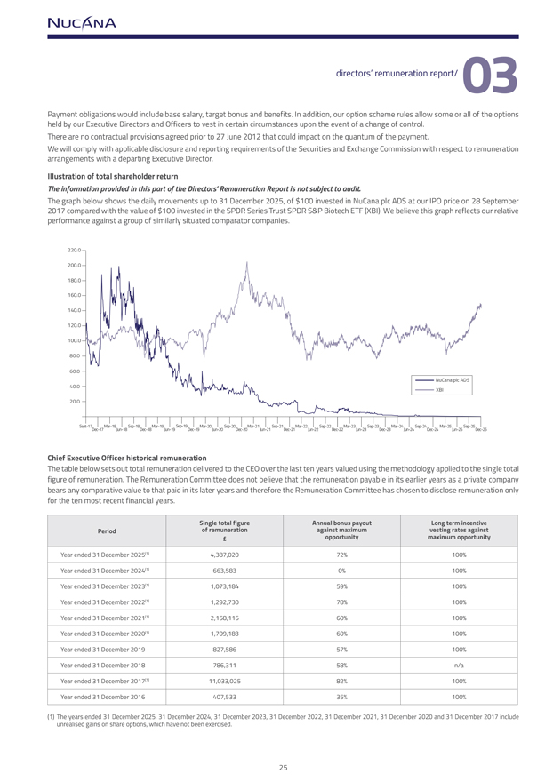
directors’ remuneration report/ 03Directors’ equity-based awards held at 31 December 2025The table below presents the interests of the directors in options to acquire our ordinary shares with a nominal value of £0.0004 per share as at 31 December 2025. A total of 2,291,915,026 options were granted to directors during the year ended 31 December 2025. One of our directors exercised options during the year ended 31 December 2025.NameOptions Grant Start date Earliest date of Dateof held date for potential exercise of ofdirector vesting any options(1) expiryExecutive Directors 1,284,367,88020-Jun-202520-Jun-2025 20-Jun-2025 20-Jun-2035Hugh Griffith 691,582,70420-Jun-202520-Jun-2025 20-Jun-202620-Jun-2035Total 1,975,950,584 Non-Executive Directors 52,934,01020-Jun-202520-Jun-2025 20-Jun-2025 20-Jun-2035Andrew Kay52,934,01020-Jun-202520-Jun-2025 20-Jun-202620-Jun-2035Total 105,868,020 35,231,75320-Jun-202520-Jun-2025 20-Jun-2025 20-Jun-2035Martin Mellish35,231,75320-Jun-202520-Jun-2025 20-Jun-202620-Jun-2035Total 70,463,506 32,823,19920-Jun-202520-Jun-2025 20-Jun-2025 20-Jun-2035Cyrille Leperlier 32,823,19920-Jun-202520-Jun-2025 20-Jun-202620-Jun-2035Total 65,646,398 23,811,89620-Jun-202520-Jun-2025 20-Jun-2025 20-Jun-2035Elliott Levy23,811,89620-Jun-202520-Jun-2025 20-Jun-202620-Jun-2035Total 47,623,792 21,0008-May-20188-May-2018 8-May-20198-May-202825,00015-May-201915-May-2019 15-May-202015-May-202947,83210-Jun-202010-Jun-2020 10-Jun-202110-Jun-20309,5679-Sep-20209-Sep-2020 9-Sep-20219-Sep-203034,65010-Feb-202110-Feb-2021 10-Feb-202210-Feb-2031Adam George(2) 33,41315-Sep-202115-Sep-2021 15-Sep-202215-Sep-203128,1259-Mar-20229-Mar-2022 9-Mar-20239-Mar-20329,37512-Jul-202212-Jul-2022 12-Jul-202312-Jul-20329,37516-Jun-202316-Jun-2023 16-Jun-202416-Jun-203318,75012-Jul-202312-Jul-2023 12-Jul-202412-Jul-203370,31313-Mar-202413-Mar-2024 13-Mar-202513-Mar-2034Total 307,400 Bali Muralidhar(3) 13,181,36320-Jun-202520-Jun-2025 20-Jun-2025 20-Jun-2035Total 13,181,363 All continued share options service until awarded the date to directors of vesting. thatwere outstanding as at 31 December 2025 use time-based vesting and are not subject to performance targets other than (2) Adam George retired from the Board on 21 March 2025. All unvested options lapsed on the date of his retiral.(3) Bali Muralidhar retired from the Board on 21 October 2025. All unvested options lapsed on the date of his retiral.The closing market price of our ADSs on 31 December 2025 was $3.60 or $0.001 per ordinary share. One ADS represents five thousand ordinary shares.Payments made to past directors During the year ended 31 December 2025, no payments were made to former directors of the Company. Payments for loss of office During the year ended 31 December 2025, no payments were made with respect to a director’s loss of office. Policy on payments for loss of office Our approach to payments in the event of termination of an Executive Director is to take account of the individual circumstances including the reason for termination, individual performance, contractual obligations and the terms of the share option scheme in which the Executive Director participates.

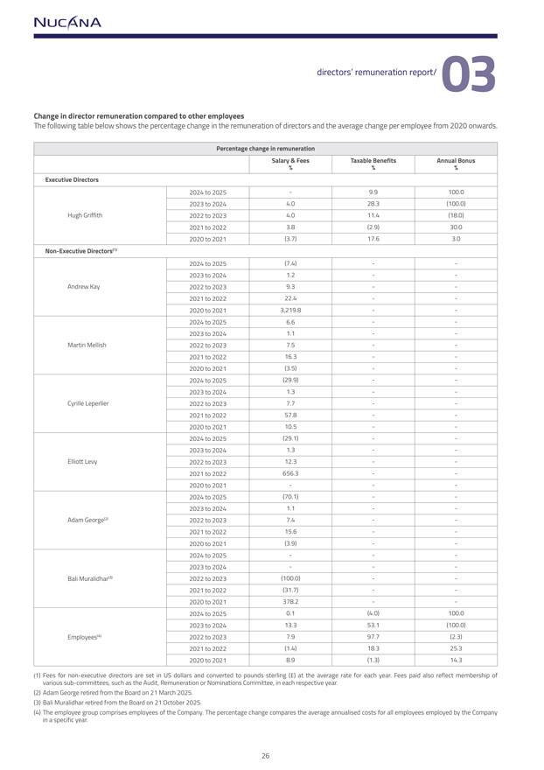
directors’ remuneration report/ 03Change in director remuneration compared to other employees The following table below shows the percentage change in the remuneration of directors and the average change per employee from 2020 onwards. Percentage change in remuneration Salary & Fees Taxable Benefits Annual Bonus % % %Executive Directors 2024 to 2025-9.9100.02023 to 20244.028.3(100.0)Hugh Griffith2022 to 20234.011.4(18.0)2021 to 20223.8(2.9)30.02020 to 2021(3.7)17.63.0Non-Executive Directors(1) 2024 to 2025(7.4)--2023 to 20241.2--Andrew Kay2022 to 20239.3--2021 to 202222.4--2020 to 20213,219.8--2024 to 20256.6--2023 to 20241.1--Martin Mellish2022 to 20237.5--2021 to 202216.3--2020 to 2021(3.5)--2024 to 2025(29.9)--2023 to 20241.3--Cyrille Leperlier 2022 to 20237.7--2021 to 202257.8--2020 to 202110.5--2024 to 2025(29.1)--2023 to 20241.3--Elliott Levy2022 to 202312.3--2021 to 2022656.3--2020 to 2021---2024 to 2025(70.1)--2023 to 20241.1--Adam George(2) 2022 to 20237.4--2021 to 202215.6--2020 to 2021(3.9)--2024 to 2025---2023 to 2024---Bali Muralidhar(3) 2022 to 2023(100.0)--2021 to 2022(31.7)--2020 to 2021378.2--2024 to 20250.1(4.0)100.02023 to 202413.353.1(100.0)Employees(4) 2022 to 20237.997.7(2.3)2021 to 2022(1.4)18.325.32020 to 20218.9(1.3)14.3(1) Fees various for sub-committees, non-executive directors such as the are Audit, set in Remuneration US dollars and or converted Nominations to Committee, pounds sterling in each () respective at the average year. rate for each year. Fees paid also reflect membership of (2) Adam George retired from the Board on 21 March 2025.(3) Bali Muralidhar retired from the Board on 21 October 2025.(4) The in a specific employee year. group comprises employees of the Company. The percentage change compares the average annualised costs for all employees employed by the Company

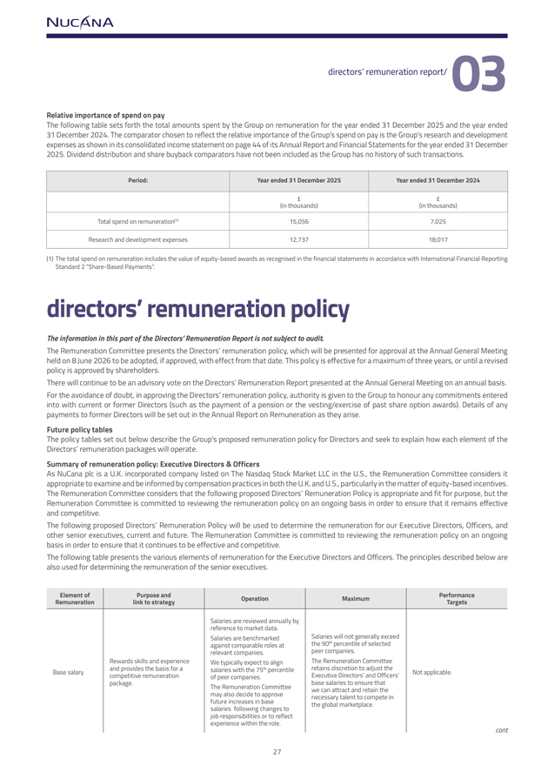
directors’ remuneration report/ 03Relative importance of spend on pay The following table sets forth the total amounts spent by the Group on remuneration for the year ended 31 December 2025 and the year ended 31 December 2024. The comparator chosen to reflect the relative importance of the Group’s spend on pay is the Group’s research and development expenses as shown in its consolidated income statement on page 44 of its Annual Report and Financial Statements for the year ended 31 December 2025. Dividend distribution and share buyback comparators have not been included as the Group has no history of such transactions. Period: Year ended 31 December 2025 Year ended 31 December 2024 (in thousands)(in thousands)Total spend on remuneration(1) 15,0567,025Research and development expenses12,73718,017(1) The total spend on remuneration includes the value of equity-based awards as recognised in the financial statements in accordance with International Financial Reporting Standard 2 “Share-Based Payments”.directors’ remuneration policyThe information in this part of the Directors’ Remuneration Report is not subject to audit. The Remuneration Committee presents the Directors’ remuneration policy, which will be presented for approval at the Annual General Meeting held on 8 June 2026 to be adopted, if approved, with effect from that date. This policy is effective for a maximum of three years, or until a revised policy is approved by shareholders. There will continue to be an advisory vote on the Directors’ Remuneration Report presented at the Annual General Meeting on an annual basis. For the avoidance of doubt, in approving the Directors’ remuneration policy, authority is given to the Group to honour any commitments entered into with current or former Directors (such as the payment of a pension or the vesting/exercise of past share option awards). Details of any payments to former Directors will be set out in the Annual Report on Remuneration as they arise.Future policy tables The policy tables set out below describe the Group’s proposed remuneration policy for Directors and seek to explain how each element of the Directors’ remuneration packages will operate.Summary of remuneration policy: Executive Directors & Officers As NuCana plc is a U.K. incorporated company listed on The Nasdaq Stock Market LLC in the U.S., the Remuneration Committee considers it appropriate to examine and be informed by compensation practices in both the U.K. and U.S., particularly in the matter of equity-based incentives. The Remuneration Committee considers that the following proposed Directors’ Remuneration Policy is appropriate and fit for purpose, but the Remuneration Committee is committed to reviewing the remuneration policy on an ongoing basis in order to ensure that it remains effective and competitive. The following proposed Directors’ Remuneration Policy will be used to determine the remuneration for our Executive Directors, Officers, and other senior executives, current and future. The Remuneration Committee is committed to reviewing the remuneration policy on an ongoing basis in order to ensure that it continues to be effective and competitive.The following table presents the various elements of remuneration for the Executive Directors and Officers. The principles described below are also used for determining the remuneration of the senior executives.Element of Purpose and Operation Maximum Performance Remuneration link to strategy Targets Salaries are reviewed annually byreference to market data.Salaries are benchmarkedSalaries will not generally exceedagainst comparable roles atthe 90th percentile of selected relevant companies.peer companies.Rewards skills and experienceWe typically expect to alignThe Remuneration CommitteeBase salaryand provides the basis for asalaries with the 75th percentile retains discretion to adjust theNot applicable.competitive remunerationof peer companies.Executive Directors’ and Officers’package.base salaries to ensure thatThe Remuneration Committeewe can attract and retain themay also decide to approvenecessary talent to compete infuture increases in basethe global marketplace.salaries following changes tojob responsibilities or to reflectexperience within the role.cont

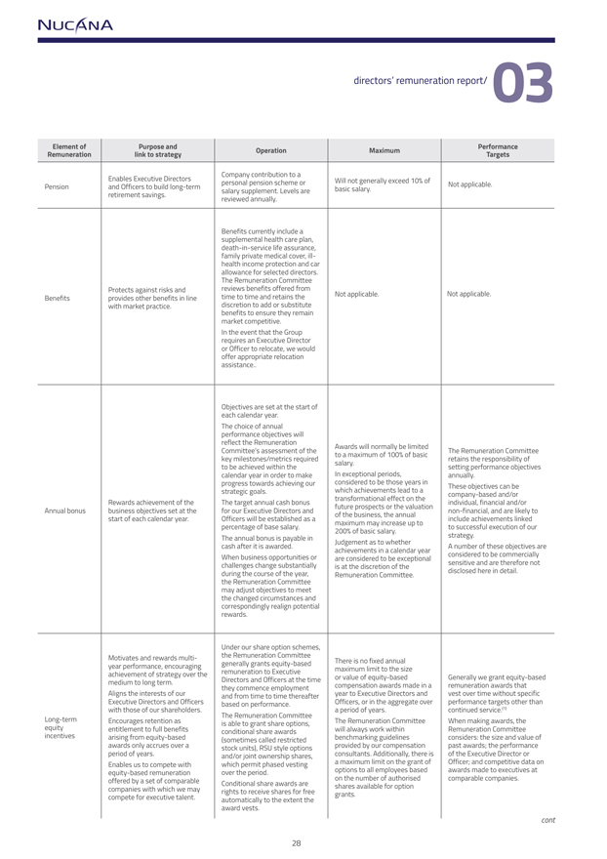
Element of Purpose and Operation Maximum PerformanceRemuneration link to strategy Targets Company contribution to aEnables Executive Directorspersonal pension scheme orWill not generally exceed 10% ofPensionand Officers to build long-termsalary supplement. Levels arebasic salary.Not applicable.retirement savings.reviewed annually.Benefits currently include asupplemental health care plan,death-in-service life assurance,family private medical cover, ill-health income protection and carallowance for selected directors.The Remuneration CommitteeProtects against risks andreviews benefits offered fromBenefitsprovides other benefits in linetime to time and retains theNot applicable.Not applicable.with market practice.discretion to add or substitutebenefits to ensure they remainmarket competitive.In the event that the Grouprequires an Executive Directoror Officer to relocate, we wouldoffer appropriate relocationassistanceObjectives are set at the start ofeach calendar year.The choice of annualperformance objectives willreflect the RemunerationAwards will normally be limitedCommittee’s assessment of theThe Remuneration Committee to a maximum of 100% of basickey milestones/metrics requiredretains the responsibility ofsalary.to be achieved within thesetting performance objectivescalendar year in order to makeIn exceptional periods,annually.progress towards achieving ourconsidered to be those years inThese objectives can bestrategic goals.which achievements lead to acompany-based and/ortransformational effect on theRewards achievement of theThe target annual cash bonus individual, financial and/orfuture prospects or the valuationAnnual bonusbusiness objectives set at thefor our Executive Directors andnon-financial, and are likely toof the business, the annualstart of each calendar year.Officers will be established as ainclude achievements linkedmaximum may increase up topercentage of base salary.to successful execution of our200% of basic salary.The annual bonus is payable instrategy.Judgement as to whethercash after it is awarded.A number of these objectives areachievements in a calendar yearWhen business opportunities orare considered to be exceptionalconsidered to be commerciallychallenges change substantiallyis at the discretion of thesensitive and are therefore notduring the course of the year,Remuneration Committee.disclosed here in detail.the Remuneration Committeemay adjust objectives to meetthe changed circumstances andcorrespondingly realign potentialrewards.Under our share option schemes,Motivates and rewards multi-the Remuneration Committeeyear performance, encouraginggenerally grants equity-basedThere is no fixed annualachievement of strategy over theremuneration to Executivemaximum limit to the sizemedium to long term.Directors and Officers at the timeor value of equity-basedGenerally we grant equity-basedthey commence employmentcompensation awards made in aremuneration awards thatAligns the interests of ourand from time to time thereafter year to Executive Directors andvest over time without specificExecutive Directors and Officersbased on performance.Officers, or in the aggregate overperformance targets other thanwith those of our shareholders.a period of years.continued service.(1) The Remuneration CommitteeLong-termEncourages retention asis able to grant share options,The Remuneration CommitteeWhen making awards, theequity entitlement to full benefitsconditional share awardswill always work withinRemuneration Committeeincentives arising from equity-based(sometimes called restrictedbenchmarking guidelinesconsiders: the size and value ofawards only accrues over astock units), RSU style optionsprovided by our compensationpast awards; the performanceperiod of years.and/or joint ownership shares,consultants. Additionally, there isof the Executive Director orEnables us to compete withwhich permit phased vestinga maximum limit on the grant ofOfficer; and competitive data onequity-based remunerationover the period.options to all employees basedawards made to executives atoffered by a set of comparableConditional share awards areshares on the number available of for authorised option comparable companies.companies with which we mayrights to receive shares for freegrants.compete for executive talent.automatically to the extent theaward vests.cont

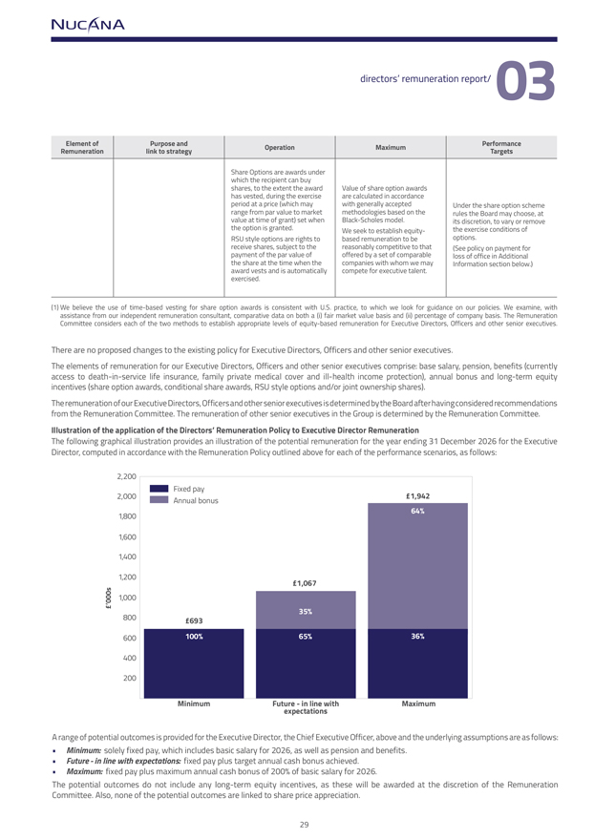
Element of Purpose and Operation Maximum PerformanceRemuneration link to strategy Targets Share Options are awards underwhich the recipient can buyshares, to the extent the awardValue of share option awardshas vested, during the exerciseare calculated in accordanceperiod at a price (which maywith generally acceptedUnder the share option schemerange from par value to marketmethodologies based on therules the Board may choose, atvalue at time of grant) set whenBlack-Scholes model.its discretion, to vary or removethe option is granted.We seek to establish equity-the exercise conditions ofRSU style options are rights tobased remuneration to beoptions.receive shares, subject to thereasonably competitive to that(See policy on payment forpayment of the par value ofoffered by a set of comparableloss of office in Additionalthe share at the time when thecompanies with whom we mayInformation section below.)award vests and is automaticallycompete for executive talent.exercised.(1) assistance We believe from the use our independent of time-based remuneration vesting for consultant, share option comparative awards is data consistent on both with a (i) U. fair S. practice, market value to which basis we and look (ii) percentage for guidance of on company our policies. basis. The We examine, Remuneration with Committee considers each of the two methods to establish appropriate levels of equity-based remuneration for Executive Directors, Officers and other senior executives.There are no proposed changes to the existing policy for Executive Directors, Officers and other senior executives.The elements of remuneration for our Executive Directors, Officers and other senior executives comprise: base salary, pension, benefits (currently access to death-in-service life insurance, family private medical cover and ill-health income protection), annual bonus and long-term equity incentives (share option awards, conditional share awards, RSU style options and/or joint ownership shares). The remuneration of our Executive Directors, Officers and other senior executives is determined by the Board after having considered recommendations from the Remuneration Committee. The remuneration of other senior executives in the Group is determined by the Remuneration Committee. Illustration of the application of the Directors’ Remuneration Policy to Executive Director RemunerationThe following graphical illustration provides an illustration of the potential remuneration for the year ending 31 December 2026 for the Executive Director, computed in accordance with the Remuneration Policy outlined above for each of the performance scenarios, as follows:A range of potential outcomes is provided for the Executive Director, the Chief Executive Officer, above and the underlying assumptions are as follows: Minimum: solely fixed pay, which includes basic salary for 2026, as well as pension and benefits. Future—in line with expectations: fixed pay plus target annual cash bonus achieved. Maximum: fixed pay plus maximum annual cash bonus of 200% of basic salary for 2026.The potential outcomes do not include any long-term equity incentives, as these will be awarded at the discretion of the Remuneration Committee. Also, none of the potential outcomes are linked to share price appreciation.

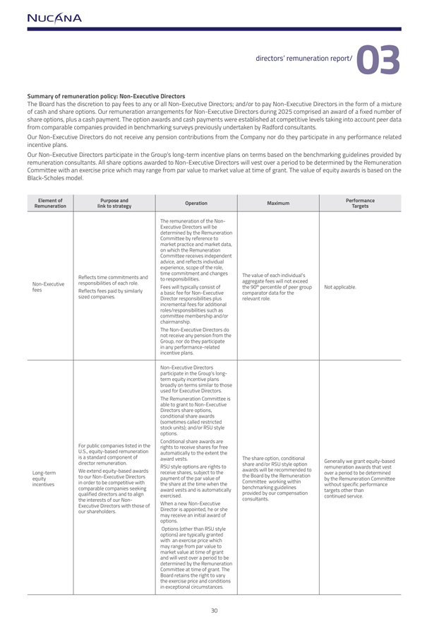
Summary of remuneration policy: Non-Executive Directors The Board has the discretion to pay fees to any or all Non-Executive Directors; and/or to pay Non-Executive Directors in the form of a mixture of cash and share options. Our remuneration arrangements for Non-Executive Directors during 2025 comprised an award of a fixed number of share options, plus a cash payment. The option awards and cash payments were established at competitive levels taking into account peer data from comparable companies provided in benchmarking surveys previously undertaken by Radford consultants. Our Non-Executive Directors do not receive any pension contributions from the Company nor do they participate in any performance related incentive plans. Our Non-Executive Directors participate in the Group’s long-term incentive plans on terms based on the benchmarking guidelines provided by remuneration consultants. All share options awarded to Non-Executive Directors will vest over a period to be determined by the Remuneration Committee with an exercise price which may range from par value to market value at time of grant. The value of equity awards is based on the Black-Scholes model. Element of Purpose and Operation Maximum PerformanceRemuneration link to strategy Targets The remuneration of the Non-Executive Directors will bedetermined by the RemunerationCommittee by reference tomarket practice and market data,on which the RemunerationCommittee receives independentadvice, and reflects individualexperience, scope of the role,Reflects time commitments andto time responsibilities. commitment and changesThe value of each individual’sNon-Executiveresponsibilities of each role.aggregate fees will not exceedFees will typically consist ofthe 90th percentile of peer group Not applicable.fees Reflects fees paid by similarlya basic fee for Non-Executivecomparator data for thesized companies.Director responsibilities plusrelevant role.incremental fees for additionalroles/responsibilities such ascommittee membership and/orchairmanship.The Non-Executive Directors donot receive any pension from theGroup, nor do they participatein any performance-relatedincentive plans.Non-Executive Directorsparticipate in the Group’s long-term equity incentive plansbroadly on terms similar to thoseused for Executive Directors.The Remuneration Committee isable to grant to Non-ExecutiveDirectors share options,conditional share awards(sometimes called restrictedstock units); and/or RSU styleoptions.Conditional share awards areFor public companies listed in therights to receive shares for freeU.S., equity-based remunerationautomatically to the extent theis a standard component ofaward vests.The share option, conditionaldirector remuneration. RSU style options are rights toshare and/or RSU style optionremuneration Generally we grant awards equity-based that vestLong-term We extend equity-based awardsreceive shares, subject to theawards will be recommended toover a period to be determinedequity to our Non-Executive Directorspayment of the par value ofthe Board by the Remunerationby the Remuneration Committeeincentives in order to be competitive withthe share at the time when theCommittee working withinwithout specific performancecomparable companies seekingaward vests and is automaticallybenchmarking guidelinestargets other thanqualified directors and to alignexercised.provided by our compensationcontinued service.the interests of our Non-consultants.Executive Directors with those ofWhen a new Non-Executiveour shareholders.Director is appointed, he or shemay receive an initial award ofoptions.Options (other than RSU styleoptions) are typically grantedwith an exercise price whichmay range from par value tomarket value at time of grantand will vest over a period to bedetermined by the RemunerationCommittee at time of grant. TheBoard retains the right to varythe exercise price and conditionsin exceptional circumstances.

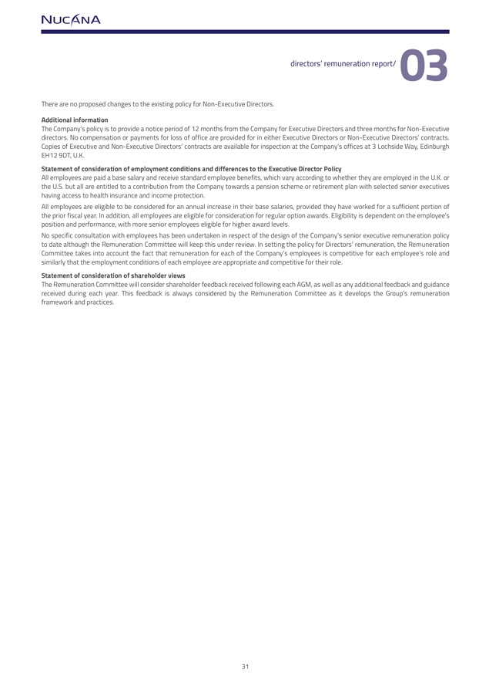
There are no proposed changes to the existing policy for Non-Executive Directors. Additional informationThe Company’s policy is to provide a notice period of 12 months from the Company for Executive Directors and three months for Non-Executive directors. No compensation or payments for loss of office are provided for in either Executive Directors or Non-Executive Directors’ contracts. Copies of Executive and Non-Executive Directors’ contracts are available for inspection at the Company’s offices at 3 Lochside Way, Edinburgh EH12 9DT, U.K.Statement of consideration of employment conditions and differences to the Executive Director PolicyAll employees are paid a base salary and receive standard employee benefits, which vary according to whether they are employed in the U.K. or the U.S. but all are entitled to a contribution from the Company towards a pension scheme or retirement plan with selected senior executives having access to health insurance and income protection.All employees are eligible to be considered for an annual increase in their base salaries, provided they have worked for a sufficient portion of the prior fiscal year. In addition, all employees are eligible for consideration for regular option awards. Eligibility is dependent on the employee’s position and performance, with more senior employees eligible for higher award levels. No specific consultation with employees has been undertaken in respect of the design of the Company’s senior executive remuneration policy to date although the Remuneration Committee will keep this under review. In setting the policy for Directors’ remuneration, the Remuneration Committee takes into account the fact that remuneration for each of the Company’s employees is competitive for each employee’s role and similarly that the employment conditions of each employee are appropriate and competitive for their role.Statement of consideration of shareholder viewsThe Remuneration Committee will consider shareholder feedback received following each AGM, as well as any additional feedback and guidance received during each year. This feedback is always considered by the Remuneration Committee as it develops the Group’s remuneration framework and practices.

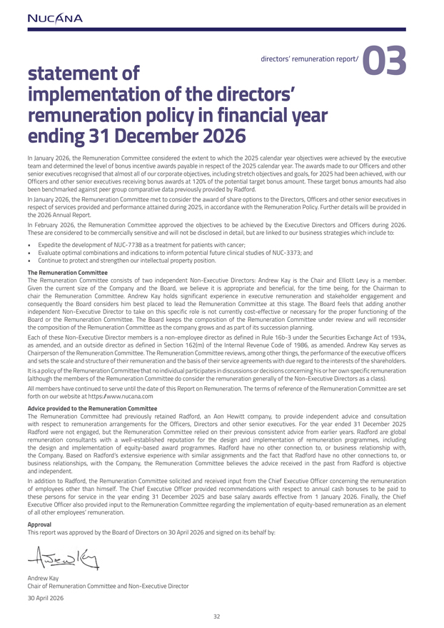
implementation of the directors’ remuneration policy in financial year ending 31 December 2026In January 2026, the Remuneration Committee considered the extent to which the 2025 calendar year objectives were achieved by the executive team and determined the level of bonus incentive awards payable in respect of the 2025 calendar year. The awards made to our Officers and other senior executives recognised that almost all of our corporate objectives, including stretch objectives and goals, for 2025 had been achieved, with our Officers and other senior executives receiving bonus awards at 120% of the potential target bonus amount. These target bonus amounts had also been benchmarked against peer group comparative data previously provided by Radford.In January 2026, the Remuneration Committee met to consider the award of share options to the Directors, Officers and other senior executives in respect of services provided and performance attained during 2025, in accordance with the Remuneration Policy. Further details will be provided in the 2026 Annual Report.In February 2026, the Remuneration Committee approved the objectives to be achieved by the Executive Directors and Officers during 2026. These are considered to be commercially sensitive and will not be disclosed in detail, but are linked to our business strategies which include to: Expedite the development of NUC-7738 as a treatment for patients with cancer; Evaluate optimal combinations and indications to inform potential future clinical studies of NUC-3373; and Continue to protect and strengthen our intellectual property position.The Remuneration Committee The Remuneration Committee consists of two independent Non-Executive Directors: Andrew Kay is the Chair and Elliott Levy is a member. Given the current size of the Company and the Board, we believe it is appropriate and beneficial, for the time being, for the Chairman to chair the Remuneration Committee. Andrew Kay holds significant experience in executive remuneration and stakeholder engagement and consequently the Board considers him best placed to lead the Remuneration Committee at this stage. The Board feels that adding another independent Non-Executive Director to take on this specific role is not currently cost-effective or necessary for the proper functioning of the Board or the Remuneration Committee. The Board keeps the composition of the Remuneration Committee under review and will reconsider the composition of the Remuneration Committee as the company grows and as part of its succession planning.Each of these Non-Executive Director members is a non-employee director as defined in Rule 16b-3 under the Securities Exchange Act of 1934, as amended, and an outside director as defined in Section 162(m) of the Internal Revenue Code of 1986, as amended. Andrew Kay serves as Chairperson of the Remuneration Committee. The Remuneration Committee reviews, among other things, the performance of the executive officers and sets the scale and structure of their remuneration and the basis of their service agreements with due regard to the interests of the shareholders. It is a policy of the Remuneration Committee that no individual participates in discussions or decisions concerning his or her own specific remuneration (although the members of the Remuneration Committee do consider the remuneration generally of the Non-Executive Directors as a class). All members have continued to serve until the date of this Report on Remuneration. The terms of reference of the Remuneration Committee are set forth on our website at https://www.nucana.comAdvice provided to the Remuneration Committee The Remuneration Committee had previously retained Radford, an Aon Hewitt company, to provide independent advice and consultation with respect to remuneration arrangements for the Officers, Directors and other senior executives. For the year ended 31 December 2025 Radford were not engaged, but the Remuneration Committee relied on their previous consistent advice from earlier years. Radford are global remuneration consultants with a well-established reputation for the design and implementation of remuneration programmes, including the design and implementation of equity-based award programmes. Radford have no other connection to, or business relationship with, the Company. Based on Radford’s extensive experience with similar assignments and the fact that Radford have no other connections to, or business relationships, with the Company, the Remuneration Committee believes the advice received in the past from Radford is objective and independent. In addition to Radford, the Remuneration Committee solicited and received input from the Chief Executive Officer concerning the remuneration of employees other than himself. The Chief Executive Officer provided recommendations with respect to annual cash bonuses to be paid to these persons for service in the year ending 31 December 2025 and base salary awards effective from 1 January 2026. Finally, the Chief Executive Officer also provided input to the Remuneration Committee regarding the implementation of equity-based remuneration as an element of all other employees’ remuneration.Approval This report was approved by the Board of Directors on 30 April 2026 and signed on its behalf by:Andrew KayChair of Remuneration Committee and Non-Executive Director30 April 2026




directors’ responsibilitiesThe directors are responsible for preparing the Strategic Report, the Directors’ Report, the Directors’ Remuneration Report and the financial statements in accordance with applicable United Kingdom law and regulations. Company law requires the directors to prepare financial statements for each financial year. Under that law the directors have elected to prepare the financial statements in conformity with International Financial Reporting Standards, or IFRS, as issued by the International Accounting Standards Board, or IASB, and in conformity with U.K.-adopted international accounting standards.Under Company law, the directors must not approve the financial statements unless they give a true and fair view of the state of affairs of the Group and Company and of the profit or loss of the Group and Company for that period. In preparing those financial statements the directors are required to:  present fairly the financial position, financial performance and cash flows of the Group and Company for that period;  prepare them on the going concern basis unless it is inappropriate to presume that the Group will continue in business;  select suitable accounting policies in accordance with IAS 8: Accounting Policies, Changes in Accounting Estimates and Errors and then apply them consistently;  present information, including accounting policies, in a manner that provides relevant, reliable, comparable and understandable information;  provide additional disclosures when compliance with the specific requirements in IFRSs is insufficient to enable users to understand the impact of particular transactions, other events and conditions on the Group’s and Company’s financial position and financial performance;  state that the Group and Company have complied with IFRSs, subject to any material departures disclosed and explained in the financial statements; and  make judgements and estimates that are reasonable and prudent.The directors are responsible for keeping adequate accounting records that are sufficient to show and explain the Group’s and Company’s transactions and disclose with reasonable accuracy at any time the financial position of the Group and Company and enable them to ensure that the financial statements comply with the Companies Act 2006. They are also responsible for safeguarding the assets of the Group and the Company and hence for taking reasonable steps for the prevention and detection of fraud and other irregularities.The directors are responsible for the maintenance and integrity of the corporate and financial information included on the Company’s website. The names of the directors are set out on page 17 of this report.

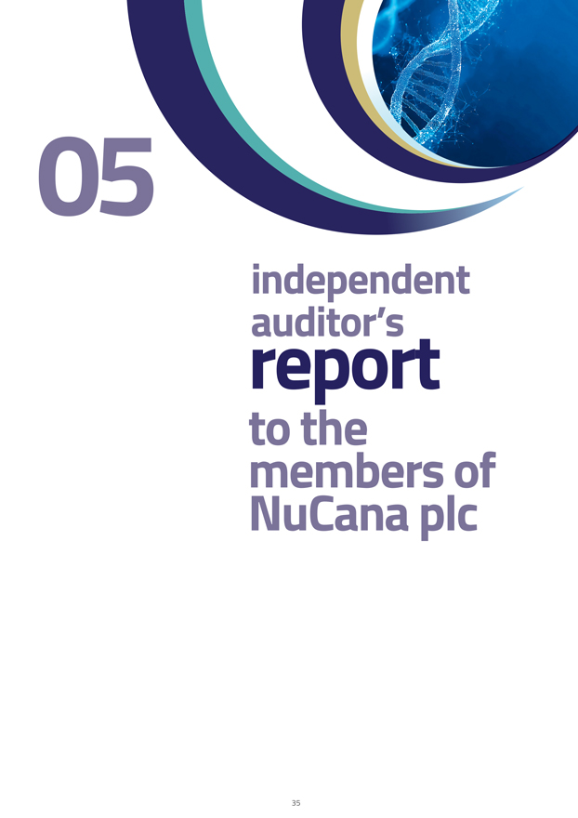

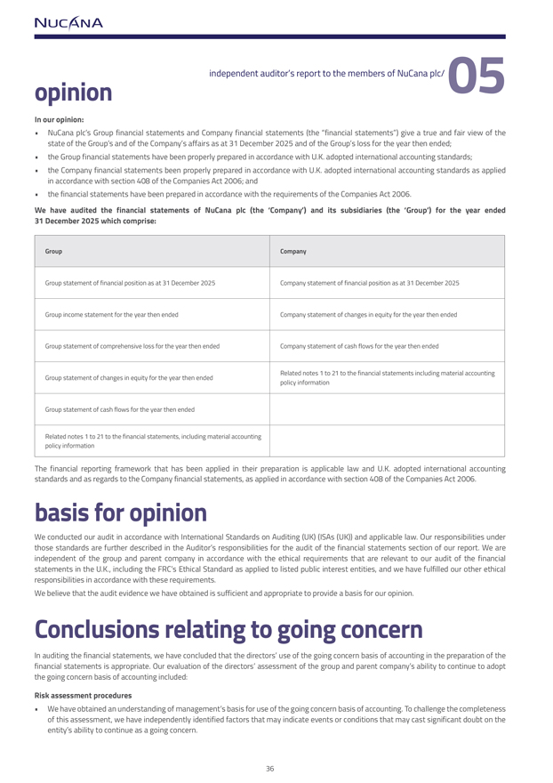
In our opinion: NuCana plc’s Group financial statements and Company financial statements (the “financial statements”) give a true and fair view of the state of the Group’s and of the Company’s affairs as at 31 December 2025 and of the Group’s loss for the year then ended;  the Group financial statements have been properly prepared in accordance with U.K. adopted international accounting standards;  the Company financial statements been properly prepared in accordance with U.K. adopted international accounting standards as applied in accordance with section 408 of the Companies Act 2006; and  the financial statements have been prepared in accordance with the requirements of the Companies Act 2006.We have audited the financial statements of NuCana plc (the ‘Company’) and its subsidiaries (the ‘Group’) for the year ended 31 December 2025 which comprise:Group CompanyGroup statement of financial position as at 31 December 2025 Company statement of financial position as at 31 December 2025Group income statement for the year then endedCompany statement of changes in equity for the year then endedGroup statement of comprehensive loss for the year then ended Company statement of cash flows for the year then endedGroup statement of changes in equity for the year then ended Related notes 1 to 21 to the financial statements including material accountingpolicy informationGroup statement of cash flows for the year then ended Related notes 1 to 21 to the financial statements, including material accountingpolicy informationstandards and as regards to the Company financial statements, as applied in accordance with section 408 of the Companies Act 2006. basis for opinionWe conducted our audit in accordance with International Standards on Auditing (UK) (ISAs (UK)) and applicable law. Our responsibilities under those standards are further described in the Auditor’s responsibilities for the audit of the financial statements section of our report. We are independent of the group and parent company in accordance with the ethical requirements that are relevant to our audit of the financial statements in the U.K., including the FRC’s Ethical Standard as applied to listed public interest entities, and we have fulfilled our other ethical responsibilities in accordance with these requirements.We believe that the audit evidence we have obtained is sufficient and appropriate to provide a basis for our opinion.Conclusions relating to going concern In auditing the financial statements, we have concluded that the directors’ use of the going concern basis of accounting in the preparation of the financial statements is appropriate. Our evaluation of the directors’ assessment of the group and parent company’s ability to continue to adopt the going concern basis of accounting included:Risk assessment procedures We have obtained an understanding of management’s basis for use of the going concern basis of accounting. To challenge the completeness of this assessment, we have independently identified factors that may indicate events or conditions that may cast significant doubt on the entity’s ability to continue as a going concern.

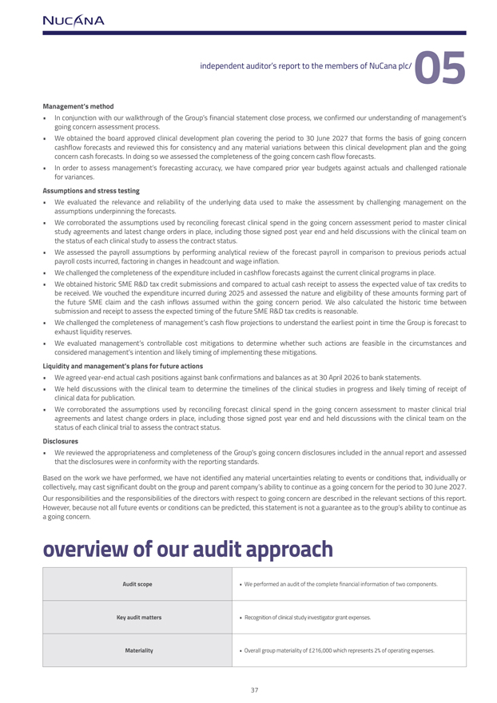
Management’s method In conjunction with our walkthrough of the Group’s financial statement close process, we confirmed our understanding of management’s going concern assessment process. We obtained the board approved clinical development plan covering the period to 30 June 2027 that forms the basis of going concern cashflow forecasts and reviewed this for consistency and any material variations between this clinical development plan and the going concern cash forecasts. In doing so we assessed the completeness of the going concern cash flow forecasts. In order to assess management’s forecasting accuracy, we have compared prior year budgets against actuals and challenged rationale for variances.Assumptions and stress testing We evaluated the relevance and reliability of the underlying data used to make the assessment by challenging management on the assumptions underpinning the forecasts.  We corroborated the assumptions used by reconciling forecast clinical spend in the going concern assessment period to master clinical study agreements and latest change orders in place, including those signed post year end and held discussions with the clinical team on the status of each clinical study to assess the contract status.  We assessed the payroll assumptions by performing analytical review of the forecast payroll in comparison to previous periods actual payroll costs incurred, factoring in changes in headcount and wage inflation.  We challenged the completeness of the expenditure included in cashflow forecasts against the current clinical programs in place. We obtained historic SME R&D tax credit submissions and compared to actual cash receipt to assess the expected value of tax credits to be received. We vouched the expenditure incurred during 2025 and assessed the nature and eligibility of these amounts forming part of the future SME claim and the cash inflows assumed within the going concern period. We also calculated the historic time between submission and receipt to assess the expected timing of the future SME R&D tax credits is reasonable.  We challenged the completeness of management’s cash flow projections to understand the earliest point in time the Group is forecast to exhaust liquidity reserves. We evaluated management’s controllable cost mitigations to determine whether such actions are feasible in the circumstances and considered management’s intention and likely timing of implementing these mitigations.Liquidity and management’s plans for future actions We agreed year-end actual cash positions against bank confirmations and balances as at 30 April 2026 to bank statements. We held discussions with the clinical team to determine the timelines of the clinical studies in progress and likely timing of receipt of clinical data for publication. We corroborated the assumptions used by reconciling forecast clinical spend in the going concern assessment to master clinical trial agreements and latest change orders in place, including those signed post year end and held discussions with the clinical team on the status of each clinical trial to assess the contract status.Disclosures We reviewed the appropriateness and completeness of the Group’s going concern disclosures included in the annual report and assessed that the disclosures were in conformity with the reporting standards.Based on the work we have performed, we have not identified any material uncertainties relating to events or conditions that, individually or collectively, may cast significant doubt on the group and parent company’s ability to continue as a going concern for the period to 30 June 2027. Our responsibilities and the responsibilities of the directors with respect to going concern are described in the relevant sections of this report. However, because not all future events or conditions can be predicted, this statement is not a guarantee as to the group’s ability to continue as a going concern.Audit scope  We performed an audit of the complete financial information of two components.Key audit matters  Recognition of clinical study investigator grant expenses.Materiality  Overall group materiality of £216,000 which represents 2% of operating expenses.

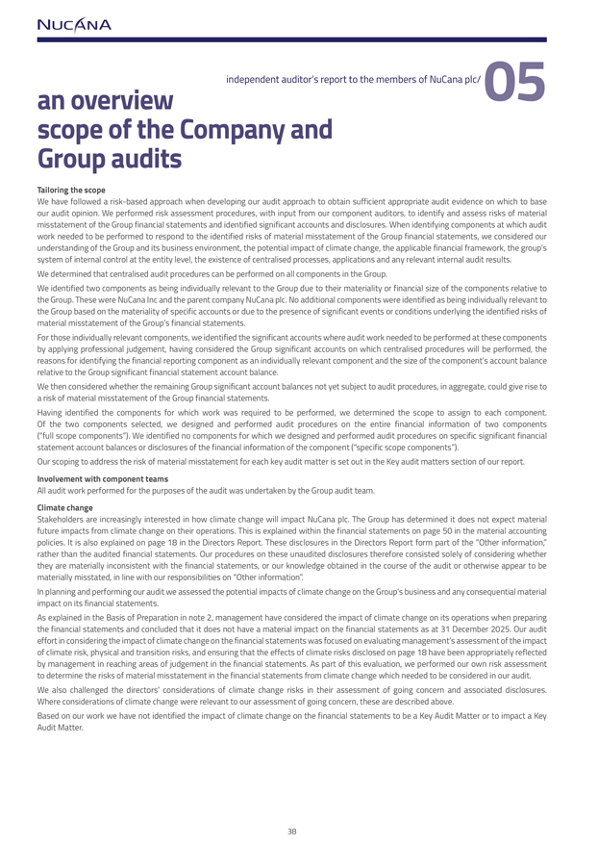
an overview scope of the Company and Group auditsTailoring the scopseWe have followed a risk-based approach when developing our audit approach to obtain sufficient appropriate audit evidence on which to base our audit opinion. We performed risk assessment procedures, with input from our component auditors, to identify and assess risks of material misstatement of the Group financial statements and identified significant accounts and disclosures. When identifying components at which audit work needed to be performed to respond to the identified risks of material misstatement of the Group financial statements, we considered our understanding of the Group and its business environment, the potential impact of climate change, the applicable financial framework, the group’s system of internal control at the entity level, the existence of centralised processes, applications and any relevant internal audit results.We determined that centralised audit procedures can be performed on all components in the Group.We identified two components as being individually relevant to the Group due to their materiality or financial size of the components relative to the Group. These were NuCana Inc and the parent company NuCana plc. No additional components were identified as being individually relevant to the Group based on the materiality of specific accounts or due to the presence of significant events or conditions underlying the identified risks of material misstatement of the Group’s financial statements. For those individually relevant components, we identified the significant accounts where audit work needed to be performed at these components by applying professional judgement, having considered the Group significant accounts on which centralised procedures will be performed, the reasons for identifying the financial reporting component as an individually relevant component and the size of the component’s account balance relative to the Group significant financial statement account balance.We then considered whether the remaining Group significant account balances not yet subject to audit procedures, in aggregate, could give rise to a risk of material misstatement of the Group financial statements. Having identified the components for which work was required to be performed, we determined the scope to assign to each component. Of the two components selected, we designed and performed audit procedures on the entire financial information of two components (“full scope components”). We identified no components for which we designed and performed audit procedures on specific significant financial statement account balances or disclosures of the financial information of the component (“specific scope components”).Our scoping to address the risk of material misstatement for each key audit matter is set out in the Key audit matters section of our report.Involvement with component teams All audit work performed for the purposes of the audit was undertaken by the Group audit team.Climate change Stakeholders are increasingly interested in how climate change will impact NuCana plc. The Group has determined it does not expect material future impacts from climate change on their operations. This is explained within the financial statements on page 50 in the material accounting policies. It is also explained on page 18 in the Directors Report. These disclosures in the Directors Report form part of the “Other information,” rather than the audited financial statements. Our procedures on these unaudited disclosures therefore consisted solely of considering whether they are materially inconsistent with the financial statements, or our knowledge obtained in the course of the audit or otherwise appear to be materially misstated, in line with our responsibilities on “Other information”. In planning and performing our audit we assessed the potential impacts of climate change on the Group’s business and any consequential material impact on its financial statements. As explained in the Basis of Preparation in note 2, management have considered the impact of climate change on its operations when preparing the financial statements and concluded that it does not have a material impact on the financial statements as at 31 December 2025. Our audit effort in considering the impact of climate change on the financial statements was focused on evaluating management’s assessment of the impact of climate risk, physical and transition risks, and ensuring that the effects of climate risks disclosed on page 18 have been appropriately reflected by management in reaching areas of judgement in the financial statements. As part of this evaluation, we performed our own risk assessment to determine the risks of material misstatement in the financial statements from climate change which needed to be considered in our audit. We also challenged the directors’ considerations of climate change risks in their assessment of going concern and associated disclosures. Where considerations of climate change were relevant to our assessment of going concern, these are described above. Based on our work we have not identified the impact of climate change on the financial statements to be a Key Audit Matter or to impact a Key Audit Matter.

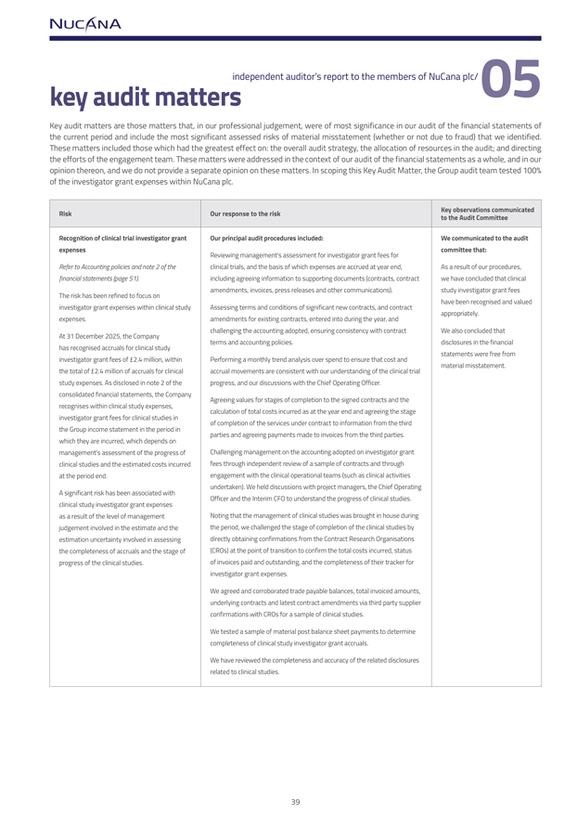
Key audit matters are those matters that, in our professional judgement, were of most significance in our audit of the financial statements of the current period and include the most significant assessed risks of material misstatement (whether or not due to fraud) that we identified. These matters included those which had the greatest effect on: the overall audit strategy, the allocation of resources in the audit; and directing the efforts of the engagement team. These matters were addressed in the context of our audit of the financial statements as a whole, and in our opinion thereon, and we do not provide a separate opinion on these matters. In scoping this Key Audit Matter, the Group audit team tested 100% of the investigator grant expenses within NuCana plc.RiskOur response to the riskKey observations communicatedto the Audit CommitteeRecognition of clinical trial investigator grantOur principal audit procedures included:We communicated to the auditexpensescommittee that:Reviewing management’s assessment for investigator grant fees forRefer to Accounting policies and note 2 of theclinical trials, and the basis of which expenses are accrued at year end,As a result of our procedures,financial statements (page 51).including agreeing information to supporting documents (contracts, contractwe have concluded that clinicalThe risk has been refined to focus onamendments, invoices, press releases and other communications).study investigator grant feesinvestigator grant expenses within clinical studyAssessing terms and conditions of significant new contracts, and contracthave been recognised and valuedexpenses.amendments for existing contracts, entered into during the year, andappropriately.At 31 December 2025, the Companychallenging the accounting adopted, ensuring consistency with contractWe also concluded thathas recognised accruals for clinical studyterms and accounting policies.disclosures in the financialinvestigator grant fees of £2.4 million, withinPerforming a monthly trend analysis over spend to ensure that cost andstatements were free fromthe total of £2.4 million of accruals for clinicalaccrual movements are consistent with our understanding of the clinical trialmaterial misstatement.study expenses. As disclosed in note 2 of theprogress, and our discussions with the Chief Operating Officer.consolidated financial statements, the CompanyAgreeing values for stages of completion to the signed contracts and therecognises within clinical study expenses,calculation of total costs incurred as at the year end and agreeing the stageinvestigator grant fees for clinical studies inof completion of the services under contract to information from the thirdthe Group income statement in the period inparties and agreeing payments made to invoices from the third parties.which they are incurred, which depends onmanagement’s assessment of the progress ofChallenging management on the accounting adopted on investigator grantclinical studies and the estimated costs incurredfees through independent review of a sample of contracts and throughat the period end.engagement with the clinical operational teams (such as clinical activitiesundertaken). We held discussions with project managers, the Chief OperatingA significant risk has been associated withOfficer and the Interim CFO to understand the progress of clinical studies.clinical study investigator grant expensesas a result of the level of managementNoting that the management of clinical studies was brought in house duringjudgement involved in the estimate and thethe period, we challenged the stage of completion of the clinical studies byestimation uncertainty involved in assessingdirectly obtaining confirmations from the Contract Research Organisationsthe completeness of accruals and the stage of(CROs) at the point of transition to confirm the total costs incurred, statusprogress of the clinical studies.of invoices paid and outstanding, and the completeness of their tracker forinvestigator grant expenses.We agreed and corroborated trade payable balances, total invoiced amounts,underlying contracts and latest contract amendments via third party supplierconfirmations with CROs for a sample of clinical studies.We tested a sample of material post balance sheet payments to determinecompleteness of clinical study investigator grant accruals.We have reviewed the completeness and accuracy of the related disclosuresrelated to clinical studies.

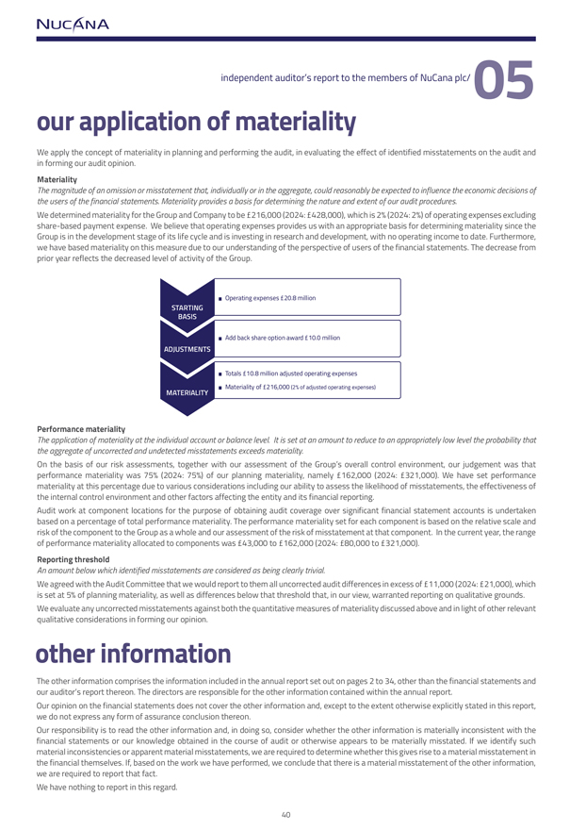
We apply the concept of materiality in planning and performing the audit, in evaluating the effect of identified misstatements on the audit and in forming our audit opinion. MaterialityThe magnitude of an omission or misstatement that, individually or in the aggregate, could reasonably be expected to influence the economic decisions of the users of the financial statements. Materiality provides a basis for determining the nature and extent of our audit procedures.We determined materiality for the Group and Company to be £216,000 (2024: £428,000), which is 2% (2024: 2%) of operating expenses excluding share-based payment expense. We believe that operating expenses provides us with an appropriate basis for determining materiality since the Group is in the development stage of its life cycle and is investing in research and development, with no operating income to date. Furthermore, we have based materiality on this measure due to our understanding of the perspective of users of the financial statements. The decrease from prior year reflects the decreased level of activity of the Group.Performance materialityThe application of materiality at the individual account or balance level. It is set at an amount to reduce to an appropriately low level the probability that the aggregate of uncorrected and undetected misstatements exceeds materiality.On the basis of our risk assessments, together with our assessment of the Group’s overall control environment, our judgement was that performance materiality was 75% (2024: 75%) of our planning materiality, namely £162,000 (2024: £321,000). We have set performance materiality at this percentage due to various considerations including our ability to assess the likelihood of misstatements, the effectiveness of the internal control environment and other factors affecting the entity and its financial reporting.Audit work at component locations for the purpose of obtaining audit coverage over significant financial statement accounts is undertaken based on a percentage of total performance materiality. The performance materiality set for each component is based on the relative scale and risk of the component to the Group as a whole and our assessment of the risk of misstatement at that component. In the current year, the range of performance materiality allocated to components was £43,000 to £162,000 (2024: £80,000 to £321,000). Reporting thresholdAn amount below which identified misstatements are considered as being clearly trivial.We agreed with the Audit Committee that we would report to them all uncorrected audit differences in excess of £11,000 (2024: £21,000), which is set at 5% of planning materiality, as well as differences below that threshold that, in our view, warranted reporting on qualitative grounds. We evaluate any uncorrected misstatements against both the quantitative measures of materiality discussed above and in light of other relevant qualitative considerations in forming our opinion.other information The other information comprises the information included in the annual report set out on pages 2 to 34, other than the financial statements and our auditor’s report thereon. The directors are responsible for the other information contained within the annual report.Our opinion on the financial statements does not cover the other information and, except to the extent otherwise explicitly stated in this report, we do not express any form of assurance conclusion thereon. Our responsibility is to read the other information and, in doing so, consider whether the other information is materially inconsistent with the financial statements or our knowledge obtained in the course of audit or otherwise appears to be materially misstated. If we identify such material inconsistencies or apparent material misstatements, we are required to determine whether this gives rise to a material misstatement in the financial themselves. If, based on the work we have performed, we conclude that there is a material misstatement of the other information, we are required to report that fact.We have nothing to report in this regard.

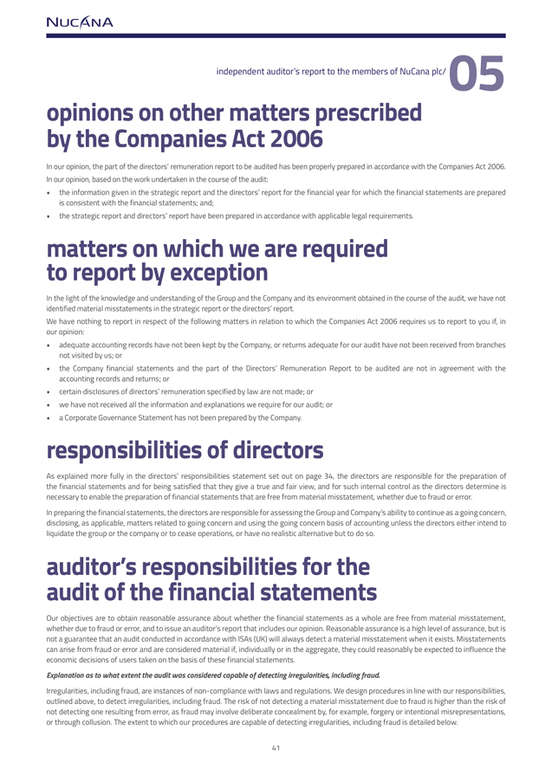
opinions on other matters prescribed by the Companies Act 2006In our opinion, the part of the directors’ remuneration report to be audited has been properly prepared in accordance with the Companies Act 2006. In our opinion, based on the work undertaken in the course of the audit:  the information given in the strategic report and the directors’ report for the financial year for which the financial statements are prepared is consistent with the financial statements; and;  the strategic report and directors’ report have been prepared in accordance with applicable legal requirements.matters on which we are required to report by exceptionIn the light of the knowledge and understanding of the Group and the Company and its environment obtained in the course of the audit, we have not identified material misstatements in the strategic report or the directors’ report.We have nothing to report in respect of the following matters in relation to which the Companies Act 2006 requires us to report to you if, in our opinion:  adequate accounting records have not been kept by the Company, or returns adequate for our audit have not been received from branches not visited by us; or  the Company financial statements and the part of the Directors’ Remuneration Report to be audited are not in agreement with the accounting records and returns; or  certain disclosures of directors’ remuneration specified by law are not made; or  we have not received all the information and explanations we require for our audit; or  a Corporate Governance Statement has not been prepared by the Company.responsibilities of directorsAs explained more fully in the directors’ responsibilities statement set out on page 34, the directors are responsible for the preparation of the financial statements and for being satisfied that they give a true and fair view, and for such internal control as the directors determine is necessary to enable the preparation of financial statements that are free from material misstatement, whether due to fraud or error. In preparing the financial statements, the directors are responsible for assessing the Group and Company’s ability to continue as a going concern, disclosing, as applicable, matters related to going concern and using the going concern basis of accounting unless the directors either intend to liquidate the group or the company or to cease operations, or have no realistic alternative but to do so.auditor’s responsibilities for the audit of the financial statementsOur objectives are to obtain reasonable assurance about whether the financial statements as a whole are free from material misstatement, whether due to fraud or error, and to issue an auditor’s report that includes our opinion. Reasonable assurance is a high level of assurance, but is not a guarantee that an audit conducted in accordance with ISAs (UK) will always detect a material misstatement when it exists. Misstatements can arise from fraud or error and are considered material if, individually or in the aggregate, they could reasonably be expected to influence the economic decisions of users taken on the basis of these financial statements. Explanation as to what extent the audit was considered capable of detecting irregularities, including fraud. Irregularities, including fraud, are instances of non-compliance with laws and regulations. We design procedures in line with our responsibilities, outlined above, to detect irregularities, including fraud. The risk of not detecting a material misstatement due to fraud is higher than the risk of not detecting one resulting from error, as fraud may involve deliberate concealment by, for example, forgery or intentional misrepresentations, or through collusion. The extent to which our procedures are capable of detecting irregularities, including fraud is detailed below.

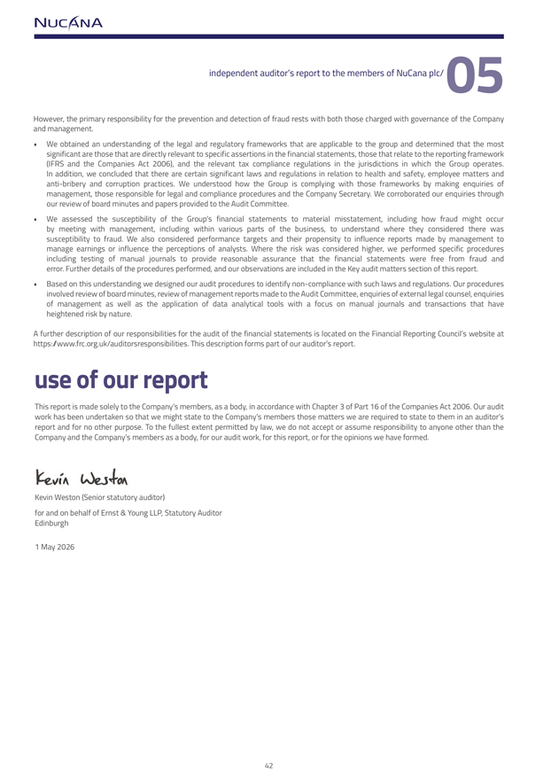
However, the primary responsibility for the prevention and detection of fraud rests with both those charged with governance of the Company and management.  We obtained an understanding of the legal and regulatory frameworks that are applicable to the group and determined that the most significant are those that are directly relevant to specific assertions in the financial statements, those that relate to the reporting framework (IFRS and the Companies Act 2006), and the relevant tax compliance regulations in the jurisdictions in which the Group operates. In addition, we concluded that there are certain significant laws and regulations in relation to health and safety, employee matters and anti-bribery and corruption practices. We understood how the Group is complying with those frameworks by making enquiries of management, those responsible for legal and compliance procedures and the Company Secretary. We corroborated our enquiries through our review of board minutes and papers provided to the Audit Committee. We assessed the susceptibility of the Group’s financial statements to material misstatement, including how fraud might occur by meeting with management, including within various parts of the business, to understand where they considered there was susceptibility to fraud. We also considered performance targets and their propensity to influence reports made by management to manage earnings or influence the perceptions of analysts. Where the risk was considered higher, we performed specific procedures including testing of manual journals to provide reasonable assurance that the financial statements were free from fraud and error. Further details of the procedures performed, and our observations are included in the Key audit matters section of this report. Based on this understanding we designed our audit procedures to identify non-compliance with such laws and regulations. Our procedures involved review of board minutes, review of management reports made to the Audit Committee, enquiries of external legal counsel, enquiries of management as well as the application of data analytical tools with a focus on manual journals and transactions that have heightened risk by nature.A further description of our responsibilities for the audit of the financial statements is located on the Financial Reporting Council’s website at https://www.frc.org.uk/auditorsresponsibilities. This description forms part of our auditor’s report.use of our report This report is made solely to the Company’s members, as a body, in accordance with Chapter 3 of Part 16 of the Companies Act 2006. Our audit work has been undertaken so that we might state to the Company’s members those matters we are required to state to them in an auditor’s report and for no other purpose. To the fullest extent permitted by law, we do not accept or assume responsibility to anyone other than the Company and the Company’s members as a body, for our audit work, for this report, or for the opinions we have formed. Kevin Weston (Senior statutory auditor) for and on behalf of Ernst & Young LLP, Statutory Auditor Edinburgh1 May 2026



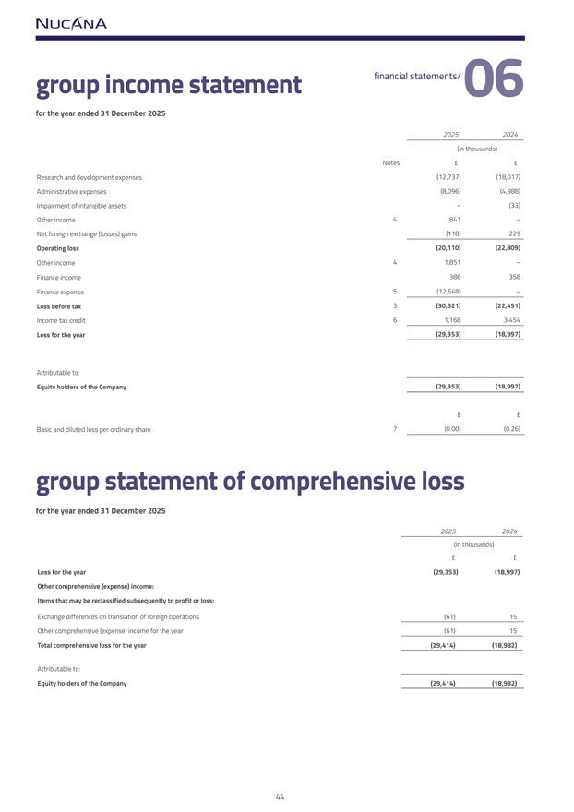
for the year ended 31 December 202520252024(in thousands)Notes££Research and development expenses(12,737)(18,017)Administrative expenses(8,096)(4,988)Impairment of intangible assets–(33)Other income4841–Net foreign exchange (losses) gains(118)229Operating loss(20,110)(22,809)Other income41,851–Finance income386358Finance expense5(12,648)–Loss before tax3(30,521)(22,451)Income tax credit61,1683,454Loss for the year(29,353)(18,997)Attributable to:Equity holders of the Company(29,353)(18,997)££Basic and diluted loss per ordinary share7(0.00)(0.26)group statement of comprehensive lossfor the year ended 31 December 202520252024(in thousands)££Loss for the year(29,353)(18,997)Other comprehensive (expense) income:Items that may be reclassified subsequently to profit or loss:Exchange differences on translation of foreign operations(61)15Other comprehensive (expense) income for the year(61)15Total comprehensive loss for the year(29,414)(18,982)Attributable to:Equity holders of the Company(29,414)(18,982)

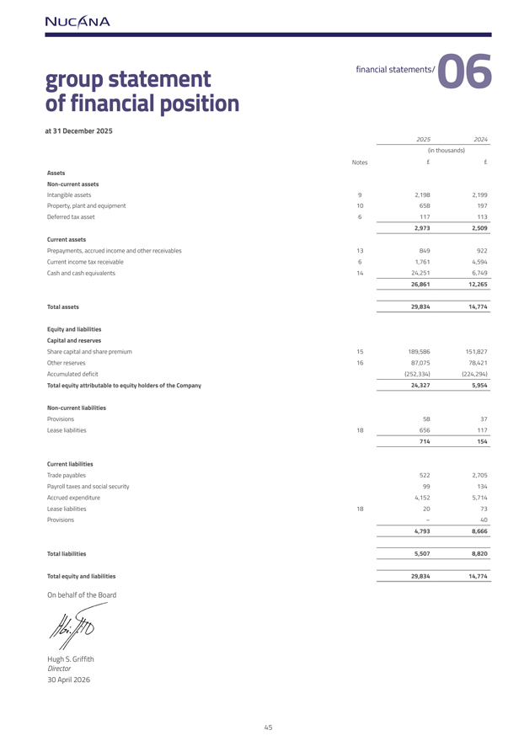
group statement of financial positionat 31 December 2025(in thousands)Notes££AssetsNon-current assetsIntangible assets92,1982,199Property, plant and equipment10658197Deferred tax asset61171132,9732,509Current assetsPrepayments, accrued income and other receivables13849922Current income tax receivable61,7614,594Cash and cash equivalents1424,2516,74926,86112,265Total assets29,83414,774Equity and liabilitiesCapital and reservesShare capital and share premium15189,586151,827Other reserves1687,07578,421Accumulated deficit(252,334)(224,294)Total equity attributable to equity holders of the Company24,3275,954Non-current liabilitiesProvisions5837Lease liabilities18656117714154Current liabilitiesTrade payables5222,705Payroll taxes and social security99134Accrued expenditure4,1525,714Lease liabilities182073Provisions–404,7938,666Total liabilities5,5078,820Total equity and liabilities29,83414,774On behalf of the Board Hugh S. GriffithDirector 30 April 2026

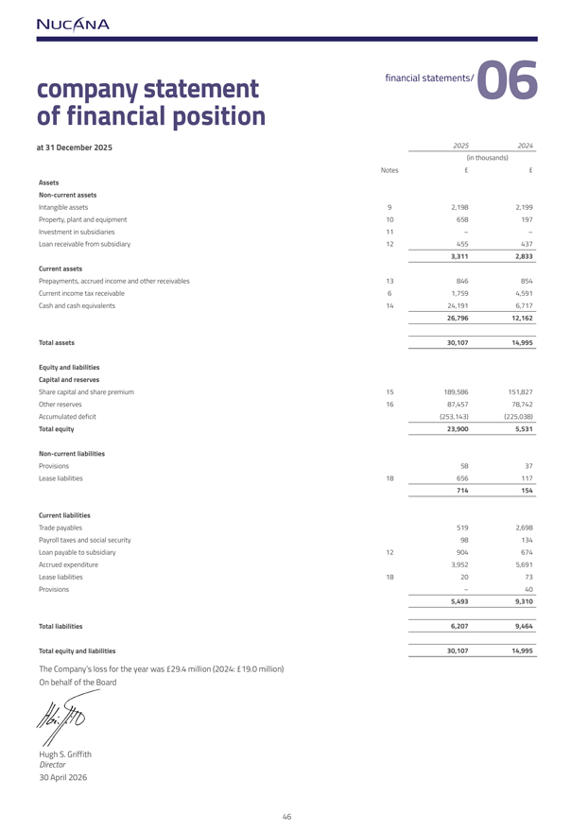
company statement of financial positionat 31 December 202520252024(in thousands)Notes££AssetsNon-current assetsIntangible assets92,1982,199Property, plant and equipment10658197Investment in subsidiaries11––Loan receivable from subsidiary124554373,3112,833Current assetsPrepayments, accrued income and other receivables13846854Current income tax receivable61,7594,591Cash and cash equivalents1424,1916,71726,79612,162Total assets30,10714,995Equity and liabilitiesCapital and reservesShare capital and share premium15189,586151,827Other reserves1687,45778,742Accumulated deficit(253,143)(225,038)Total equity23,9005,531Non-current liabilitiesProvisions5837Lease liabilities18656117714154Current liabilitiesTrade payables5192,698Payroll taxes and social security98134Loan payable to subsidiary12904674Accrued expenditure3,9525,691Lease liabilities182073Provisions–405,4939,310Total liabilities6,2079,464Total equity and liabilities30,10714,995The Company’s loss for the year was £29.4 million (2024: £19.0 million) On behalf of the Board Hugh S. GriffithDirector30 April 2026

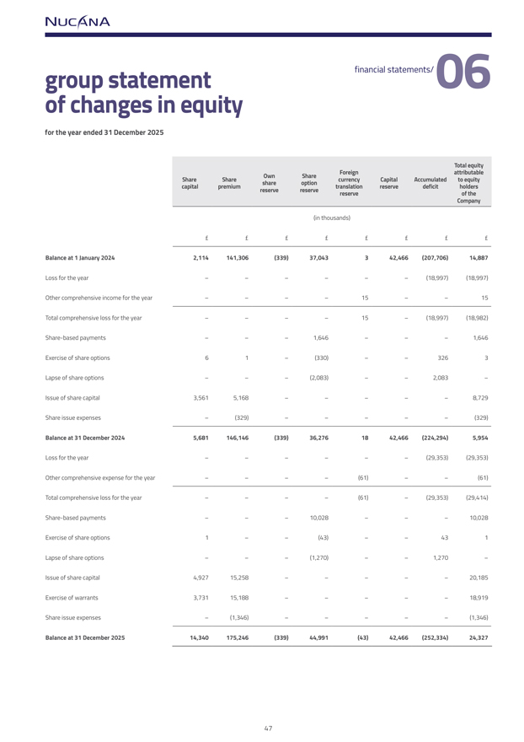
group statement of changes in equityfor the year ended 31 December 2025Total equityOwnShareForeignattributableShareSharecurrencyCapitalAccumulated to equityshareoptioncapitalpremiumtranslationreservedeficitholdersreservereservereserveof theCompany(in thousands)££££££££Balance at 1 January 20242,114141,306(339)37,043342,466(207,706)14,887Loss for the year––––––(18,997)(18,997)Other comprehensive income for the year––––15––15Total comprehensive loss for the year––––15–(18,997)(18,982)Share-based payments–––1,646–––1,646Exercise of share options61–(330)––3263Lapse of share options–––(2,083)––2,083–Issue of share capital3,5615,168–––––8,729Share issue expenses–(329)–––––(329)Balance at 31 December 20245,681146,146(339)36,2761842,466(224,294)5,954Loss for the year––––––(29,353)(29,353)Other comprehensive expense for the year––––(61)––(61)Total comprehensive loss for the year––––(61)–(29,353)(29,414)Share-based payments–––10,028–––10,028Exercise of share options1––(43)––431Lapse of share options–––(1,270)––1,270–Issue of share capital4,92715,258–––––20,185Exercise of warrants3,73115,188–––––18,919Share issue expenses–(1,346)–––––(1,346)Balance at 31 December 202514,340175,246(339)44,991(43)42,466(252,334)24,327

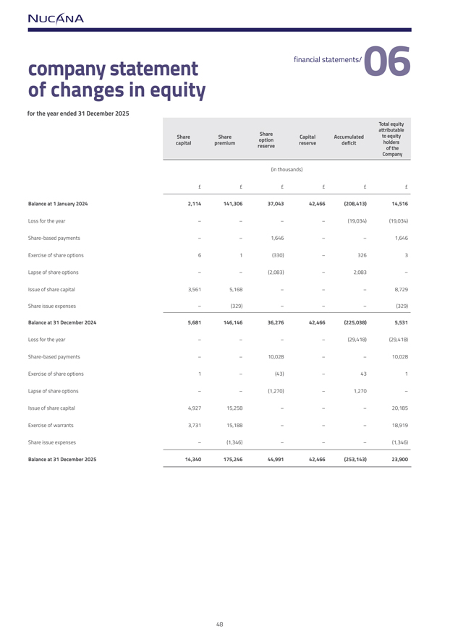
company statement of changes in equityfor the year ended 31 December 2025Total equityShareattributableShareShareCapitalAccumulatedto equitycapitalpremiumoptionreservedeficitholdersreserveof theCompany(in thousands)££££££Balance at 1 January 20242,114141,30637,04342,466(208,413)14,516Loss for the year––––(19,034)(19,034)Share-based payments––1,646––1,646Exercise of share options61(330)–3263Lapse of share options––(2,083)–2,083–Issue of share capital3,5615,168–––8,729Share issue expenses–(329)–––(329)Balance at 31 December 20245,681146,14636,27642,466(225,038)5,531Loss for the year––––(29,418)(29,418)Share-based payments––10,028––10,028Exercise of share options1–(43)–431Lapse of share options––(1,270)–1,270–Issue of share capital4,92715,258–––20,185Exercise of warrants3,73115,188–––18,919Share issue expenses–(1,346)–––(1,346)Balance at 31 December 202514,340175,24644,99142,466(253,143)23,900

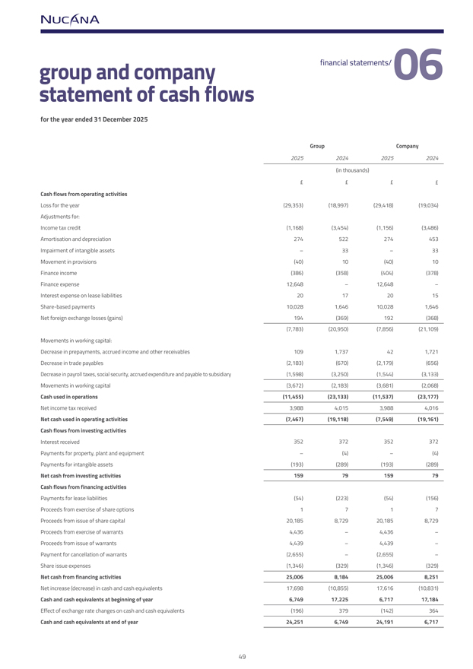
group and company statement of cash flowsfor the year ended 31 December 2025GroupCompany2025202420252024(in thousands)££££Cash flows from operating activitiesLoss for the year(29,353)(18,997)(29,418)(19,034)Adjustments for:Income tax credit(1,168)(3,454)(1,156)(3,486)Amortisation and depreciation274522274453Impairment of intangible assets–33–33Movement in provisions(40)10(40)10Finance income(386)(358)(404)(378)Finance expense12,648–12,648–Interest expense on lease liabilities20172015Share-based payments10,0281,64610,0281,646Net foreign exchange losses (gains)194(369)192(368)(7,783)(20,950)(7,856)(21,109)Movements in working capital:Decrease in prepayments, accrued income and other receivables1091,737421,721Decrease in trade payables(2,183)(670)(2,179)(656)Decrease in payroll taxes, social security, accrued expenditure and payable to subsidiary(1,598)(3,250)(1,544)(3,133)Movements in working capital(3,672)(2,183)(3,681)(2,068)Cash used in operations(11,455)(23,133)(11,537)(23,177)Net income tax received3,9884,0153,9884,016Net cash used in operating activities(7,467)(19,118)(7,549)(19,161)Cash flows from investing activitiesInterest received352372352372Payments for property, plant and equipment–(4)–(4)Payments for intangible assets(193)(289)(193)(289)Net cash from investing activities1597915979Cash flows from financing activitiesPayments for lease liabilities(54)(223)(54)(156)Proceeds from exercise of share options1717Proceeds from issue of share capital20,1858,72920,1858,729Proceeds from exercise of warrants4,436–4,436–Proceeds from issue of warrants4,439–4,439–Payment for cancellation of warrants(2,655)–(2,655)–Share issue expenses(1,346)(329)(1,346)(329)Net cash from financing activities25,0068,18425,0068,251Net increase (decrease) in cash and cash equivalents17,698(10,855)17,616(10,831)Cash and cash equivalents at beginning of year6,74917,2256,71717,184Effect of exchange rate changes on cash and cash equivalents(196)379(142)364Cash and cash equivalents at end of year24,2516,74924,1916,717

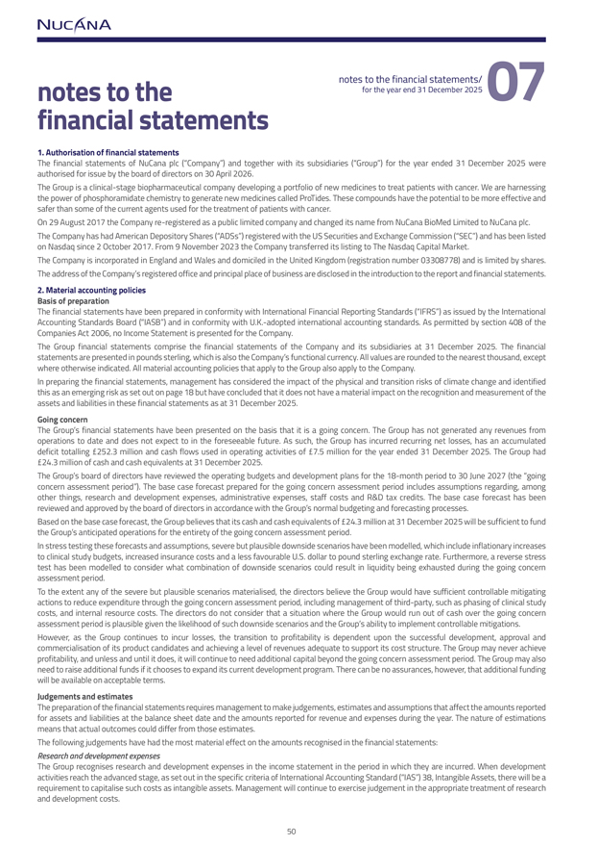
for the year end 31 December 2025financial statements1. Authorisation of financial statements The financial statements of NuCana plc (“Company”) and together with its subsidiaries (“Group”) for the year ended 31 December 2025 were authorised for issue by the board of directors on 30 April 2026. The Group is a clinical-stage biopharmaceutical company developing a portfolio of new medicines to treat patients with cancer. We are harnessing the power of phosphoramidate chemistry to generate new medicines called ProTides. These compounds have the potential to be more effective and safer than some of the current agents used for the treatment of patients with cancer.On 29 August 2017 the Company re-registered as a public limited company and changed its name from NuCana BioMed Limited to NuCana plc. The Company has had American Depository Shares (“ADSs”) registered with the US Securities and Exchange Commission (“SEC”) and has been listed on Nasdaq since 2 October 2017. From 9 November 2023 the Company transferred its listing to The Nasdaq Capital Market. The Company is incorporated in England and Wales and domiciled in the United Kingdom (registration number 03308778) and is limited by shares. The address of the Company’s registered office and principal place of business are disclosed in the introduction to the report and financial statements.2. Material accounting policies Basis of preparationThe financial statements have been prepared in conformity with International Financial Reporting Standards (“IFRS”) as issued by the International Accounting Standards Board (“IASB”) and in conformity with U.K.-adopted international accounting standards. As permitted by section 408 of the Companies Act 2006, no Income Statement is presented for the Company.The Group financial statements comprise the financial statements of the Company and its subsidiaries at 31 December 2025. The financial statements are presented in pounds sterling, which is also the Company’s functional currency. All values are rounded to the nearest thousand, except where otherwise indicated. All material accounting policies that apply to the Group also apply to the Company.In preparing the financial statements, management has considered the impact of the physical and transition risks of climate change and identified this as an emerging risk as set out on page 18 but have concluded that it does not have a material impact on the recognition and measurement of the assets and liabilities in these financial statements as at 31 December 2025.Going concernThe Group’s financial statements have been presented on the basis that it is a going concern. The Group has not generated any revenues from operations to date and does not expect to in the foreseeable future. As such, the Group has incurred recurring net losses, has an accumulated deficit totalling £252.3 million and cash flows used in operating activities of £7.5 million for the year ended 31 December 2025. The Group had £24.3 million of cash and cash equivalents at 31 December 2025.The Group’s board of directors have reviewed the operating budgets and development plans for the 18-month period to 30 June 2027 (the “going concern assessment period”). The base case forecast prepared for the going concern assessment period includes assumptions regarding, among other things, research and development expenses, administrative expenses, staff costs and R&D tax credits. The base case forecast has been reviewed and approved by the board of directors in accordance with the Group’s normal budgeting and forecasting processes.Based on the base case forecast, the Group believes that its cash and cash equivalents of £24.3 million at 31 December 2025 will be sufficient to fund the Group’s anticipated operations for the entirety of the going concern assessment period.In stress testing these forecasts and assumptions, severe but plausible downside scenarios have been modelled, which include inflationary increases to clinical study budgets, increased insurance costs and a less favourable U.S. dollar to pound sterling exchange rate. Furthermore, a reverse stress test has been modelled to consider what combination of downside scenarios could result in liquidity being exhausted during the going concern assessment period.To the extent any of the severe but plausible scenarios materialised, the directors believe the Group would have sufficient controllable mitigating actions to reduce expenditure through the going concern assessment period, including management of third-party, such as phasing of clinical study costs, and internal resource costs. The directors do not consider that a situation where the Group would run out of cash over the going concern assessment period is plausible given the likelihood of such downside scenarios and the Group’s ability to implement controllable mitigations. However, as the Group continues to incur losses, the transition to profitability is dependent upon the successful development, approval and commercialisation of its product candidates and achieving a level of revenues adequate to support its cost structure. The Group may never achieve profitability, and unless and until it does, it will continue to need additional capital beyond the going concern assessment period. The Group may also need to raise additional funds if it chooses to expand its current development program. There can be no assurances, however, that additional funding will be available on acceptable terms. Judgements and estimatesThe preparation of the financial statements requires management to make judgements, estimates and assumptions that affect the amounts reported for assets and liabilities at the balance sheet date and the amounts reported for revenue and expenses during the year. The nature of estimations means that actual outcomes could differ from those estimates. The following judgements have had the most material effect on the amounts recognised in the financial statements:Research and development expensesThe Group recognises research and development expenses in the income statement in the period in which they are incurred. When development activities reach the advanced stage, as set out in the specific criteria of International Accounting Standard (“IAS”) 38, Intangible Assets, there will be a requirement to capitalise such costs as intangible assets. Management will continue to exercise judgement in the appropriate treatment of research and development costs.

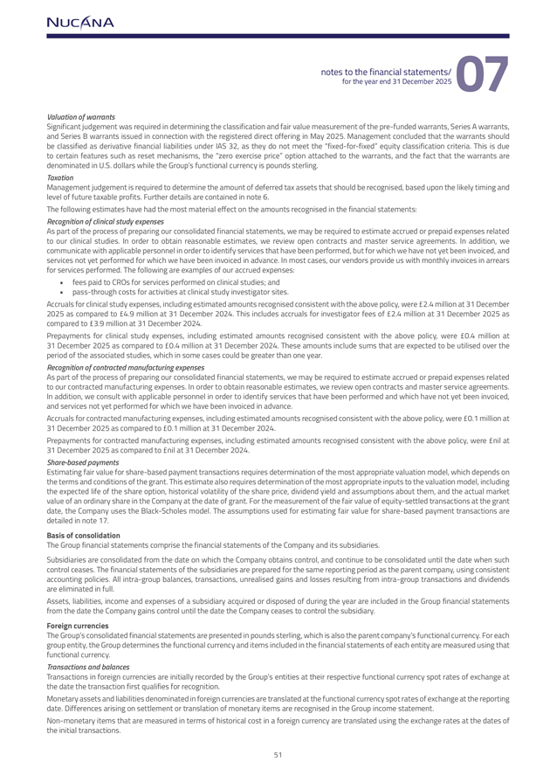
Valuation of warrantsSignificant judgement was required in determining the classification and fair value measurement of the pre-funded warrants, Series A warrants, and Series B warrants issued in connection with the registered direct offering in May 2025. Management concluded that the warrants should be classified as derivative financial liabilities under IAS 32, as they do not meet the “fixed-for-fixed” equity classification criteria. This is due to certain features such as reset mechanisms, the “zero exercise price” option attached to the warrants, and the fact that the warrants are denominated in U.S. dollars while the Group’s functional currency is pounds sterling.TaxationManagement judgement is required to determine the amount of deferred tax assets that should be recognised, based upon the likely timing and level of future taxable profits. Further details are contained in note 6. The following estimates have had the most material effect on the amounts recognised in the financial statements:Recognition of clinical study expensesAs part of the process of preparing our consolidated financial statements, we may be required to estimate accrued or prepaid expenses related to our clinical studies. In order to obtain reasonable estimates, we review open contracts and master service agreements. In addition, we communicate with applicable personnel in order to identify services that have been performed, but for which we have not yet been invoiced, and services not yet performed for which we have been invoiced in advance. In most cases, our vendors provide us with monthly invoices in arrears for services performed. The following are examples of our accrued expenses:  fees paid to CROs for services performed on clinical studies; and  pass-through costs for activities at clinical study investigator sites.Accruals for clinical study expenses, including estimated amounts recognised consistent with the above policy, were £2.4 million at 31 December 2025 as compared to £4.9 million at 31 December 2024. This includes accruals for investigator fees of £2.4 million at 31 December 2025 as compared to £3.9 million at 31 December 2024.Prepayments for clinical study expenses, including estimated amounts recognised consistent with the above policy, were £0.4 million at 31 December 2025 as compared to £0.4 million at 31 December 2024. These amounts include sums that are expected to be utilised over the period of the associated studies, which in some cases could be greater than one year.Recognition of contracted manufacturing expensesAs part of the process of preparing our consolidated financial statements, we may be required to estimate accrued or prepaid expenses related to our contracted manufacturing expenses. In order to obtain reasonable estimates, we review open contracts and master service agreements. In addition, we consult with applicable personnel in order to identify services that have been performed and which have not yet been invoiced, and services not yet performed for which we have been invoiced in advance. Accruals for contracted manufacturing expenses, including estimated amounts recognised consistent with the above policy, were £0.1 million at 31 December 2025 as compared to £0.1 million at 31 December 2024.Prepayments for contracted manufacturing expenses, including estimated amounts recognised consistent with the above policy, were £nil at 31 December 2025 as compared to £nil at 31 December 2024.Share-based paymentsEstimating fair value for share-based payment transactions requires determination of the most appropriate valuation model, which depends on the terms and conditions of the grant. This estimate also requires determination of the most appropriate inputs to the valuation model, including the expected life of the share option, historical volatility of the share price, dividend yield and assumptions about them, and the actual market value of an ordinary share in the Company at the date of grant. For the measurement of the fair value of equity-settled transactions at the grant date, the Company uses the Black-Scholes model. The assumptions used for estimating fair value for share-based payment transactions are detailed in note 17.Basis of consolidationThe Group financial statements comprise the financial statements of the Company and its subsidiaries.Subsidiaries are consolidated from the date on which the Company obtains control, and continue to be consolidated until the date when such control ceases. The financial statements of the subsidiaries are prepared for the same reporting period as the parent company, using consistent accounting policies. All intra-group balances, transactions, unrealised gains and losses resulting from intra-group transactions and dividends are eliminated in full.Assets, liabilities, income and expenses of a subsidiary acquired or disposed of during the year are included in the Group financial statements from the date the Company gains control until the date the Company ceases to control the subsidiary.Foreign currenciesThe Group’s consolidated financial statements are presented in pounds sterling, which is also the parent company’s functional currency. For each group entity, the Group determines the functional currency and items included in the financial statements of each entity are measured using that functional currency. Transactions and balances Transactions in foreign currencies are initially recorded by the Group’s entities at their respective functional currency spot rates of exchange at the date the transaction first qualifies for recognition.Monetary assets and liabilities denominated in foreign currencies are translated at the functional currency spot rates of exchange at the reporting date. Differences arising on settlement or translation of monetary items are recognised in the Group income statement.Non-monetary items that are measured in terms of historical cost in a foreign currency are translated using the exchange rates at the dates of the initial transactions.

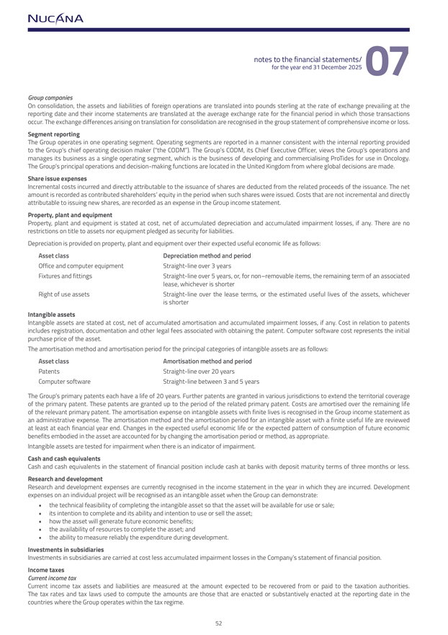
Group companies On consolidation, the assets and liabilities of foreign operations are translated into pounds sterling at the rate of exchange prevailing at the reporting date and their income statements are translated at the average exchange rate for the financial period in which those transactions occur. The exchange differences arising on translation for consolidation are recognised in the group statement of comprehensive income or loss.Segment reportingThe Group operates in one operating segment. Operating segments are reported in a manner consistent with the internal reporting provided to the Group’s chief operating decision maker (“the CODM”). The Group’s CODM, its Chief Executive Officer, views the Group’s operations and manages its business as a single operating segment, which is the business of developing and commercialising ProTides for use in Oncology. The Group’s principal operations and decision-making functions are located in the United Kingdom from where global decisions are made.Share issue expensesIncremental costs incurred and directly attributable to the issuance of shares are deducted from the related proceeds of the issuance. The net amount is recorded as contributed shareholders’ equity in the period when such shares were issued. Costs that are not incremental and directly attributable to issuing new shares, are recorded as an expense in the Group income statement.Property, plant and equipmentProperty, plant and equipment is stated at cost, net of accumulated depreciation and accumulated impairment losses, if any. There are no restrictions on title to assets nor equipment pledged as security for liabilities.Depreciation is provided on property, plant and equipment over their expected useful economic life as follows:Asset classDepreciation method and periodOffice and computer equipmentStraight-line over 3 yearsFixtures and fittingsStraight-line over 5 years, or, for non–removable items, the remaining term of an associatedlease, whichever is shorterRight of use assetsStraight-line over the lease terms, or the estimated useful lives of the assets, whicheveris shorterIntangible assetsIntangible assets are stated at cost, net of accumulated amortisation and accumulated impairment losses, if any. Cost in relation to patents includes registration, documentation and other legal fees associated with obtaining the patent. Computer software cost represents the initial purchase price of the asset. The amortisation method and amortisation period for the principal categories of intangible assets are as follows:Asset classAmortisation method and periodPatentsStraight-line over 20 yearsComputer softwareStraight-line between 3 and 5 yearsThe Group’s primary patents each have a life of 20 years. Further patents are granted in various jurisdictions to extend the territorial coverage of the primary patent. These patents are granted up to the period of the related primary patent. Costs are amortised over the remaining life of the relevant primary patent. The amortisation expense on intangible assets with finite lives is recognised in the Group income statement as an administrative expense. The amortisation method and the amortisation period for an intangible asset with a finite useful life are reviewed at least at each financial year end. Changes in the expected useful economic life or the expected pattern of consumption of future economic benefits embodied in the asset are accounted for by changing the amortisation period or method, as appropriate.Intangible assets are tested for impairment when there is an indicator of impairment.Cash and cash equivalents Cash and cash equivalents in the statement of financial position include cash at banks with deposit maturity terms of three months or less.Research and developmentResearch and development expenses are currently recognised in the income statement in the year in which they are incurred. Development expenses on an individual project will be recognised as an intangible asset when the Group can demonstrate:  the technical feasibility of completing the intangible asset so that the asset will be available for use or sale;  its intention to complete and its ability and intention to use or sell the asset;  how the asset will generate future economic benefits;  the availability of resources to complete the asset; and  the ability to measure reliably the expenditure during development.Investments in subsidiariesInvestments in subsidiaries are carried at cost less accumulated impairment losses in the Company’s statement of financial position.Income taxesCurrent income taxCurrent income tax assets and liabilities are measured at the amount expected to be recovered from or paid to the taxation authorities. The tax rates and tax laws used to compute the amounts are those that are enacted or substantively enacted at the reporting date in the countries where the Group operates within the tax regime.

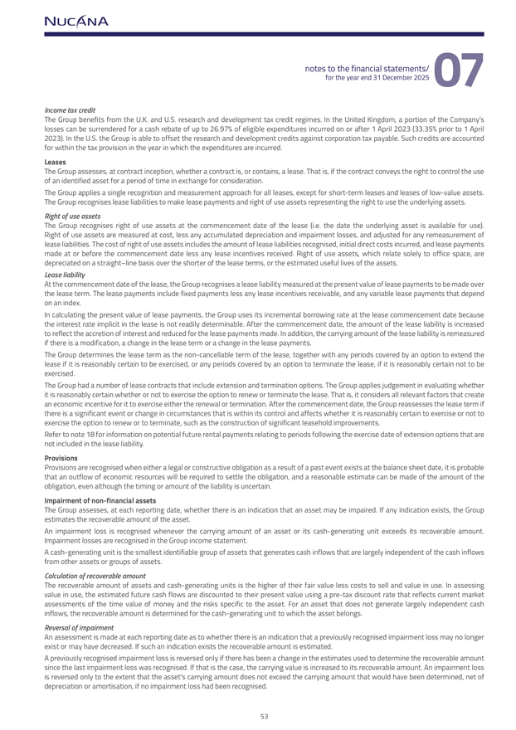
Income tax creditThe Group benefits from the U.K. and U.S. research and development tax credit regimes. In the United Kingdom, a portion of the Company’s losses can be surrendered for a cash rebate of up to 26.97% of eligible expenditures incurred on or after 1 April 2023 (33.35% prior to 1 April 2023). In the U.S. the Group is able to offset the research and development credits against corporation tax payable. Such credits are accounted for within the tax provision in the year in which the expenditures are incurred.LeasesThe Group assesses, at contract inception, whether a contract is, or contains, a lease. That is, if the contract conveys the right to control the use of an identified asset for a period of time in exchange for consideration.The Group applies a single recognition and measurement approach for all leases, except for short-term leases and leases of low-value assets. The Group recognises lease liabilities to make lease payments and right of use assets representing the right to use the underlying assets.Right of use assetsThe Group recognises right of use assets at the commencement date of the lease (i.e. the date the underlying asset is available for use). Right of use assets are measured at cost, less any accumulated depreciation and impairment losses, and adjusted for any remeasurement of lease liabilities. The cost of right of use assets includes the amount of lease liabilities recognised, initial direct costs incurred, and lease payments made at or before the commencement date less any lease incentives received. Right of use assets, which relate solely to office space, are depreciated on a straight–line basis over the shorter of the lease terms, or the estimated useful lives of the assets.Lease liabilityAt the commencement date of the lease, the Group recognises a lease liability measured at the present value of lease payments to be made over the lease term. The lease payments include fixed payments less any lease incentives receivable, and any variable lease payments that depend on an index. In calculating the present value of lease payments, the Group uses its incremental borrowing rate at the lease commencement date because the interest rate implicit in the lease is not readily determinable. After the commencement date, the amount of the lease liability is increased to reflect the accretion of interest and reduced for the lease payments made. In addition, the carrying amount of the lease liability is remeasured if there is a modification, a change in the lease term or a change in the lease payments.The Group determines the lease term as the non-cancellable term of the lease, together with any periods covered by an option to extend the lease if it is reasonably certain to be exercised, or any periods covered by an option to terminate the lease, if it is reasonably certain not to be exercised.The Group had a number of lease contracts that include extension and termination options. The Group applies judgement in evaluating whether it is reasonably certain whether or not to exercise the option to renew or terminate the lease. That is, it considers all relevant factors that create an economic incentive for it to exercise either the renewal or termination. After the commencement date, the Group reassesses the lease term if there is a significant event or change in circumstances that is within its control and affects whether it is reasonably certain to exercise or not to exercise the option to renew or to terminate, such as the construction of significant leasehold improvements.Refer to note 18 for information on potential future rental payments relating to periods following the exercise date of extension options that are not included in the lease liability.ProvisionsProvisions are recognised when either a legal or constructive obligation as a result of a past event exists at the balance sheet date, it is probable that an outflow of economic resources will be required to settle the obligation, and a reasonable estimate can be made of the amount of the obligation, even although the timing or amount of the liability is uncertain.Impairment of non-financial assetsThe Group assesses, at each reporting date, whether there is an indication that an asset may be impaired. If any indication exists, the Group estimates the recoverable amount of the asset. An impairment loss is recognised whenever the carrying amount of an asset or its cash-generating unit exceeds its recoverable amount. Impairment losses are recognised in the Group income statement.A cash-generating unit is the smallest identifiable group of assets that generates cash inflows that are largely independent of the cash inflows from other assets or groups of assets.Calculation of recoverable amountThe recoverable amount of assets and cash-generating units is the higher of their fair value less costs to sell and value in use. In assessing value in use, the estimated future cash flows are discounted to their present value using a pre-tax discount rate that reflects current market assessments of the time value of money and the risks specific to the asset. For an asset that does not generate largely independent cash inflows, the recoverable amount is determined for the cash-generating unit to which the asset belongs.Reversal of impairmentAn assessment is made at each reporting date as to whether there is an indication that a previously recognised impairment loss may no longer exist or may have decreased. If such an indication exists the recoverable amount is estimated.A previously recognised impairment loss is reversed only if there has been a change in the estimates used to determine the recoverable amount since the last impairment loss was recognised. If that is the case, the carrying value is increased to its recoverable amount. An impairment loss is reversed only to the extent that the asset’s carrying amount does not exceed the carrying amount that would have been determined, net of depreciation or amortisation, if no impairment loss had been recognised.

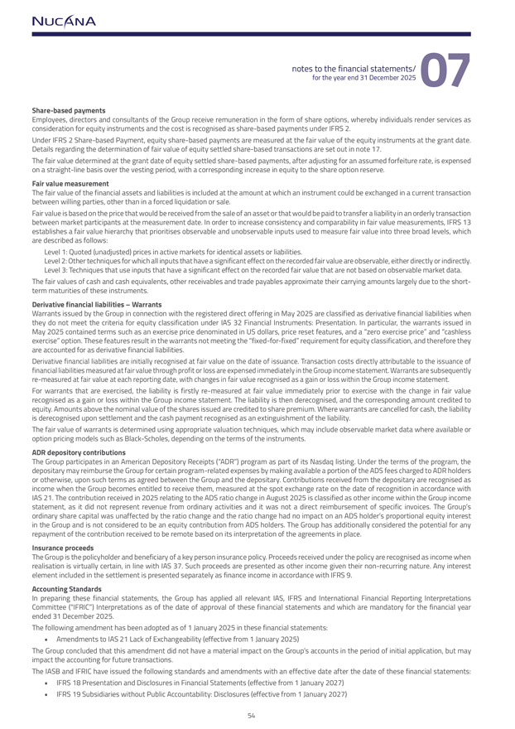
Share-based paymentsEmployees, directors and consultants of the Group receive remuneration in the form of share options, whereby individuals render services as consideration for equity instruments and the cost is recognised as share-based payments under IFRS 2. Under IFRS 2 Share-based Payment, equity share-based payments are measured at the fair value of the equity instruments at the grant date. Details regarding the determination of fair value of equity settled share-based transactions are set out in note 17.The fair value determined at the grant date of equity settled share-based payments, after adjusting for an assumed forfeiture rate, is expensed on a straight-line basis over the vesting period, with a corresponding increase in equity to the share option reserve.Fair value measurementThe fair value of the financial assets and liabilities is included at the amount at which an instrument could be exchanged in a current transaction between willing parties, other than in a forced liquidation or sale.Fair value is based on the price that would be received from the sale of an asset or that would be paid to transfer a liability in an orderly transaction between market participants at the measurement date. In order to increase consistency and comparability in fair value measurements, IFRS 13 establishes a fair value hierarchy that prioritises observable and unobservable inputs used to measure fair value into three broad levels, which are described as follows: Level 1: Quoted (unadjusted) prices in active markets for identical assets or liabilities. Level 2: Other techniques for which all inputs that have a significant effect on the recorded fair value are observable, either directly or indirectly. Level 3: Techniques that use inputs that have a significant effect on the recorded fair value that are not based on observable market data. The fair values of cash and cash equivalents, other receivables and trade payables approximate their carrying amounts largely due to the short-term maturities of these instruments. Derivative financial liabilities – WarrantsWarrants issued by the Group in connection with the registered direct offering in May 2025 are classified as derivative financial liabilities when they do not meet the criteria for equity classification under IAS 32 Financial Instruments: Presentation. In particular, the warrants issued in May 2025 contained terms such as an exercise price denominated in US dollars, price reset features, and a “zero exercise price” and “cashless exercise” option. These features result in the warrants not meeting the “fixed-for-fixed” requirement for equity classification, and therefore they are accounted for as derivative financial liabilities.Derivative financial liabilities are initially recognised at fair value on the date of issuance. Transaction costs directly attributable to the issuance of financial liabilities measured at fair value through profit or loss are expensed immediately in the Group income statement. Warrants are subsequently re-measured at fair value at each reporting date, with changes in fair value recognised as a gain or loss within the Group income statement. For warrants that are exercised, the liability is firstly re-measured at fair value immediately prior to exercise with the change in fair value recognised as a gain or loss within the Group income statement. The liability is then derecognised, and the corresponding amount credited to equity. Amounts above the nominal value of the shares issued are credited to share premium. Where warrants are cancelled for cash, the liability is derecognised upon settlement and the cash payment recognised as an extinguishment of the liability.The fair value of warrants is determined using appropriate valuation techniques, which may include observable market data where available or option pricing models such as Black-Scholes, depending on the terms of the instruments.ADR depository contributionsThe Group participates in an American Depository Receipts (“ADR”) program as part of its Nasdaq listing. Under the terms of the program, the depositary may reimburse the Group for certain program-related expenses by making available a portion of the ADS fees charged to ADR holders or otherwise, upon such terms as agreed between the Group and the depositary. Contributions received from the depositary are recognised as income when the Group becomes entitled to receive them, measured at the spot exchange rate on the date of recognition in accordance with IAS 21. The contribution received in 2025 relating to the ADS ratio change in August 2025 is classified as other income within the Group income statement, as it did not represent revenue from ordinary activities and it was not a direct reimbursement of specific invoices. The Group’s ordinary share capital was unaffected by the ratio change and the ratio change had no impact on an ADS holder’s proportional equity interest in the Group and is not considered to be an equity contribution from ADS holders. The Group has additionally considered the potential for any repayment of the contribution received to be remote based on its interpretation of the agreements in place.Insurance proceedsThe Group is the policyholder and beneficiary of a key person insurance policy. Proceeds received under the policy are recognised as income when realisation is virtually certain, in line with IAS 37. Such proceeds are presented as other income given their non-recurring nature. Any interest element included in the settlement is presented separately as finance income in accordance with IFRS 9.Accounting StandardsIn preparing these financial statements, the Group has applied all relevant IAS, IFRS and International Financial Reporting Interpretations Committee (“IFRIC”) Interpretations as of the date of approval of these financial statements and which are mandatory for the financial year ended 31 December 2025.The following amendment has been adopted as of 1 January 2025 in these financial statements:  Amendments to IAS 21 Lack of Exchangeability (effective from 1 January 2025)The Group concluded that this amendment did not have a material impact on the Group’s accounts in the period of initial application, but may impact the accounting for future transactions.The IASB and IFRIC have issued the following standards and amendments with an effective date after the date of these financial statements:  IFRS 18 Presentation and Disclosures in Financial Statements (effective from 1 January 2027)  IFRS 19 Subsidiaries without Public Accountability: Disclosures (effective from 1 January 2027)

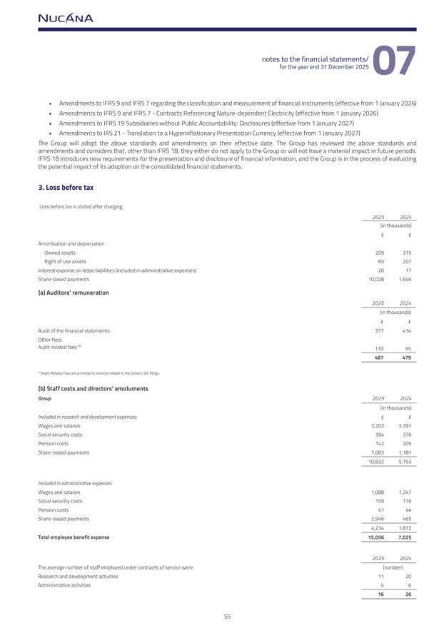
 Amendments to IFRS 9 and IFRS 7 regarding the classification and measurement of financial instruments (effective from 1 January 2026)  Amendments to IFRS 9 and IFRS 7—Contracts Referencing Nature-dependent Electricity (effective from 1 January 2026)  Amendments to IFRS 19 Subsidiaries without Public Accountability: Disclosures (effective from 1 January 2027)  Amendments to IAS 21—Translation to a Hyperinflationary Presentation Currency (effective from 1 January 2027)The Group will adopt the above standards and amendments on their effective date. The Group has reviewed the above standards and amendments and considers that, other than IFRS 18, they either do not apply to the Group or will not have a material impact in future periods. IFRS 18 introduces new requirements for the presentation and disclosure of financial information, and the Group is in the process of evaluating the potential impact of its adoption on the consolidated financial statements.3. Loss before taxLoss before tax is stated after charging:20252024(in thousands)££Amortisation and depreciationOwned assets209315Right of use assets65207Interest expense on lease liabilities (included in administrative expenses)2017Share-based payments10,0281,646(a) Auditors’ remuneration20252024(in thousands)££Audit of the financial statements377414Other fees:Audit-related fees (1)11065487479(1) Audit-Related Fees are primarily for services related to the Group’s SEC filings.(b) Staff costs and directors’ emolumentsGroup20252024(in thousands)Included in research and development expenses:££Wages and salaries3,2033,391Social security costs394376Pension costs142205Share-based payments7,0831,18110,8225,153Included in administrative expenses:Wages and salaries1,0881,247Social security costs159116Pension costs4144Share-based payments2,9464654,2341,872Total employee benefit expense15,0567,02520252024The average number of staff employed under contracts of service were:(number)Research and development activities1120Administrative activities561626

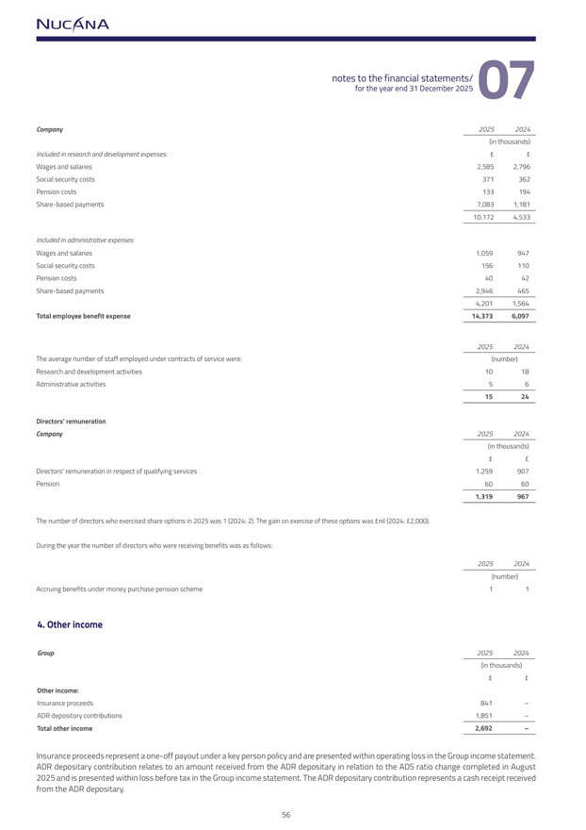
Company20252024(in thousands)Included in research and development expenses:££Wages and salaries2,5852,796Social security costs371362Pension costs133194Share-based payments7,0831,18110,1724,533Included in administrative expenses:Wages and salaries1,059947Social security costs156110Pension costs4042Share-based payments2,9464654,2011,564Total employee benefit expense14,3736,09720252024The average number of staff employed under contracts of service were:(number)Research and development activities1018Administrative activities561524Directors’ remunerationCompany20252024(in thousands)££Directors’ remuneration in respect of qualifying services1,259907Pension60601,319967The number of directors who exercised share options in 2025 was 1 (2024: 2). The gain on exercise of these options was £nil (2024: £2,000).During the year the number of directors who were receiving benefits was as follows:20252024(number)Accruing benefits under money purchase pension scheme114. Other incomeGroup20252024(in thousands)££Other income:Insurance proceeds841–ADR depository contributions1,851–Total other income2,692–Insurance proceeds represent a one-off payout under a key person policy and are presented within operating loss in the Group income statement. ADR depositary contribution relates to an amount received from the ADR depositary in relation to the ADS ratio change completed in August 2025 and is presented within loss before tax in the Group income statement. The ADR depositary contribution represents a cash receipt received from the ADR depositary.

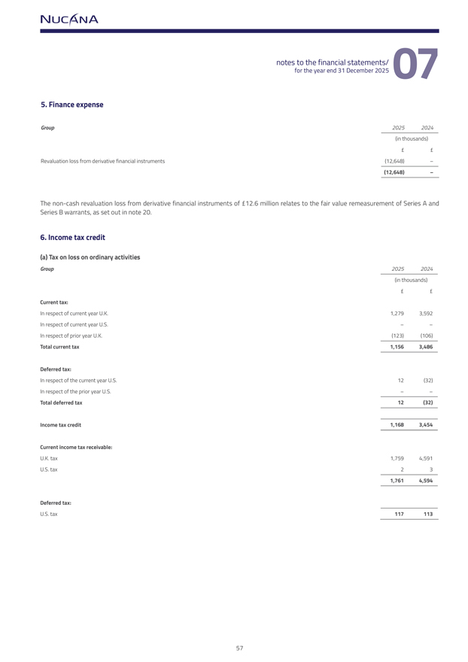
5. Finance expenseGroup20252024(in thousands)££Revaluation loss from derivative financial instruments(12,648)–(12,648)–The non-cash revaluation loss from derivative financial instruments of £12.6 million relates to the fair value remeasurement of Series A andSeries B warrants, as set out in note 20.6. Income tax credit(a) Tax on loss on ordinary activitiesGroup20252024(in thousands)££Current tax:In respect of current year U.K.1,2793,592In respect of current year U.S.––In respect of prior year U.K.(123)(106)Total current tax1,1563,486Deferred tax:In respect of the current year U.S.12(32)In respect of the prior year U.S.––Total deferred tax12(32)Income tax credit1,1683,454Current income tax receivable:U.K. tax1,7594,591U.S. tax231,7614,594Deferred tax:U.S. tax117113

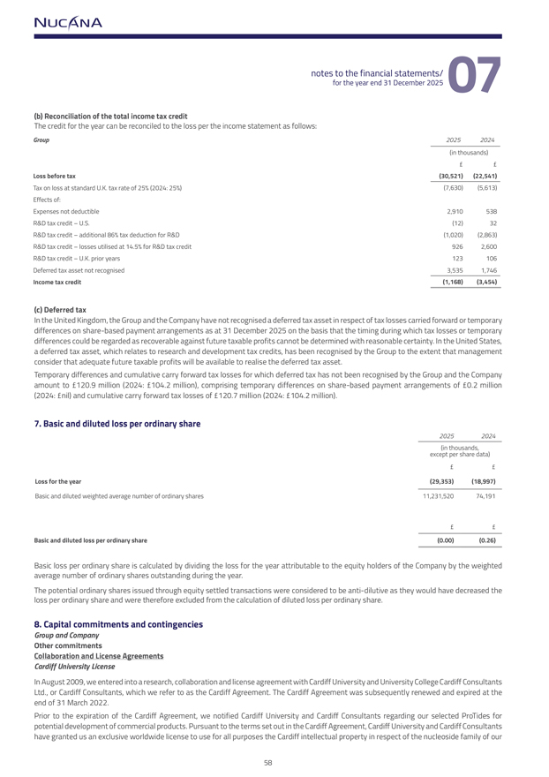
(b) Reconciliation of the total income tax creditThe credit for the year can be reconciled to the loss per the income statement as follows:Group20252024(in thousands)££Loss before tax(30,521)(22,541)Tax on loss at standard U.K. tax rate of 25% (2024: 25%)(7,630)(5,613)Effects of:Expenses not deductible2,910538R&D tax credit – U.S.(12)32R&D tax credit – additional 86% tax deduction for R&D(1,020)(2,863)R&D tax credit – losses utilised at 14.5% for R&D tax credit9262,600R&D tax credit – U.K. prior years123106Deferred tax asset not recognised3,5351,746Income tax credit(1,168)(3,454)(c) Deferred taxIn the United Kingdom, the Group and the Company have not recognised a deferred tax asset in respect of tax losses carried forward or temporary differences on share-based payment arrangements as at 31 December 2025 on the basis that the timing during which tax losses or temporary differences could be regarded as recoverable against future taxable profits cannot be determined with reasonable certainty. In the United States, a deferred tax asset, which relates to research and development tax credits, has been recognised by the Group to the extent that management consider that adequate future taxable profits will be available to realise the deferred tax asset. Temporary differences and cumulative carry forward tax losses for which deferred tax has not been recognised by the Group and the Company amount to £120.9 million (2024: £104.2 million), comprising temporary differences on share-based payment arrangements of £0.2 million (2024: £nil) and cumulative carry forward tax losses of £120.7 million (2024: £104.2 million).7. Basic and diluted loss per ordinary share20252024(in thousands,except per share data)££Loss for the year(29,353)(18,997)Basic and diluted weighted average number of ordinary shares11,231,52074,191££Basic and diluted loss per ordinary share(0.00)(0.26)Basic loss per ordinary share is calculated by dividing the loss for the year attributable to the equity holders of the Company by the weighted average number of ordinary shares outstanding during the year.The potential ordinary shares issued through equity settled transactions were considered to be anti-dilutive as they would have decreased the loss per ordinary share and were therefore excluded from the calculation of diluted loss per ordinary share.8. Capital commitments and contingenciesGroup and CompanyOther commitmentsCollaboration and License AgreementsCardiff University License In August 2009, we entered into a research, collaboration and license agreement with Cardiff University and University College Cardiff Consultants Ltd., or Cardiff Consultants, which we refer to as the Cardiff Agreement. The Cardiff Agreement was subsequently renewed and expired at the end of 31 March 2022. Prior to the expiration of the Cardiff Agreement, we notified Cardiff University and Cardiff Consultants regarding our selected ProTides for potential development of commercial products. Pursuant to the terms set out in the Cardiff Agreement, Cardiff University and Cardiff Consultants have granted us an exclusive worldwide license to use for all purposes the Cardiff intellectual property in respect of the nucleoside family of our

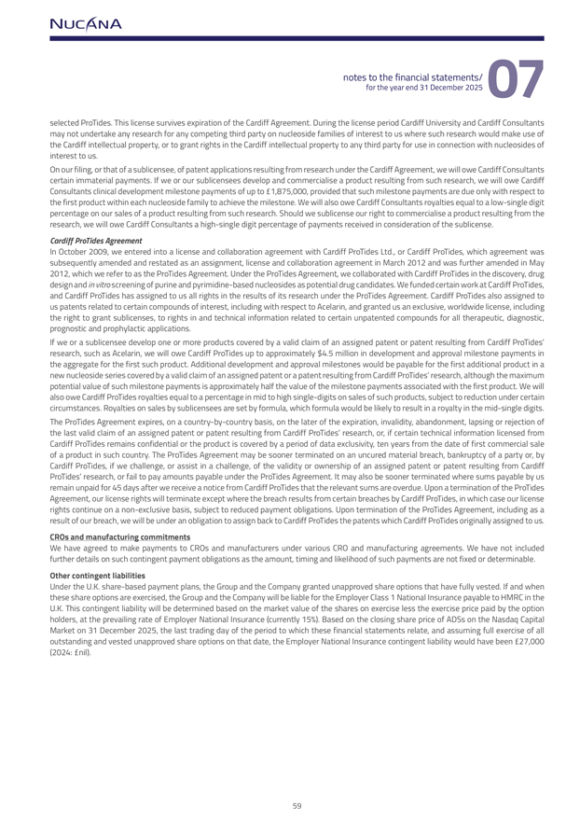
selected ProTides. This license survives expiration of the Cardiff Agreement. During the license period Cardiff University and Cardiff Consultants may not undertake any research for any competing third party on nucleoside families of interest to us where such research would make use of the Cardiff intellectual property, or to grant rights in the Cardiff intellectual property to any third party for use in connection with nucleosides of interest to us.On our filing, or that of a sublicensee, of patent applications resulting from research under the Cardiff Agreement, we will owe Cardiff Consultants certain immaterial payments. If we or our sublicensees develop and commercialise a product resulting from such research, we will owe Cardiff Consultants clinical development milestone payments of up to 1,875,000, provided that such milestone payments are due only with respect to the first product within each nucleoside family to achieve the milestone. We will also owe Cardiff Consultants royalties equal to a low-single digit percentage on our sales of a product resulting from such research. Should we sublicense our right to commercialise a product resulting from the research, we will owe Cardiff Consultants a high-single digit percentage of payments received in consideration of the sublicense. Cardiff ProTides Agreement In October 2009, we entered into a license and collaboration agreement with Cardiff ProTides Ltd., or Cardiff ProTides, which agreement was subsequently amended and restated as an assignment, license and collaboration agreement in March 2012 and was further amended in May 2012, which we refer to as the ProTides Agreement. Under the ProTides Agreement, we collaborated with Cardiff ProTides in the discovery, drug design and in vitro screening of purine and pyrimidine-based nucleosides as potential drug candidates. We funded certain work at Cardiff ProTides, and Cardiff ProTides has assigned to us all rights in the results of its research under the ProTides Agreement. Cardiff ProTides also assigned to us patents related to certain compounds of interest, including with respect to Acelarin, and granted us an exclusive, worldwide license, including the right to grant sublicenses, to rights in and technical information related to certain unpatented compounds for all therapeutic, diagnostic, prognostic and prophylactic applications. If we or a sublicensee develop one or more products covered by a valid claim of an assigned patent or patent resulting from Cardiff ProTides’ research, such as Acelarin, we will owe Cardiff ProTides up to approximately $4.5 million in development and approval milestone payments in the aggregate for the first such product. Additional development and approval milestones would be payable for the first additional product in a new nucleoside series covered by a valid claim of an assigned patent or a patent resulting from Cardiff ProTides’ research, although the maximum potential value of such milestone payments is approximately half the value of the milestone payments associated with the first product. We will also owe Cardiff ProTides royalties equal to a percentage in mid to high single-digits on sales of such products, subject to reduction under certain circumstances. Royalties on sales by sublicensees are set by formula, which formula would be likely to result in a royalty in the mid-single digits. The ProTides Agreement expires, on a country-by-country basis, on the later of the expiration, invalidity, abandonment, lapsing or rejection of the last valid claim of an assigned patent or patent resulting from Cardiff ProTides’ research, or, if certain technical information licensed from Cardiff ProTides remains confidential or the product is covered by a period of data exclusivity, ten years from the date of first commercial sale of a product in such country. The ProTides Agreement may be sooner terminated on an uncured material breach, bankruptcy of a party or, by Cardiff ProTides, if we challenge, or assist in a challenge, of the validity or ownership of an assigned patent or patent resulting from Cardiff ProTides’ research, or fail to pay amounts payable under the ProTides Agreement. It may also be sooner terminated where sums payable by us remain unpaid for 45 days after we receive a notice from Cardiff ProTides that the relevant sums are overdue. Upon a termination of the ProTides Agreement, our license rights will terminate except where the breach results from certain breaches by Cardiff ProTides, in which case our license rights continue on a non-exclusive basis, subject to reduced payment obligations. Upon termination of the ProTides Agreement, including as a result of our breach, we will be under an obligation to assign back to Cardiff ProTides the patents which Cardiff ProTides originally assigned to us. CROs and manufacturing commitmentsWe have agreed to make payments to CROs and manufacturers under various CRO and manufacturing agreements. We have not included further details on such contingent payment obligations as the amount, timing and likelihood of such payments are not fixed or determinable.Other contingent liabilitiesUnder the U.K. share-based payment plans, the Group and the Company granted unapproved share options that have fully vested. If and when these share options are exercised, the Group and the Company will be liable for the Employer Class 1 National Insurance payable to HMRC in the U.K. This contingent liability will be determined based on the market value of the shares on exercise less the exercise price paid by the option holders, at the prevailing rate of Employer National Insurance (currently 15%). Based on the closing share price of ADSs on the Nasdaq Capital Market on 31 December 2025, the last trading day of the period to which these financial statements relate, and assuming full exercise of all outstanding and vested unapproved share options on that date, the Employer National Insurance contingent liability would have been £27,000 (2024: £nil).

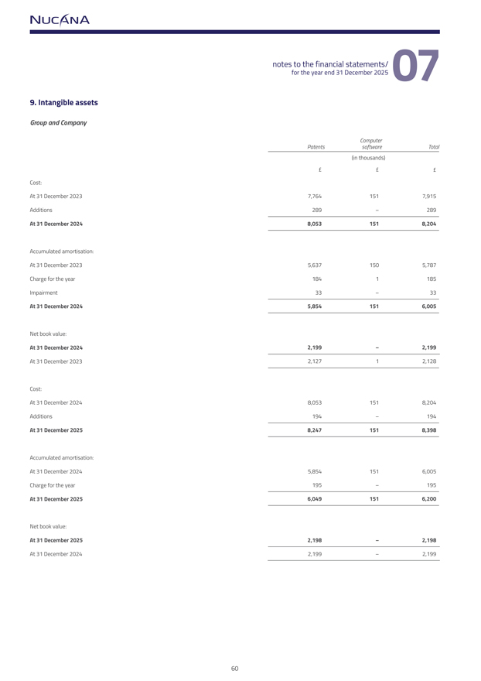
9. Intangible assetsGroup and CompanyComputerPatentssoftwareTotal(in thousands)Cost:At 31 December 20237,7641517,915Additions289–289At 31 December 20248,0531518,204Accumulated amortisation:At 31 December 20235,6371505,787Charge for the year1841185Impairment33–33At 31 December 20245,8541516,005Net book value:At 31 December 20242,199–2,199At 31 December 20232,12712,128Cost:At 31 December 20248,0531518,204Additions194–194At 31 December 20258,2471518,398Accumulated amortisation:At 31 December 20245,8541516,005Charge for the year195–195At 31 December 20256,0491516,200Net book value:At 31 December 20252,198–2,198At 31 December 20242,199–2,199

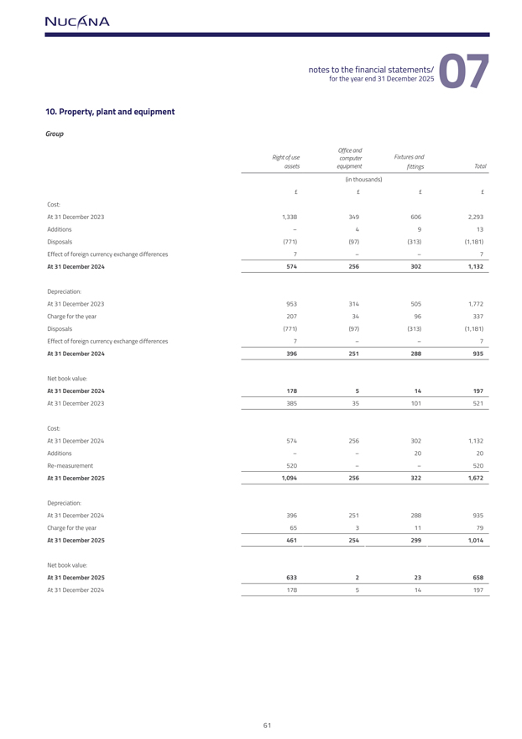
10. Property, plant and equipmentGroupOffice andRight of usecomputerFixtures andassetsequipmentfittingsTotal(in thousands)Cost:At 31 December 20231,3383496062,293Additions–4913Disposals(771)(97)(313)(1,181)Effect of foreign currency exchange differences7––7At 31 December 20245742563021,132Depreciation:At 31 December 20239533145051,772Charge for the year2073496337Disposals(771)(97)(313)(1,181)Effect of foreign currency exchange differences7––7At 31 December 2024396251288935Net book value:At 31 December 2024178514197At 31 December 202338535101521Cost:At 31 December 20245742563021,132Additions––2020Re-measurement520––520At 31 December 20251,0942563221,672Depreciation:At 31 December 2024396251288935Charge for the year6531179At 31 December 20254612542991,014Net book value:At 31 December 2025633223658At 31 December 2024178514197

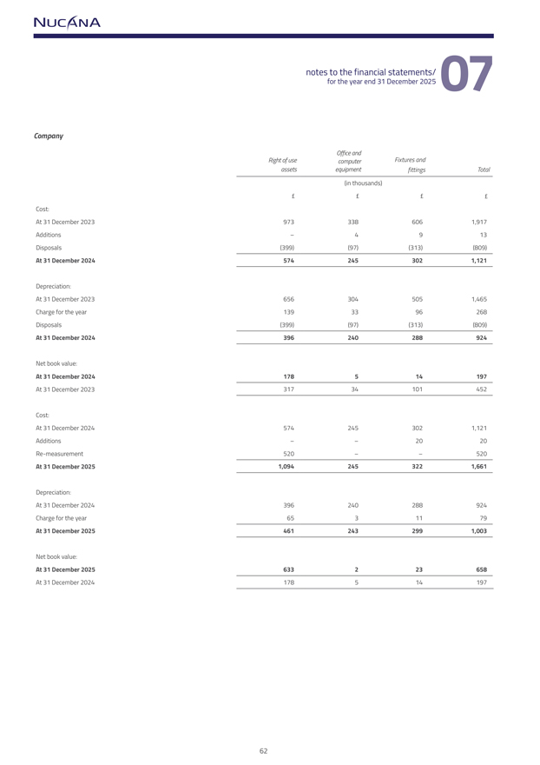
CompanyOffice andRight of usecomputerFixtures andassetsequipmentfittingsTotal(in thousands)££££Cost:At 31 December 20239733386061,917Additions–4913Disposals(399)(97)(313)(809)At 31 December 20245742453021,121Depreciation:At 31 December 20236563045051,465Charge for the year1393396268Disposals(399)(97)(313)(809)At 31 December 2024396240288924Net book value:At 31 December 2024178514197At 31 December 202331734101452Cost:At 31 December 20245742453021,121Additions––2020Re-measurement520––520At 31 December 20251,0942453221,661Depreciation:At 31 December 2024396240288924Charge for the year6531179At 31 December 20254612432991,003Net book value:At 31 December 2025633223658At 31 December 2024178514197

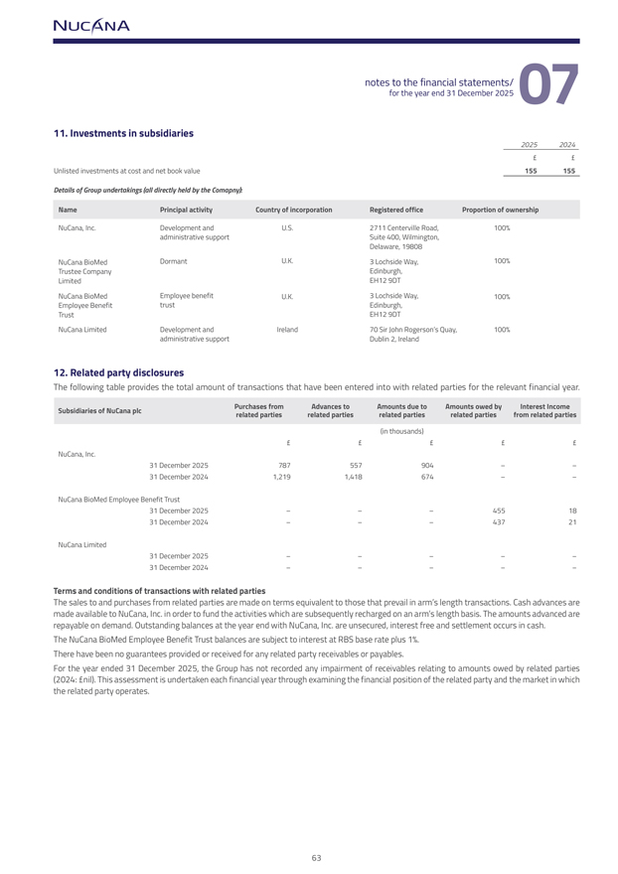
11. Investments in subsidiaries20252024££Unlisted investments at cost and net book value155155Details of Group undertakings (all directly held by the Comapny):NamePrincipal activityCountry of incorporationRegistered officeProportion of ownershipNuCana, Inc.Development andU.S.2711 Centerville Road,100%administrative supportSuite 400, Wilmington,Delaware, 19808NuCana BioMedDormantU.K.3 Lochside Way,100%Trustee CompanyEdinburgh,LimitedEH12 9DTNuCana BioMedEmployee benefitU.K.3 Lochside Way,100%Employee BenefittrustEdinburgh,TrustEH12 9DTNuCana LimitedDevelopment andIreland70 Sir John Rogerson’s Quay,100%administrative supportDublin 2, Ireland12. Related party disclosuresThe following table provides the total amount of transactions that have been entered into with related parties for the relevant financial year.Subsidiaries of NuCana plcPurchases fromAdvances toAmounts due toAmounts owed byInterest Incomerelated partiesrelated partiesrelated partiesrelated partiesfrom related parties(in thousands)£££££NuCana, Inc.31 December 2025787557904––31 December 20241,2191,418674––NuCana BioMed Employee Benefit Trust31 December 2025–––4551831 December 2024–––43721NuCana Limited31 December 2025–––––31 December 2024–––––Terms and conditions of transactions with related partiesThe sales to and purchases from related parties are made on terms equivalent to those that prevail in arm’s length transactions. Cash advances are made available to NuCana, Inc. in order to fund the activities which are subsequently recharged on an arm’s length basis. The amounts advanced are repayable on demand. Outstanding balances at the year end with NuCana, Inc. are unsecured, interest free and settlement occurs in cash. The NuCana BioMed Employee Benefit Trust balances are subject to interest at RBS base rate plus 1%. There have been no guarantees provided or received for any related party receivables or payables. For the year ended 31 December 2025, the Group has not recorded any impairment of receivables relating to amounts owed by related parties (2024: £nil). This assessment is undertaken each financial year through examining the financial position of the related party and the market in which the related party operates.

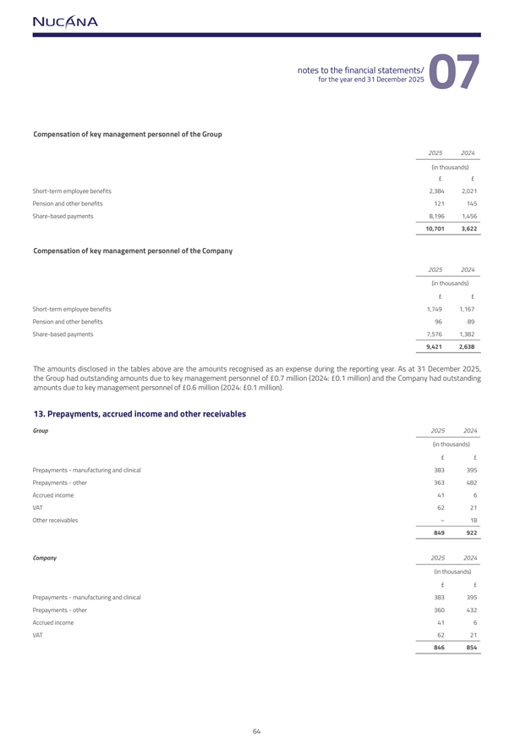
Compensation of key management personnel of the Group20252024(in thousands)Short-term employee benefits2,3842,021Pension and other benefits121145Share-based payments8,1961,45610,7013,622Compensation of key management personnel of the Company20252024(in thousands)Short-term employee benefits1,7491,167Pension and other benefits9689Share-based payments7,5761,3829,4212,638The amounts disclosed in the tables above are the amounts recognised as an expense during the reporting year. As at 31 December 2025,the Group had outstanding amounts due to key management personnel of 0.7 million (2024: 0.1 million) and the Company had outstandingamounts due to key management personnel of 0.6 million (2024: 0.1 million).13. Prepayments, accrued income and other receivablesGroup20252024(in thousands)Prepayments—manufacturing and clinical383395Prepayments—other363482Accrued income416VAT6221Other receivables–18849922Company20252024(in thousands)Prepayments—manufacturing and clinical383395Prepayments—other360432Accrued income416VAT6221846854

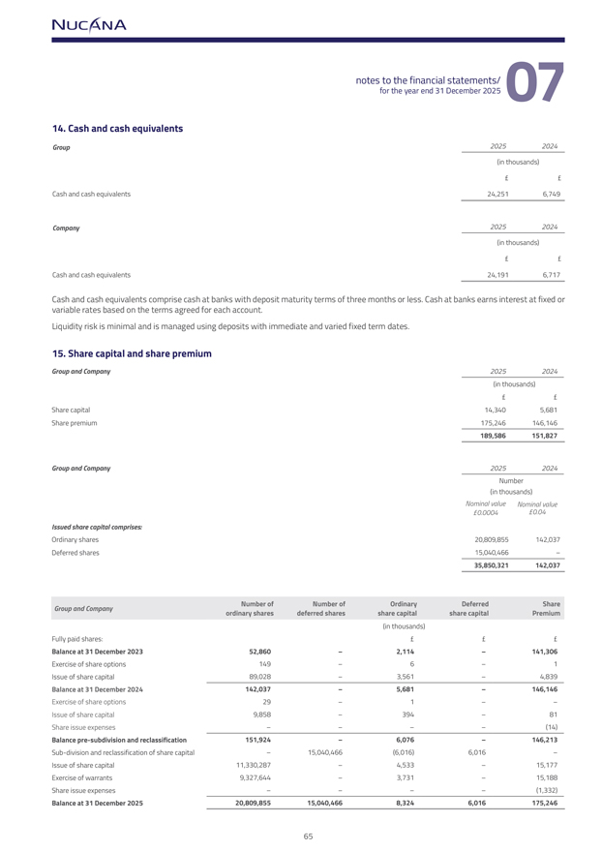
14. Cash and cash equivalentsGroup20252024(in thousands)Cash and cash equivalents24,2516,749Company20252024(in thousands)Cash and cash equivalents24,1916,717Cash and cash equivalents comprise cash at banks with deposit maturity terms of three months or less. Cash at banks earns interest at fixed or variable rates based on the terms agreed for each account. Liquidity risk is minimal and is managed using deposits with immediate and varied fixed term dates.15. Share capital and share premiumGroup and Company20252024(in thousands)Share capital14,3405,681Share premium175,246146,146189,586151,827Group and Company20252024Number(in thousands)Nominal valueNominal value0.00040.04Issued share capital comprises:Ordinary shares20,809,855142,037Deferred shares15,040,466–35,850,321142,037Group and CompanyNumber ofNumber ofOrdinaryDeferredShareordinary sharesdeferred sharesshare capitalshare capitalPremium(in thousands)Fully paid shares:Balance at 31 December 202352,860–2,114–141,306Exercise of share options149–6–1Issue of share capital89,028–3,561–4,839Balance at 31 December 2024142,037–5,681–146,146Exercise of share options29–1––Issue of share capital9,858–394–81Share issue expenses––––(14)Balance pre-subdivision and reclassification151,924–6,076–146,213Sub-division and reclassification of share capital–15,040,466(6,016)6,016–Issue of share capital11,330,287–4,533–15,177Exercise of warrants9,327,644–3,731–15,188Share issue expenses––––(1,332)Balance at 31 December 202520,809,85515,040,4668,3246,016175,246

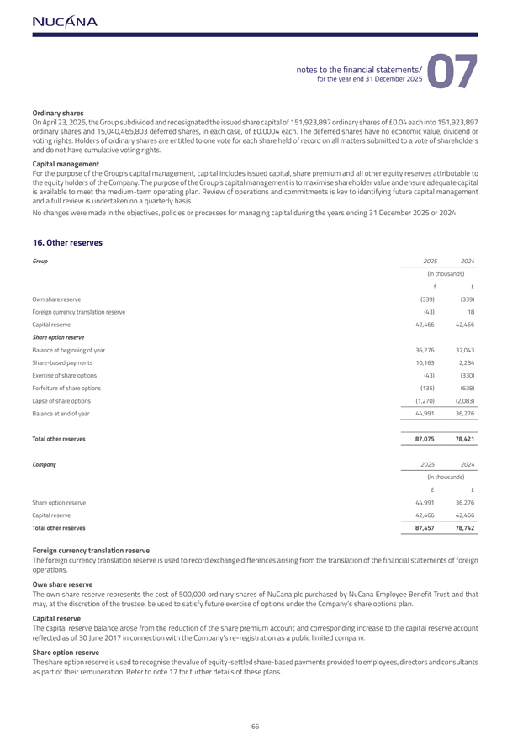
Ordinary sharesOn April 23, 2025, the Group subdivided and redesignated the issued share capital of 151,923,897 ordinary shares of 0.04 each into 151,923,897 ordinary shares and 15,040,465,803 deferred shares, in each case, of 0.0004 each. The deferred shares have no economic value, dividend or voting rights. Holders of ordinary shares are entitled to one vote for each share held of record on all matters submitted to a vote of shareholders and do not have cumulative voting rights.Capital managementFor the purpose of the Group’s capital management, capital includes issued capital, share premium and all other equity reserves attributable to the equity holders of the Company. The purpose of the Group’s capital management is to maximise shareholder value and ensure adequate capital is available to meet the medium-term operating plan. Review of operations and commitments is key to identifying future capital management and a full review is undertaken on a quarterly basis.No changes were made in the objectives, policies or processes for managing capital during the years ending 31 December 2025 or 2024.16. Other reservesGroup20252024(in thousands)Own share reserve(339)(339)Foreign currency translation reserve(43)18Capital reserve42,46642,466Share option reserveBalance at beginning of year36,27637,043Share-based payments10,1632,284Exercise of share options(43)(330)Forfeiture of share options(135)(638)Lapse of share options(1,270)(2,083)Balance at end of year44,99136,276Total other reserves87,07578,421Company20252024(in thousands)Share option reserve44,99136,276Capital reserve42,46642,466Total other reserves87,45778,742Foreign currency translation reserveThe foreign currency translation reserve is used to record exchange differences arising from the translation of the financial statements of foreign operations. Own share reserveThe own share reserve represents the cost of 500,000 ordinary shares of NuCana plc purchased by NuCana Employee Benefit Trust and that may, at the discretion of the trustee, be used to satisfy future exercise of options under the Company’s share options plan. Capital reserveThe capital reserve balance arose from the reduction of the share premium account and corresponding increase to the capital reserve account reflected as of 30 June 2017 in connection with the Company’s re-registration as a public limited company.Share option reserveThe share option reserve is used to recognise the value of equity-settled share-based payments provided to employees, directors and consultants as part of their remuneration. Refer to note 17 for further details of these plans.

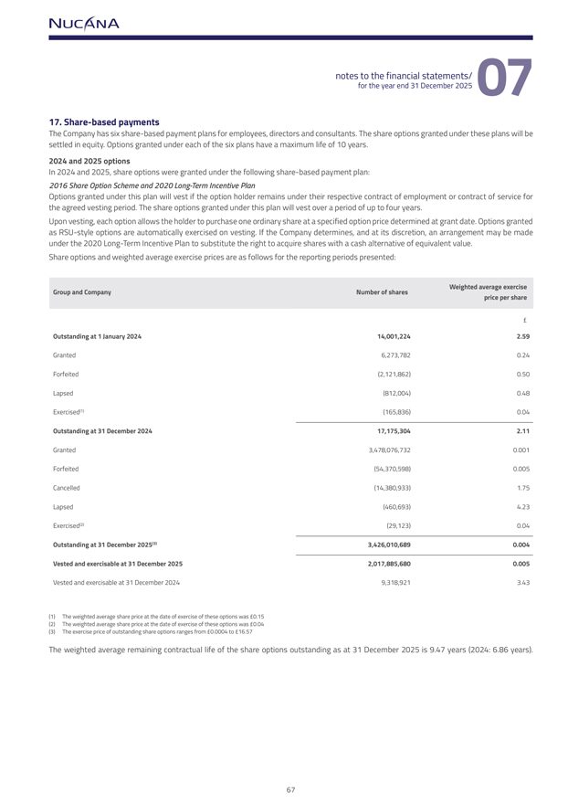
17. Share-based paymentsThe Company has six share-based payment plans for employees, directors and consultants. The share options granted under these plans will be settled in equity. Options granted under each of the six plans have a maximum life of 10 years.2024 and 2025 optionsIn 2024 and 2025, share options were granted under the following share-based payment plan:2016 Share Option Scheme and 2020 Long-Term Incentive PlanOptions granted under this plan will vest if the option holder remains under their respective contract of employment or contract of service for the agreed vesting period. The share options granted under this plan will vest over a period of up to four years.Upon vesting, each option allows the holder to purchase one ordinary share at a specified option price determined at grant date. Options granted as RSU-style options are automatically exercised on vesting. If the Company determines, and at its discretion, an arrangement may be made under the 2020 Long-Term Incentive Plan to substitute the right to acquire shares with a cash alternative of equivalent value.Share options and weighted average exercise prices are as follows for the reporting periods presented:Group and CompanyNumber of sharesWeighted average exerciseprice per shareOutstanding at 1 January 202414,001,2242.59Granted6,273,7820.24Forfeited(2,121,862)0.50Lapsed(812,004)0.48Exercised(1)(165,836)0.04Outstanding at 31 December 202417,175,3042.11Granted3,478,076,7320.001Forfeited(54,370,598)0.005Cancelled(14,380,933)1.75Lapsed(460,693)4.23Exercised(2)(29,123)0.04Outstanding at 31 December 2025(3)3,426,010,6890.004Vested and exercisable at 31 December 20252,017,885,6800.005Vested and exercisable at 31 December 20249,318,9213.43(1) The weighted average share price at the date of exercise of these options was 0.15 (2) The weighted average share price at the date of exercise of these options was 0.04 (3) The exercise price of outstanding share options ranges from 0.0004 to 16.57The weighted average remaining contractual life of the share options outstanding as at 31 December 2025 is 9.47 years (2024: 6.86 years).

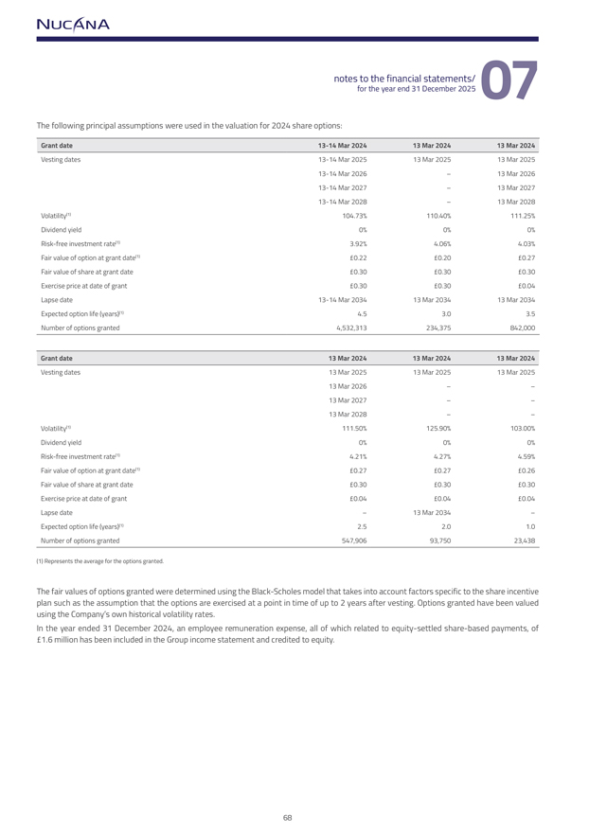
The following principal assumptions were used in the valuation for 2024 share options:Grant date13-14 Mar 202413 Mar 202413 Mar 2024Vesting dates13-14 Mar 202513 Mar 202513 Mar 202513-14 Mar 2026–13 Mar 202613-14 Mar 2027–13 Mar 202713-14 Mar 2028–13 Mar 2028Volatility(1)104.73%110.40%111.25%Dividend yield0%0%0%Risk-free investment rate(1)3.92%4.06%4.03%Fair value of option at grant date(1)£0.22£0.20£0.27Fair value of share at grant date£0.30£0.30£0.30Exercise price at date of grant£0.30£0.30£0.04Lapse date13-14 Mar 203413 Mar 203413 Mar 2034Expected option life (years)(1)4.53.03.5Number of options granted4,532,313234,375842,000Grant date13 Mar 202413 Mar 202413 Mar 2024Vesting dates13 Mar 202513 Mar 202513 Mar 202513 Mar 2026––13 Mar 2027––13 Mar 2028––Volatility(1)111.50%125.90%103.00%Dividend yield0%0%0%Risk-free investment rate(1)4.21%4.27%4.59%Fair value of option at grant date(1)£0.27£0.27£0.26Fair value of share at grant date£0.30£0.30£0.30Exercise price at date of grant£0.04£0.04£0.04Lapse date–13 Mar 2034–Expected option life (years)(1)2.52.01.0Number of options granted547,90693,75023,438(1) Represents the average for the options granted.The fair values of options granted were determined using the Black-Scholes model that takes into account factors specific to the share incentive plan such as the assumption that the options are exercised at a point in time of up to 2 years after vesting. Options granted have been valued using the Company’s own historical volatility rates.In the year ended 31 December 2024, an employee remuneration expense, all of which related to equity-settled share-based payments, of £1.6 million has been included in the Group income statement and credited to equity.

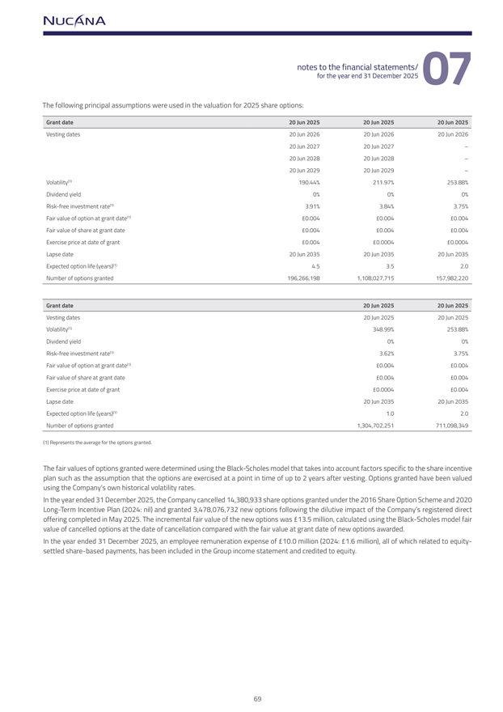
The following principal assumptions were used in the valuation for 2025 share options:Grant date20 Jun 202520 Jun 202520 Jun 2025Vesting dates20 Jun 202620 Jun 202620 Jun 202620 Jun 202720 Jun 2027–20 Jun 202820 Jun 2028–20 Jun 202920 Jun 2029–Volatility(1)190.44%211.97%253.88%Dividend yield0%0%0%Risk-free investment rate(1)3.91%3.84%3.75%Fair value of option at grant date(1)£0.004£0.004£0.004Fair value of share at grant date£0.004£0.004£0.004Exercise price at date of grant£0.004£0.0004£0.0004Lapse date20 Jun 203520 Jun 203520 Jun 2035Expected option life (years)(1)4.53.52.0Number of options granted196,266,1981,108,027,715157,982,220Grant date20 Jun 202520 Jun 2025Vesting dates20 Jun 202520 Jun 2025Volatility(1)348.99%253.88%Dividend yield0%0%Risk-free investment rate(1)3.62%3.75%Fair value of option at grant date(1)£0.004£0.004Fair value of share at grant date£0.004£0.004Exercise price at date of grant£0.0004£0.004Lapse date20 Jun 203520 Jun 2035Expected option life (years)(1)1.02.0Number of options granted1,304,702,251711,098,349(1) Represents the average for the options granted.The fair values of options granted were determined using the Black-Scholes model that takes into account factors specific to the share incentive plan such as the assumption that the options are exercised at a point in time of up to 2 years after vesting. Options granted have been valued using the Company’s own historical volatility rates.In the year ended 31 December 2025, the Company cancelled 14,380,933 share options granted under the 2016 Share Option Scheme and 2020 Long-Term Incentive Plan (2024: nil) and granted 3,478,076,732 new options following the dilutive impact of the Company’s registered direct offering completed in May 2025. The incremental fair value of the new options was £13.5 million, calculated using the Black-Scholes model fair value of cancelled options at the date of cancellation compared with the fair value at grant date of new options awarded.In the year ended 31 December 2025, an employee remuneration expense of £10.0 million (2024: £1.6 million), all of which related to equity-settled share-based payments, has been included in the Group income statement and credited to equity.

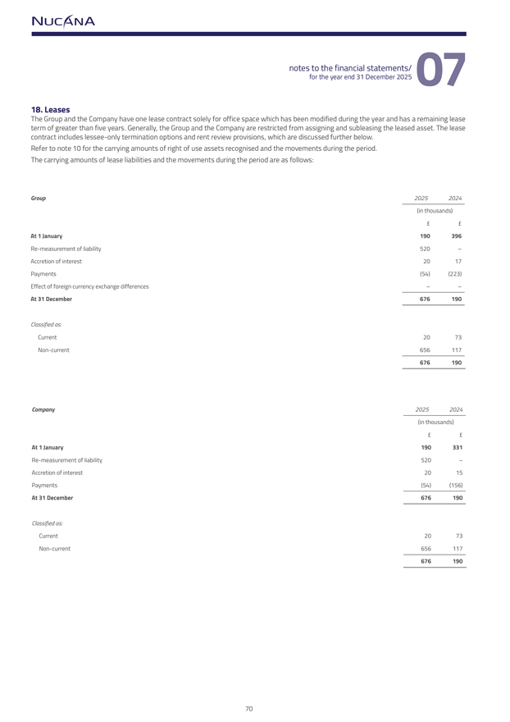
18. LeasesThe Group and the Company have one lease contract solely for office space which has been modified during the year and has a remaining lease term of greater than five years. Generally, the Group and the Company are restricted from assigning and subleasing the leased asset. The lease contract includes lessee-only termination options and rent review provisions, which are discussed further below. Refer to note 10 for the carrying amounts of right of use assets recognised and the movements during the period. The carrying amounts of lease liabilities and the movements during the period are as follows:Group20252024(in thousands)££At 1 January190396Re-measurement of liability520–Accretion of interest2017Payments(54)(223)Effect of foreign currency exchange differences––At 31 December676190Classified as:Current2073Non-current656117676190Company20252024(in thousands)££At 1 January190331Re-measurement of liability520–Accretion of interest2015Payments(54)(156)At 31 December676190Classified as:Current2073Non-current656117676190

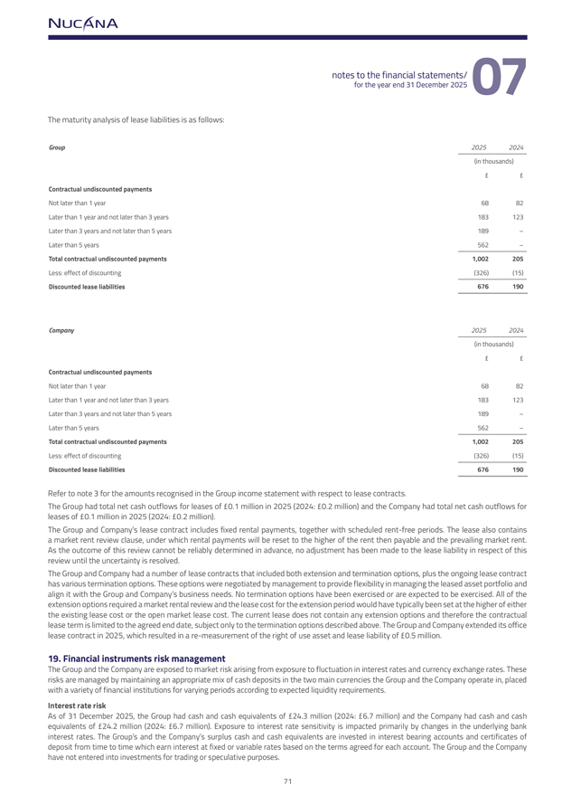
The maturity analysis of lease liabilities is as follows:Group20252024(in thousands)££Contractual undiscounted paymentsNot later than 1 year6882Later than 1 year and not later than 3 years183123Later than 3 years and not later than 5 years189–Later than 5 years562–Total contractual undiscounted payments1,002205Less: effect of discounting(326)(15)Discounted lease liabilities676190Company20252024(in thousands)££Contractual undiscounted paymentsNot later than 1 year6882Later than 1 year and not later than 3 years183123Later than 3 years and not later than 5 years189–Later than 5 years562–Total contractual undiscounted payments1,002205Less: effect of discounting(326)(15)Discounted lease liabilities676190Refer to note 3 for the amounts recognised in the Group income statement with respect to lease contracts.The Group had total net cash outflows for leases of £0.1 million in 2025 (2024: £0.2 million) and the Company had total net cash outflows for leases of £0.1 million in 2025 (2024: £0.2 million).The Group and Company’s lease contract includes fixed rental payments, together with scheduled rent-free periods. The lease also contains a market rent review clause, under which rental payments will be reset to the higher of the rent then payable and the prevailing market rent. As the outcome of this review cannot be reliably determined in advance, no adjustment has been made to the lease liability in respect of this review until the uncertainty is resolved.The Group and Company had a number of lease contracts that included both extension and termination options, plus the ongoing lease contract has various termination options. These options were negotiated by management to provide flexibility in managing the leased asset portfolio and align it with the Group and Company’s business needs. No termination options have been exercised or are expected to be exercised. All of the extension options required a market rental review and the lease cost for the extension period would have typically been set at the higher of either the existing lease cost or the open market lease cost. The current lease does not contain any extension options and therefore the contractual lease term is limited to the agreed end date, subject only to the termination options described above. The Group and Company extended its office lease contract in 2025, which resulted in a re-measurement of the right of use asset and lease liability of £0.5 million.19. Financial instruments risk management The Group and the Company are exposed to market risk arising from exposure to fluctuation in interest rates and currency exchange rates. These risks are managed by maintaining an appropriate mix of cash deposits in the two main currencies the Group and the Company operate in, placed with a variety of financial institutions for varying periods according to expected liquidity requirements.Interest rate risk As of 31 December 2025, the Group had cash and cash equivalents of £24.3 million (2024: £6.7 million) and the Company had cash and cash equivalents of £24.2 million (2024: £6.7 million). Exposure to interest rate sensitivity is impacted primarily by changes in the underlying bank interest rates. The Group’s and the Company’s surplus cash and cash equivalents are invested in interest bearing accounts and certificates of deposit from time to time which earn interest at fixed or variable rates based on the terms agreed for each account. The Group and the Company have not entered into investments for trading or speculative purposes.

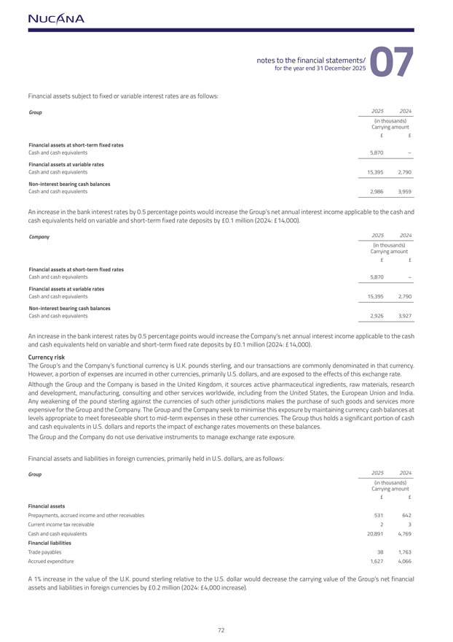
Financial assets subject to fixed or variable interest rates are as follows:Group20252024(in thousands)Carrying amount££Financial assets at short-term fixed ratesCash and cash equivalents5,870–Financial assets at variable ratesCash and cash equivalents15,3952,790Non-interest bearing cash balancesCash and cash equivalents2,9863,959An increase in the bank interest rates by 0.5 percentage points would increase the Group’s net annual interest income applicable to the cash andcash equivalents held on variable and short-term fixed rate deposits by £0.1 million (2024: £14,000).Company20252024(in thousands)Carrying amount££Financial assets at short-term fixed ratesCash and cash equivalents5,870–Financial assets at variable ratesCash and cash equivalents15,3952,790Non-interest bearing cash balancesCash and cash equivalents2,9263,927An increase in the bank interest rates by 0.5 percentage points would increase the Company’s net annual interest income applicable to the cash and cash equivalents held on variable and short-term fixed rate deposits by £0.1 million (2024: £14,000). Currency risk The Group’s and the Company’s functional currency is U.K. pounds sterling, and our transactions are commonly denominated in that currency. However, a portion of expenses are incurred in other currencies, primarily U.S. dollars, and are exposed to the effects of this exchange rate. Although the Group and the Company is based in the United Kingdom, it sources active pharmaceutical ingredients, raw materials, research and development, manufacturing, consulting and other services worldwide, including from the United States, the European Union and India. Any weakening of the pound sterling against the currencies of such other jurisdictions makes the purchase of such goods and services more expensive for the Group and the Company. The Group and the Company seek to minimise this exposure by maintaining currency cash balances at levels appropriate to meet foreseeable short to mid-term expenses in these other currencies. The Group thus holds a significant portion of cash and cash equivalents in U.S. dollars and reports the impact of exchange rates movements on these balances.The Group and the Company do not use derivative instruments to manage exchange rate exposure.Financial assets and liabilities in foreign currencies, primarily held in U.S. dollars, are as follows:Group20252024(in thousands)Carrying amount££Financial assetsPrepayments, accrued income and other receivables531642Current income tax receivable23Cash and cash equivalents20,8914,769Financial liabilitiesTrade payables381,763Accrued expenditure1,6274,066A 1% increase in the value of the U.K. pound sterling relative to the U.S. dollar would decrease the carrying value of the Group’s net financial assets and liabilities in foreign currencies by £0.2 million (2024: £4,000 increase).

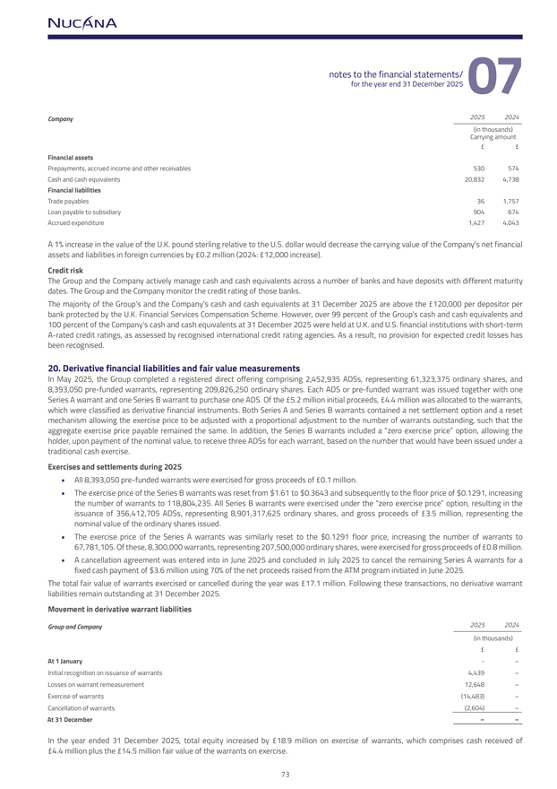
Company20252024(in thousands)Carrying amount££Financial assetsPrepayments, accrued income and other receivables530574Cash and cash equivalents20,8324,738Financial liabilitiesTrade payables361,757Loan payable to subsidiary904674Accrued expenditure1,4274,043A 1% increase in the value of the U.K. pound sterling relative to the U.S. dollar would decrease the carrying value of the Company’s net financial assets and liabilities in foreign currencies by £0.2 million (2024: £12,000 increase).Credit riskThe Group and the Company actively manage cash and cash equivalents across a number of banks and have deposits with different maturity dates. The Group and the Company monitor the credit rating of those banks.The majority of the Group’s and the Company’s cash and cash equivalents at 31 December 2025 are above the £120,000 per depositor per bank protected by the U.K. Financial Services Compensation Scheme. However, over 99 percent of the Group’s cash and cash equivalents and 100 percent of the Company’s cash and cash equivalents at 31 December 2025 were held at U.K. and U.S. financial institutions with short-term A-rated credit ratings, as assessed by recognised international credit rating agencies. As a result, no provision for expected credit losses has been recognised.20. Derivative financial liabilities and fair value measurementsIn May 2025, the Group completed a registered direct offering comprising 2,452,935 ADSs, representing 61,323,375 ordinary shares, and 8,393,050 pre-funded warrants, representing 209,826,250 ordinary shares. Each ADS or pre-funded warrant was issued together with one Series A warrant and one Series B warrant to purchase one ADS. Of the £5.2 million initial proceeds, £4.4 million was allocated to the warrants, which were classified as derivative financial instruments. Both Series A and Series B warrants contained a net settlement option and a reset mechanism allowing the exercise price to be adjusted with a proportional adjustment to the number of warrants outstanding, such that the aggregate exercise price payable remained the same. In addition, the Series B warrants included a “zero exercise price” option, allowing the holder, upon payment of the nominal value, to receive three ADSs for each warrant, based on the number that would have been issued under a traditional cash exercise.Exercises and settlements during 2025  All 8,393,050 pre-funded warrants were exercised for gross proceeds of £0.1 million.  The exercise price of the Series B warrants was reset from $1.61 to $0.3643 and subsequently to the floor price of $0.1291, increasing the number of warrants to 118,804,235. All Series B warrants were exercised under the “zero exercise price” option, resulting in the issuance of 356,412,705 ADSs, representing 8,901,317,625 ordinary shares, and gross proceeds of £3.5 million, representing the nominal value of the ordinary shares issued.  The exercise price of the Series A warrants was similarly reset to the $0.1291 floor price, increasing the number of warrants to 67,781,105. Of these, 8,300,000 warrants, representing 207,500,000 ordinary shares, were exercised for gross proceeds of £0.8 million.  A cancellation agreement was entered into in June 2025 and concluded in July 2025 to cancel the remaining Series A warrants for a fixed cash payment of $3.6 million using 70% of the net proceeds raised from the ATM program initiated in June 2025.The total fair value of warrants exercised or cancelled during the year was £17.1 million. Following these transactions, no derivative warrant liabilities remain outstanding at 31 December 2025.Movement in derivative warrant liabilitiesGroup and Company20252024(in thousands)££At 1 January-–Initial recognition on issuance of warrants4,439–Losses on warrant remeasurement12,648–Exercise of warrants(14,483)–Cancellation of warrants(2,604)–At 31 December––In the year ended 31 December 2025, total equity increased by £18.9 million on exercise of warrants, which comprises cash received of £4.4 million plus the £14.5 million fair value of the warrants on exercise.

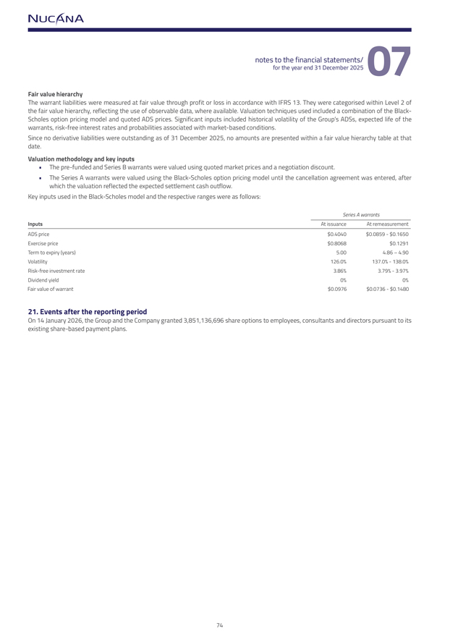
Fair value hierarchyThe warrant liabilities were measured at fair value through profit or loss in accordance with IFRS 13. They were categorised within Level 2 of the fair value hierarchy, reflecting the use of observable data, where available. Valuation techniques used included a combination of the Black-Scholes option pricing model and quoted ADS prices. Significant inputs included historical volatility of the Group’s ADSs, expected life of the warrants, risk-free interest rates and probabilities associated with market-based conditions.Since no derivative liabilities were outstanding as of 31 December 2025, no amounts are presented within a fair value hierarchy table at that date.Valuation methodology and key inputs  The pre-funded and Series B warrants were valued using quoted market prices and a negotiation discount.  The Series A warrants were valued using the Black-Scholes option pricing model until the cancellation agreement was entered, after which the valuation reflected the expected settlement cash outflow.Key inputs used in the Black-Scholes model and the respective ranges were as follows:Series A warrantsInputsAt issuanceAt remeasurementADS price$0.4040$0.0859—$0.1650Exercise price$0.8068$0.1291Term to expiry (years)5.004.86 – 4.90Volatility126.0%137.0%—138.0%Risk-free investment rate3.86%3.79%—3.97%Dividend yield0%0%Fair value of warrant$0.0976$0.0736—$0.148021. Events after the reporting periodOn 14 January 2026, the Group and the Company granted 3,851,136,696 share options to employees, consultants and directors pursuant to its existing share-based payment plans.

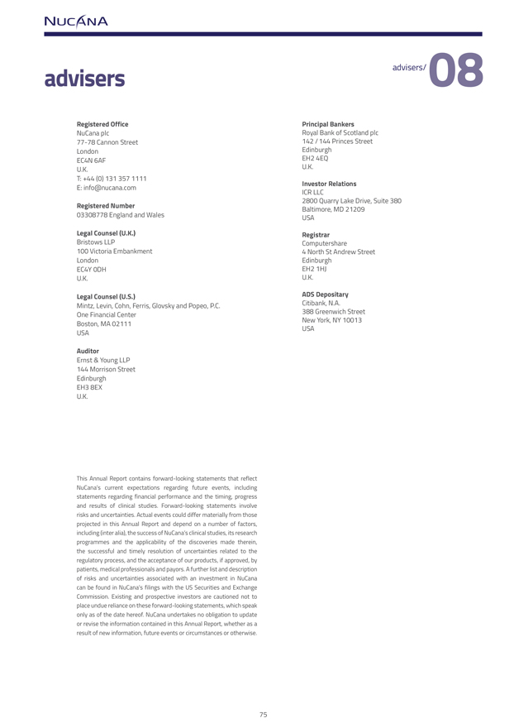
advisersRegistered OfficePrincipal BankersNuCana plcRoyal Bank of Scotland plc77-78 Cannon Street142 / 144 Princes StreetLondonEdinburghEC4N 6AFEH2 4EQU.K.U.K.T: +44 (0) 131 357 1111E: info@nucana.comInvestor RelationsICR LLC2800 Quarry Lake Drive, Suite 380Registered NumberBaltimore, MD 2120903308778 England and WalesUSALegal Counsel (U.K.)RegistrarBristows LLPComputershare100 Victoria Embankment4 North St Andrew StreetLondonEdinburghEC4Y 0DHEH2 1HJU.K.U.K.Legal Counsel (U.S.)ADS DepositaryMintz, Levin, Cohn, Ferris, Glovsky and Popeo, P.C.Citibank, N.A.One Financial Center388 Greenwich StreetBoston, MA 02111New York, NY 10013USAUSAAuditorErnst & Young LLP144 Morrison StreetEdinburghEH3 8EXU.K.This Annual Report contains forward-looking statements that reflect NuCana’s current expectations regarding future events, including statements regarding financial performance and the timing, progress and results of clinical studies. Forward-looking statements involve risks and uncertainties. Actual events could differ materially from those projected in this Annual Report and depend on a number of factors, including (inter alia), the success of NuCana’s clinical studies, its research programmes and the applicability of the discoveries made therein, the successful and timely resolution of uncertainties related to the regulatory process, and the acceptance of our products, if approved, by patients, medical professionals and payors. A further list and description of risks and uncertainties associated with an investment in NuCana can be found in NuCana’s filings with the US Securities and Exchange Commission. Existing and prospective investors are cautioned not to place undue reliance on these forward-looking statements, which speak only as of the date hereof. NuCana undertakes no obligation to update or revise the information contained in this Annual Report, whether as a result of new information, future events or circumstances or otherwise.



